**Student’s Grade Analysis using Machine Learning Techniques of Bachelor of Engineering Student of Pokhara University, Fall 2019**



**Faculty Research Report (Grant No: RMC_SOE-075/074/F-4)**

**Submitted to**

**Research Management Cell-School of Engineering (RMC_SOE)**

**Pokhara University**

**Pokhara-Lekhnath Metropolitan City- Ward 30, Kaski**

**Submitted by**

**Yagyanath Rimal, Lecturer**

**(2021)**

**Declaration**

**I hereby declare that this faculty research report is my/our own work and that it contains no materials previously published. I/We have not used its materials for the award of any kind and any other degree. Where other authors' sources of information have been used, they have been acknowledged. Ideas/Views expressed in this report not necessarily represent the views of RMC_SOE. However, this will be the joint property of the research and RMC_SOE.**

**Signature:**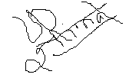

**Yagyanath Rimal**

**Date: 2021/07/16**

**Student’s Grade Analysis using Machine Learning Techniques of Bachelor of Engineering Student of Pokhara University, Fall 2019**

**Submitted by**

**Yagyanath Rimal**

**Lecturer**

**Has been evaluated by**

**Signature:** 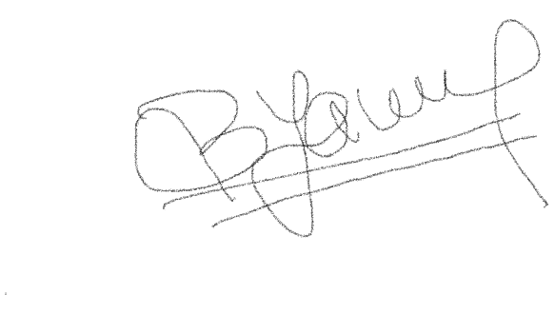

**Name of Expert:** Bal Krishna Nyaupane

**Designation:** Assistant Professor

**Date:**16/07/2021

**Student’s Grade Analysis using Machine Learning Techniques of Bachelor of Engineering Student of Pokhara University, Fall 2019**

**Submitted by**

**Yagyanath Rimal, Lecturer**

**Has been approved by RMC_SOE**

1. **Signature Chairman RMC_SOE:**

**Name:**

1. **Signature Member:**

**Name:**

1. **Signature Member:**

**Name:**

1. **Signature Member:**

**Name:**

1. **Signature Member:**

**Name:**

**Acknowledgement**

I would like to express my sincere thanks to the director of the engineering school for the grant and support for the research. This work would not have been conceivable without the appropriate, helpful guidance from faculty members and staff in the Dean's office, the faculty of science and technology. I express special thanks to the RMC research committee, the chairman and prominent members of his team, SOE, for being continuously available and discussing the research results and the students and staff for data collection and intermediate and final defense. My sincere thanks to all program coordinators, students, and enumerators for providing valuable support in completing this research. My true appreciation and appreciation for Prof. Dr Binaya Kumar Mishra for empowering me to research topics fully, being continuously accessible to organized research work, and for her invaluable collaborations and feedback from proposal to the final manuscript formation of this research in most cases. My composition of original copies. I want to thank Associate Professor Dr Madhusudan Kayatta and Dr. Suresh Baral for their valuable comments in making a difference in testing analysis and selecting appropriate tools for student grade analysis and their constant support and motivation.

I would also like to express my gratitude to all interviewed students, Student Data Enumerator, Aashish Sharma, Anish Wagle, Saroj Sharma, Rita Parajuli, to collect large data sets on students from both constituent schools.

Finally, I express my gratitude to the reviewer for pointing me on the right path in academic research tools and research findings and interpreting student scores for completing this manuscript. I like to take this opportunity to thank the university's teaching and non-teaching staff for their constant encouragement and support during my few years at Pokhara University.

I cannot end without my family, Sakuntala, Pagani, my son Ashraya Rimal and my daughter Aaradhya Rimal, in whose constant encouragement and support. I have relied on them to design my thesis report and complicate this research work.

## **Abstract**

Data analysis and its statistical forecast of student performance before the final exam can help students, faculty, and parents make timely decisions. Here, the researcher would like to predict the student's score before the final exam and then compare the score between the internal range and the final range of each sample of subjects using machine learning techniques for performing the assessment. Finally, he proposed the best recommendation of the network model to predict the next student grade based on the training and test datasets of 580 sampled students of Pokhara University in Nepal 2019. Internal evaluation, high school, plus two, the total and subjects such as since subjects classified in physics, mathematics, chemistry and biology and public or a private school education and the educational status of parents ultimately influence the final grade in the engineering degree were analyzed significantly using 24 models of different neural networks (forward / backwards) after preprocessing using boruta and random forest methodology.

Machine learning offers one of the most cost-effective and widely used approaches to developing critical forecasting tools. Numerous advances in machine learning research have emerged in recent years that have been applied in a wide variety of applications in the computing domain. The researcher uses recent advances in neural network machine learning research to provide GPA prediction tools with improved predictive performance. First, the researcher used the Boruta algorithm to separate large independent variables for the prediction of the final GPA, and second, the random forest methodology is used to predict the GPA and then the multiple and single hidden learned models for the prediction of the GPA of the student model with its respective accuracy. It was analyzed using a confusion matrix, histogram, and regression analysis of various machine learning neural network models to predict the student's final grade accuracy. This research formulates the student's grade complex's qualitative and quantitative prediction problems based on background information using multi-instance regression.

However, the single-layer neural network model (N = 5) predicts the best accuracy in both training and forward traversal testing, while the hidden multilayer model (N = 7,3,2) from the backward model predicts the most accurate result for the GPA prediction. Likewise, based on the random parenting suggestion of forestry students, the school of a private or government institution and their SLC grades were a less insignificant contribution to predicting A grade in engineering degrees. Likewise, mathematical scores and internal scores were found to be significant across 22 independent background variables.

## **Contents**

**Abstract** v

**Contents** vi

**List of Tables** viii

**List of Figures** viii

**Keywords** ix

Chapter 1: Introduction 1

**Background** 1

**Objectives** 4

**Hypothesis** 4

**Research Question** 4

**How a Neural Network Model Works** 5

Chapter 2: Literature Review 11

**Literature Review** 11

Chapter 3: Methodology 21

**Methodology** 21

**The Study Area** 22

**Theoretical Framework** 24

**Data Acquisition and Preprocessing** 24

**Model Design and Setup** 26

**Data Correction and Management using Boruta Algorithm** 27

**Random Forest Methodology for Large Feature Selection** 32

**Plus, two Back Propagation Grade Prediction using Random Forest** 40

**Before Examination Grade Prediction using Random Forest** 45

Chapter 4: Results and Discussions 53

**Neural Network of Pass/Fail Prediction using Single Layer** 53

**Neural Network Correction with Single Layer with Five Neurons (N=5)** 56

**Neural Network of Two Hidden Layer (N=7, 3)** 59

**Neural Network with Three Hidden Layers (N= 7, 3, 2)** 61

**Neural Network with Original Datasets (N=7 ,3 ,2)** 65

**Back Propagation of Five Hidden Layers (N=5)** 73

**Back Propagation of Two Hidden Layers (N = 7, 3)** 76

**Back Propagation of Three Hidden Layers (N= 7,3,2)** 77

**Neural Network with Four Hidden Layers (N= 25, 12, 7, 3)** 80

**Hypothesis Testing** 82

**Multi-nominal Logistic Regression** 84

**Correlation and Linear Regression** 86

Chapter 5: Major Findings and Conclusion 93

**Performance Measures** 93

**Conclusion and Recommendation** 94

**References** 98

**Annex1: Research Questionnaire** 102

**Annex: Photographs** 103

## **List of Tables**

Table 1: University Result Summary Fall 2019 Examination 23

Table 2: Final Grade Conversion Table 25

Table 3: Data Sets in Normal Sample 27

Table 4: Data Sets in Normalized Sample 28

Table 5: Summary Table by Program 91

## **List of Figures**

Figure 1: First Before and After Histogram of Same Variable 6

Figure 2: Single Hidden Layer Neural Network 7

Figure 3: Histogram of Output Result 8

Figure 4: Neural Network with Passed Student 9

Figure 5: Test and Training Conversed Output Histogram 10

Figure 6: Human Cell of Neuron Structure 18

Figure 7: Data Organization and Management 27

Figure 8: Output of Boruta Algorithm 31

Figure 9: Important, Tentative Important and Non important Plot 32

Figure 10: OOB Plot of Random Forest 34

Figure 11: Error Vs Trees and Mtry Plot 35

Figure 12: Nodes and Number of Trees Histogram 37

Figure 13: Mean Decrease Accuracy and Ranking Plots 37

Figure 14: Partial Dependency Plots 39

Figure 15: Partial Dependency Plot of Internal Grade 39

Figure 16: MDS Plot of All GPA Points 40

Figure 17: Histogram of Plus to and Bachelor Grade Distribution 41

Figure 18: Trees and Mtry Plot 42

Figure 19: Histogram Nodes and Gini Decrease Plot 42

Figure 20: Mean Decrease Accuracy and Gini Decrease Plot 43

Figure 21: Partial Dependency Plot of Plus2 Grade 43

Figure 22: Neural Network of 21 Independent Variables 44

Figure 23: Histogram of Conversed Output Values 44

Figure 24: Histogram of Half Model Passed Student 45

Figure 25: Mean Decrease Gini Plot 47

Figure 26: Partial Plot of Math’s and Plus2 Grade 47

Figure 27: Mean Accuracy and Gini Decrease Plot 48

Figure 28: Partial Plot of Internal Marks 49

Figure 29 : Partial Plot of Previous Grade 50

Figure 30: MDS Plot of Grades 50

Figure 31: Mean Accuracy and GINI Decrease Plot 51

Figure 32: Partial Plot of Internal Grades 51

Figure 33: Neural Network Singe Layer of All Result 54

Figure 34: Histogram of Training and Test Conversed Output 54

Figure 35 : Histogram of Half Neural Network Model 55

Figure 36: Neural Network with Single Layer 5 Neurons 57

Figure 37: Histogram of Conversed Output of Single Layer 5 Neurons 57

Figure 38: Histogram of Single Layer Conversed Output of 5 Neurons 58

Figure 39: Neural Network of Two Hidden Layers ( 7,3) 59

Figure 40: Histogram Output of Test and Training Data of Two Hidden Layer 60

Figure 41: Histogram Output of Training and Test 61

Figure 42: Neural Network Model of Three Hidden Layers 63

Figure 43: Histogram of Test and Training Output 63

Figure 44: Histogram of Training and Test Data 64

Figure 45: Neural Network Model of (7,3,2) with Original Data 66

Figure 46: Histogram of Training and Test of Original Data 67

Figure 47: Histogram of Three Hidden Layers with Original Datasets 68

Figure 48: Single Layer Backpropagation Neural Network 71

Figure 49: Histogram of Single Hidden Layer Backpropagation 71

Figure 50: Neural Network of Single Layer Backpropagation 72

Figure 51: Histogram of Single Layer Conversed Value 73

Figure 52: Full and Half Model Neural Network of Single Layer 5 Neuron 74

Figure 53: Full Model Histograms of 5 Neuron Single Layer 74

Figure 54: Half Model Histogram of Training and Test data 75

Figure 55 : Neural Network with Two Hidden Layer N = 7,3 76

Figure 56: Histogram of Conversed Using Two Layers 77

Figure 57: Full and Half Neural Network Model using N= 7,3,2 78

Figure 58: Full and Half Model Histogram of Neural Network 79

Figure 59: Full and Half Model Neural Network of (N= 25,12,7,3) 81

Figure 60: Histogram Output Neuron of Four Layer Network 81

Figure 61: Correlation Plots 88

Figure 62: Residual and QQ Plots 88

Figure 63: Residual and QQ Plot 90

Figure 64 : Half Neural Network Comparison 93

Figure 65: Full Model Comparison 94

## **Keywords**

Assignments; Final Examination Grade Marks Prediction; Neural Network Analysis, Artificial Neural Network

# **Chapter 1: Introduction**

## **Background**

The teaching-learning process encompasses various methodologies such as storytelling, discussion, teaching, training, and direct research practices between student and teacher. Learning is making oneself known from the unknown concept, which requires the most practical and appropriate theoretical concept of brain development, which ultimately facilitates learning, the acquisition of knowledge, skills, values, beliefs and therefore, habit to human learning. The teaching methodology is called pedagogy which facilitates the acquisition by the student of new knowledge. Similarly, evaluation is the process of characterizing and evaluating some aspects of an educational process of learning outcomes, sometimes called evaluation. The educational institution generally requires the assessment student to demonstrate stakeholder effectiveness and measure performance for assessment purposes. Students in their classroom performance and activities to improve their performance are an integral part of any education. However, many practices are applied to measure student performance in the instant semester. Most Western international quality assurance establishes various criteria for the accreditation of the measures used, which directly establish the various procedures of the practical teaching activities and evaluation process in the new mechanism approach to determine their qualifications. An assessment such as tests, interviews, questionnaires, problem-solving, case studies, questionnaires is various tools that were used to standardize the learning process around the world.

Measuring knowledge is another important milestone of a learning institution term such as overcoming/failing. However, the formative assessment focuses on program implementation while summative assessment tests with various measures (Yahya, Mohamed, & Abdelfatah, 2011) adequately assess students' qualifications. On the other hand, the teaching and learning process through Eastern educational philosophy emphasizes the main achievements of teachers, which means that teachers are fully responsible for their class to carry out effective planning and activities within the course for the evaluation of their students. The Assessment Preference Inventory (API), which measured student preferences as a pre-test and perceptions as a post-test (Filip, 2008) is always good for learning at regular intervals. There are still two main grading systems available around the world. One is the percentage system that rates students as 1st grade, 2nd grade, 3rd grade, and they scored positive/negative with equivalent grade margins. Altogether there were 9 grades, which are A +, A, B +, B, C +, C, D, E and NA refers to 'outstanding' will be given to students with a score between 100 and 90, A to students with a score between 80 and 89, B + for those who obtain scores between 70 and 79, B for scores between 60 and 69, C + for scores between 50 and 59, and C for world scores between 40 and 49 practice that rules of each university system can vary. Although the Grade Calculation (GPA) is weighted by credit hours, multiply each numerical value of the grade by the number of credits the course is worth. Adding these numbers together and dividing by the total number of credits each student has earned is another grading system that is emerging smoothly.

A neural network used in deep learning consists of several layers connected to work on the structure and function of the human brain. It learns from large volumes of data and uses a complex algorithm to train the neuron. When multidimensional input data is sent to the network to predict two dog images, the dog information is found in information vectors fed through hidden layers for prediction accuracy. During network forwarding, past information was not remembered as it formed another layer with the weight and output of each node. The feedback network used regression and classification problems of predictive variables is used in image recognition. The deep neural network is used for acoustic modelling, the deep network for cancer detection, and the recurrent neural network for speech recognition.

According to (Woodford, 2017) a neural network functions like computer programs of brain neurons assembled from hundreds, thousands or millions of artificial brain cells that learn and behave remarkably similar to the human brain of 100 billion neurons. The neurons are so small that they could pack about 100 of their cell bodies into a single millimeter by transmitting the axon to the node. The neural network simulates many densely interconnected brain cells within a computer to learn human-like things, recognized patterns and decisions. The best thing about the neural network is to learn how the brain is sometimes called an artificial neural network where millions of artificial neurons called units are arranged in a series of layers, each connecting to the layers of each side. The input, concealed and output units are connected completely connected. This means that each input and output network has been connected to one unit with other units, and the weight represents their weights. Heavier weights affect another. A richer structure is called a deep neural network for dealing with more complex problems; however, it requires greater training speed. A neural network works like computer programs of brain neurons assembled from hundreds, thousands, or millions of artificial brain cells that learn and behave in extraordinary ways. A richer structure is called a deep neural network for dealing with more complex problems. However, it requires greater training speed.

**Feedforward neural network**

Information processing in a neural network flows in two ways when data is sent to another layer through training, and the model is fed into the network via input signals triggered using BIOS terms for layers in the one-way flow, known as a relay network. Each unit has received inputs, and the other units are multiplied by the link weights travelling using the trigger function using sigmoid and threshold value triggers and units of theirs. The neural network learns things through feedback as it does so, changes the weight, and reduces the output between actual and expected output, was two matches exactly. Information only advances in this type of network by using a constant bios activation function to another level. Input layers range from hidden layers to output layers. The network enables function flows in only one direction from the input layer to the output layer, passing through the hidden layers. Each unit in a level is linked forward to each unit in the next level to convert the final forecast.

**Backward propagation**

The concept of backpropagation was first described by Arthur E. Bryson and Yu-Chi Ho in 1969, who won research on artificial neural networks. As the algorithm's name suggests, errors propagate backwards from the output nodes to the internal nodes. Technically speaking, backpropagation is used to calculate the network error gradient relative to the network's modifiable weights. This gradient is almost always used in a simple stochastic gradient descent algorithm to find weights that minimize cumulative errors. Backpropagation is used in a more general sense, to refer to the whole procedure which includes both the computation of the gradient and its use in the stochastic descent of the gradient. Backward propagation generally allows rapid convergence to satisfactory local minima by mistake in the type of networks to which it is adapted.

Backpropagation is a multi-layered feedback network with a layer of hidden z-drives. The output units y has b (i) polarization, and the hidden unit z has b (h) polarization. Both output and hidden drives have bias. The bias acts as weights in connection units whose output is always 1. The input layer is connected to the hidden layer, and the output layer is connected to the output layer using interconnect weights. The backpropagation architecture resembles a multi-layered feedback network. The increasing number of hidden layers determines the computational complexity of the network—consequently, the time required for convergence and error minimization. The bias is provided for both the hidden and the output layer, to act on the net input to be calculated.

The standard and generally well-functioning method used in the algorithm can be applied to any network. It does not require special features of the function to be learned. The calculation time is reduced if the chosen weights are if the weights chosen are small at the beginning.

There is a batch update of weights, which provides a calming effect on the weight correction terms.

The problem appears to be overwhelmingly complex when using large data sets, but there is a solution. The solution to the problem may change over time, within the limits of the given input, and the output parameters may or may not be numeric.

The feature extraction method limits the nature and outcome of the preprocessing step, and the decision to use a grayscale image versus a binary image, a filled representation, thinned skeletons versus full-stroke images is dependent on the nature of the features to be extracted. In 1979, Kunihiko Fukushima invented an artificial neural network with a multi-layered hierarchical architecture and acquired the ability to recognize visual patterns through learning.

## **Objectives**

The specific objectives of this research are to analyze the grade performance of Fall 2019 SOE students.

To assess whether the completion of the continuous assessment determines the final grade.

To know the correlation between internal grades and final grades obtained by students.

To predict the student's grade before the final exam based on previous associative performance using various machine learning techniques.

## **Hypothesis**

H1: there is no significant difference between the mark of each subject with the continuous evaluation of the student.

H1: There is a significant difference between the pass rates of different batches of students.

## **Research Question**

What strategies can be adopted to reduce the consistency of the student's internal and final grades?

## **How a Neural Network Model Works**

The neural network is the best tool for large noisy data however it has less interpretability as compared to other models. Here the researcher tries to explain clearly elaborate its working modality and hyperparameter designed of sample research data. After loading the neural network library, the data sets of student records loaded using read.csv command as the input data variable in r console. The str command is used to describe the database description as however, the database value needs to be normalized using min and max procedures in machine learning model. Here researcher just selects 16 independent variables for prediction student marks of 580 observations with their normalized values for the purpose of describing how neural network model works. Here researcher tries to explain with all students’ model with GPA as explanatory variables having "0" "1" "2" "3" "4" "5" "6" "7" levels of final scored grades indicates 0 for fail,1 for A,2 for A-,3 for B+ and so on order the structure of data looks like.

$ GPA: int 2 3 1 3 2 5 5 2 2 2 ...

$ SLC: num 0.69 0.792 0.583 0.833 0.861 ...

$ School: num 1 1 0 0 0 1 0 1 1 1 ...

$ Plus: num 0.833 0.722 0.694 0.778 0.778 ...

$ Physics: num 0.811 0.568 0.541 0.676 0.676 ...

$ Math: num 0.519 0.75 0.577 0.865 0.865 ...

$ Chemistry: num 0.789 0.553 0.763 0.395 0.395 ...

$ Bio: num 0.924 0.815 0.761 0.761 0.761 ...

$ Parent1: num 0 1 0.667 0.333 0.333 ...

$ Parent2: num 0.667 1 1 1 1 ...

$ X1: num 0.88 0.94 0.98 0.8 1 0.84 1 0.88 0.9 0.92 ...

$ X2: num 0.78 0.78 0.88 0.82 0.82 0.72 0.82 0.88 0.88 0.9 ...

$ X3: num 0.542 0.375 0.542 0.917 0.917 ...

$ X4: num 0.88 0.82 0.86 0.72 0.76 0.72 0.76 0.92 0.84 0.9 ...

$ X5: num 0.84 0.96 0.78 0.72 0.9 0.92 0.9 0.78 0.84 0.78 ...

$ X6: num 0.84 0.8 0.82 0.64 0.84 0.68 0.84 0.64 0.94 0.94 ...

The data has a dependent and independent association of variables whose values in integer type of all independent variables in GPA. The GPA has 0 if the student has failed otherwise passed in final examination results 2019. The student marks SGPA could be converted with a respective categorical factor with 10 levels of A, A-, B+ B, B-, C+, C, C- D+, D, D- and Fail grade. However, there were only seven distinct grades. Here the research problem is supervised machine learning needs classification of neural network with numerical representation. One more step for data normalization using mean max whose plots in histogram were displayed in figure 1 below. Where all database or each column are normalized the concept of substation of minimum and divides by max and subtraction of minimum of each record of student observation. The summary statists present in the describes normalized and non-normalized in similar histogram of same marks columns. The dependent variable GPA produce10 categories with factor type numeric type as.

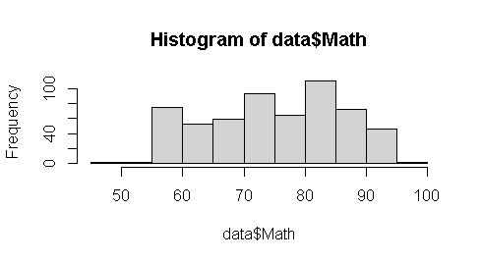 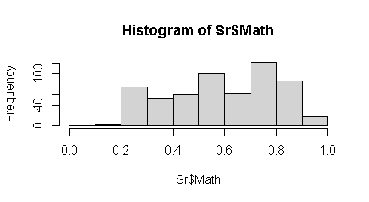

Figure 1: First Before and After Histogram of Same Variable

After setting out seed value to get similar output after each next execution from the model. The tidyverse package is used to filter the selected datasets make new research split subset. The data partition splits sample function divides two samples with 70% and 30% for training and test for model design validation randomly. After loading neural network package of neural network using n=neuralnet (p ~ SLC + School + Plus + Physics +Math +Chemistry + Bio + Parent1 + Parent2+ X1+ X2 + X3 +X4 +X5 + X6, data=training, hidden=c (1), err.fct="sse, linear. output = FALSE) model. Here the hyperparameters like “sse” (sum of the square) is chosen for error calculation purpose with single hidden layer to produce linear output become set as false. The differential function for calculation of errors "ce" cross entropy or "sse" could be selected. The plot “plot(n)” displays the output depends on the dependent variable GPA having numeric or factor category too after seeing repetition with minimum errors in plot (n, rep=1) if we set more repetition in design may select other execution rep value. The hidden hyper parameter 1 indicates a single hidden layer for mathematical explanation here.

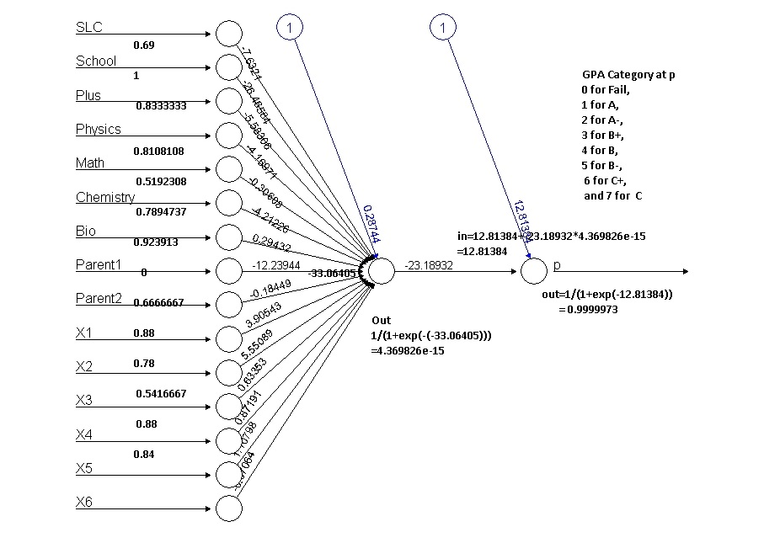

Figure 2: Single Hidden Layer Neural Network

The model output with original value is calculated using compute function output=neural net: compute (n, training [, -1]) command display the output as 0.4812963, 0.4812963 0.4812963 0.4812963 values of all 580 sample variables of student database.

The head (training [1,]) describes first records of GPAX, SLC, Plus, Physics, Math, Chemistry, Bio, Parent1, X1, X2, X3, X4, X5 and X61 respectively their weights are 0.3907611 0.7916667, 0.7222222, 0.5675676, 0.75, 0.5526316, 0.8152174, 1 0.94, 0.78, 0.375, 0.82 ,0.96 and 2 0.8 describes (y-) respectively the output conversed value product at last layer after traversed though hidden layer in between. The hidden parameter computes more adjustment if multiple layers need to converse to the GPAX. Another hyperparameter err.fct="see" is chosen for only when the data sets with having more than two categories either true or false type if so err.fct=” ce” dependent outcome is applicable for design the model. The first node received weight of first 13 input nodes and hidden layer 14 node is calculated with the sum and bios and sum of each weight of previous input neuron as in14 = 0.28744+ (-7.6321* 0.69)+ (-26.465584*1)+ (-5.58306 * 0.8333333) + (-4.16971 *0.8108108) + (-0.30608 * 0.5192308) + (-4.211226 * 0.7894737) + (0.29432 * 0.923913)+(-12.23944*0) + (18449* 0.6666667)+ (3.90543*0.88)+ (5.55089*0.78) +(0.63353* 0.5416667 )+ (0.87191*0.88)+ (1.10798 * 0.84)+ (-0.07064*0.84) which produce the value of (-33.06405) is input at node 15th node and produced the output using sigmoid function is 1/(1+exp(-in14)) is 4.369826e-15 which always lines in between 1 and 0 because which used sigmoid function that indicates association and the 15th node input become to calculated its weight using 12.81384+(-23.18932*4.369826e-15) produces the value -12.81384 ultimately the output from 16th is again calculated using sigmoid function 1/(1+exp(-(-12.81384))) produces each input signals 0.9999973 which is shown in figure conversed outcomes matched with head first records using result command whose output is display as.

1 0.99996886

8 0.99996885

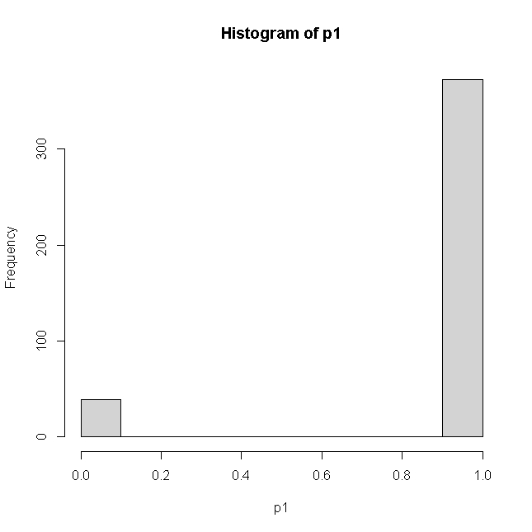

Figure 3: Histogram of Output Result

9 0.99996864

11 0.99996871

12 0.99996874

13 0.99996881

576 0.01189466

578 0.99996886

580 0.99996886

This is our inquiry of prediction of grade of eight scale graded whose histogram predication on seven scale grades model (0 for Fail, 1 for A, 2 for A-, 3 for B+ 4 for B 5 for B- 5 for C+ and 7 for C-. The model testing and validation using confusion matrix of model could be calculated using compute function compute (n, training [, -1]) function with excluding its dependent variable GPA grade of student. The head result plots the histogram further plotted for the proper prediction of accurate grade based on input signals conversed. Whose prediction and accuracy could be calculated based on predict function after grouped up again using the logic pred1= ifelse (p2>=0.88,1, ifelse(p2>=.75, 2, ifelse (p2>=.65,3, ifelse(p2>=0.55,4, ifelse(p2>=0.30,5, ifelse(p2>=0.2,6, ifelse(p2>=.15,7,0))))))) matrix as.

pred2 0 1 2 3 4 5 6 7

0 4 0 1 1 1 0 0 0

1 70 19 28 22 6 13 1 1

3 1 0 0 0 0 0 0 0

Which accuracy using formula 1-sum (diag (tab2))/sum(tab2) is 0.8630952. From the above accuracies indicate these data need to be make prepare more correction in the model to get more accuracy although there were more than 86 percent accuracy in both training and test data sets of 580 student records of final examination 2019. If incase if we used 22 predictor variables using final grade the accuracy goes around 50 percent less and when the dependent variable only has two categories this model produces 97 percent accuracy. This process indicates based on dependent variables type and margin of accuracy with categorial type model production largely differs and needs some data preparation too. However, due to many dependent variables with eight prediction category this model did accuracy more than 85 percent is good enough.

Similarly, the prediction of neural network with only passed student model (half model) after selection of same data sets of above 13 input data sets with the only passed student whose scored final grade of categorized A for 1, A- for 2, B+ for 3, B for 4, B- for 5, C+ for 6, and C- for 7 seven category result of engineering students. After normalized of predictor variable to explanatory variables the training and testing data separation of 70 and 30 percent of only 290 records (Half Model). The model n=neuralnet (GPA~SLC+ School+ Plus + Physics +Math Chemistry+ Bio+Parent1+ Parent2 +X1+ X2+ X3+ X4+ X5+ X6, data=training, hidden=c (1), err.fct="sse”, linear. output=TRUE). Here error factor is used as the sum of the square with a single hidden neural network conversed quite differently with accuracy.

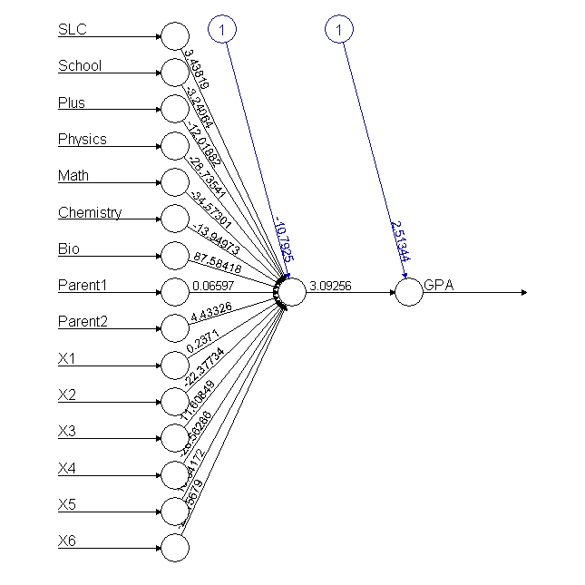

Figure 4: Neural Network with Passed Student

From the above output conversion of neuron, the input to in14th node is calculated 2.39998+ (2.08578*0.69) + (4.64526*1) + (0.25413*0.8285714) + (2.83408*0.8108108) + (1.0983* 0.4047619) + (2.69845*0.7894737) + (1.2807*0.923913) + (0.65258*0) + (4.74991*0.6666667) + (0.31636*.7777778) + (0.93483*0.56) +(0.29306*0.5217391) +(0.63501*0.7777778) +(0.59444*0.7575758) +(1.36278*0.7647059). Which produce the input to 14th node is 20.82648 and is again passed to sigmoid function input to another node 1/(1+exp(-in14)) is 1 and again input to 15th node is 1 must always lines between 1 and 0 because of sigmoid function then output from that node is again calculated with 0.21029 +(2.43648*out14) is 2.64677 wight to another node. Thus, the final node SGPAO=1/(1+exp(-SGPA)) output from the last neuron is 0.9338116 implies the accuracy of 93 percent matched. This matched with head first records of net$result value of model. The after applying of output with net. neuron result calculated as data of 290 records of passed students.

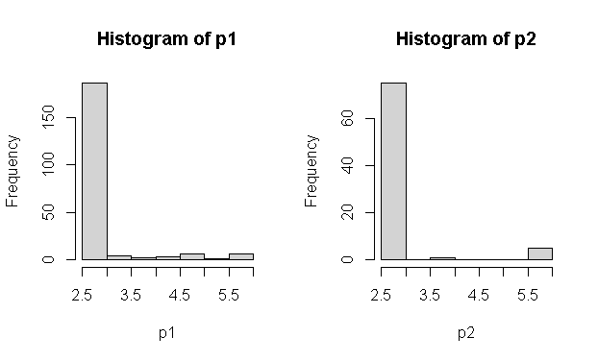

Figure 5: Test and Training Conversed Output Histogram

The prediction after calculating compute function the respective values of each grade is further categorized assuming ifelse(p2>=5.5,1, ifelse(p2>=5,2, ifelse(p2>=4.5,3, ifelse(p2>=4.0,4, ifelse(p2>=3.5,5, ifelse (p2>=3,6,7)))))) condition for the purpose of total predication formed table (pred1, training$GPA) is 0.8271605 percent. This model design produce more than 82 presents is quite a good model prediction although the random samples of splitting differ validation. However, the model predicts more accurately than full model although this needs some improvement of selecting dependent variable before design final model of GPA prediction.

pred2 1 2 3 4 5 6

1 0 1 2 0 2 0

5 0 1 0 0 0 0

7 14 25 13 12 9 2

These above explanations summarized that data preparation needs to get more accurate result. The average of both tests of training and test accuracy implies more than 85 percent accuracy is good model without data management.

# **Chapter 2: Literature Review**

## **Literature Review**

Although a similar study was carried out in the department of education, the University of Maastricht (David, Rijt, Filip, & Janine, 2008) concluded that no relationships were found between students' perceptions of assessment and their perceptions assessment scores. Although students preferred written tests, including home exams and papers tests, in which they are allowed to use supporting materials such as notes and books, as well as papers or projects. The oral test and the other modes of alternative assessment mentioned in the question computerized tests and groups work are not best students' preferences procedures agreed. Similarly, the type of grade prediction research carried out in The Islamic University of Bahawalpur (Muhammad & Aijaz Ahmed, 2007) concluded that 16 students got more than 80 marks in internal assignments, but they failed in the final examination. However, this study covers master in education students. Similarly, for those students, who scored the highest 88.07 marks in assignments, score least mean 49.57 shows students are getting the lowest marks in the final examination.

Similarly, (Brijesh Kumar & Saurabha, 2011) apply the ID3 algorithm use sample of 50 students to identify various attributes to perform best scores. (Naqui, 2006) Used linear regression on a sample of 300 students from affiliated colleges of Panjab University. The study (John & Manabete, 2015) surveyed 1847 students in Nigerian Universities concluded that the internal consistency reliability of grade was 0.86 used heterogeneous classes in university students. They applied the Naive Bayes method to predict student performance from the data warehouse of the student data. The research collected a sample of 220 students, out of which 175 records are considered training, 45 records are considered as test data achieve 86.66% accuracy.

Similarly, (Patel, 2017) suggests that the internal examination pattern must be in university standard of three tests of any subject should be conducted properly recommended, use one algorithm to have good predictive accuracy among a large class data. (Sorour, Mine, & Hirokawa, 2014) claims to achieve 82 per cent accuracy using artificial neural network using decision tree algorithm based on J48 and multiple linear regression to predict student performance using regression analysis of 181 students' marks.

Similarly, (Ramaswami & Rasthnasbapathy, 2010) applied the Bayesian and CHID algorithm used 5560 students to predict the performance of higher secondary students based on 35 contributing attributing background information of students. Similar findings were reported by (Brijesh Kumar & Saurabha, 2011) use Naïve Bayesian classification of 300 students. (Pandey & Pal, 2012) the study sample of 600 students used the Bayes classification algorithm. Similar (Cohen, 1995) research conducted to predict student performance of 778 Portuguese students using machine learning algorithm concluded that decision tree algorithm is the best, to predict whether the student would pass or fail in mathematics and Portuguese language courses.

Many studies investigated the ways of applying machine learning techniques for various educational purposes. (Havan & Harshil, 2015) investigated the application of machine learning techniques in distance learning for drop-outs used Bayesian classification for their drop-out student grade. Similarly, (Nikolopoulos, 2009) research conducted national institute of Athens conducted a survey on student drop out survey use of Naive Bayes indeed performed better than any other machine learning algorithm. However, the vital contribution of this study was that time-invariant features that might be detrimental to the machine learning process are better left out of the study entirely. He also concluded that instead of demographic characteristics of students, using initial attendance and homework grades produces a better prediction rate at earlier stages. (Brijesh Kumar & Saurabh, 2012) Conducted a study on the student performance-based by selecting 300 students from 5 different degree colleges of BCA students of Dr R. M. L. Awadh University, Faizabad, India, use the Bayesian classification method using 17 attributes. It was found that the factors like students' grades in the secondary exam, living location, medium of teaching, mother's qualification, students’ other habits, annual family income, and student's family status were highly correlated with the student academic performance. In study concluded that those variables whose probability values were greater than 0.70 were the highly influencing variables with high probability values. These features were used for prediction model construction of both variable selection and prediction, model using MATLAB.

The neural network model concept is based on the brain's anatomy; it turns out that this model introduced a new approach for solving technical problems outside biological science. However, there were two types of machine learning techniques, i.e., supervised and unsupervised, which could be selected based on problem definition and prediction. In general, there were four categories; classification techniques are carried out when there is a new category will be predicted after having various attributes being contributed in different attributes of input data. Similarly, the loan application is a high, medium, or low risk. Spouse regression analysis always predicts fixed numeric values after setting out various input data attributes. The price of the stock is always in numeric increment or decrement, not a category.

The cluster analysis techniques apply when organizing similar items into various groups, the resulting grade of the student in a single class category of A, A-, B+, B, B- C+, C- D marks. Data analysis is the rule to capture the association between items and events applied to test the association with similar variables.

Similarly, (Rushika, Juilee, Pooja, Sachee, & Priya, 2018) studied farmers' crop prediction in Maharashtra crop suits their soil quality, soil nutrients, and soil composition used Multiple Linear Regression (MLR) technique for crop analysis prediction. The decision tree algorithm and classification are used to perform analysis of over 362 datasets of crops. The training dataset was classified into organic, inorganic, and real estate for predicting the type of soil. The backpropagation network uses a hidden layer which helps in better performance in predicting soil properties. The two-regression supervised machine learning methods are used Support Vector Machine (SVM) and Relevance Vector Machine (RVM) to show effectiveness in soil quality prediction used smart wireless device for sensing soil moisture and meteorological data. The wireless device gives an error rate of 15% and 95% accuracy. However, it has not been tested for real-time data. Which used three methods includes Decision tree, Naive Bayes classifier, and KNN classifier which analyses soil and predicts crop yield, farmers' crop prediction. (El & Yasser, 2008) use Support Vector machine to identify the B cell antigenic sequences is critical for understanding disease pathogenesis, for identifying potential autoantigens, and for designing vaccines and immune-based cancer therapies for predicting linear B-cell epitopes and flexible length linear B-cell epitopes, respectively, using string kernel-based support vector machine (SVM) classifiers. Likewise, (Verdes, Granitto, Navone, & Ceccatto, 2010) predict frost prediction for horticultural with considering various methodological variables temperatures frost protection of fruits and vegetables of machine learning techniques usually employed in regression and classification problems, including artificial neural networks, used Bayes classifiers, and k-Nearest Neighbors. The results obtained in this study reveal a very noisy structure of the data (Shoon Lei, Zaw Zaw, Faridah, & Ibrahim, 2014) entropy-based gene selection approach to select relevant prognostic genes that are directly responsible for recurrence prediction. This proposed system has achieved an average accuracy of 98.9% in predicting cancer recurrence over three cancer datasets. It is one of the deadliest diseases globally and is responsible for around 13% of all deaths worldwide. The cancer incidence rate is growing at an alarming rate in the world Naive Bayes, which is fundamentally built on the strong independence assumption, is a very popular classifier in machine learning due to its simplicity, efficiency, and efficacy (Fisher, 2014).

(Kalejaye, Folorunso, & Usman, 2015) at the Federal University of Agriculture, Abeokuta, Nigeria, use of artificial neural network (ANN) model for predicting students' academic performance in a University System, based on the previous datasets consists of 60 students in the Department of Computer and information science, Tai Solaria University of education in Ogun state, who have completed four academic sessions from the university. The codes were written and executed using MATLAB format.

The test data evaluations showed that the ANN model could correctly predict students' final grade with 91.7% accuracy for CGPA prediction. In this work, various demographic features (age, gender, and race), as well as college entrance examination results, were used to train a neural network to predict the final student grade of students in e-learning courses using multiple feed-forward neural networks and multiple-choice test data administered to the students of National Technical University, Athens, Greece as input. Engineering course of the University of Ibadan using various influencing factors such as unlevel scores, matriculation exam scores, age on admission, parental educational background, and others as input variables. The results indicated that the neural network was able to correctly estimate the performance of more than 70% of prospective students at University Malaysia, Pohang using a fuzzy logic system of secondary school results, mode of entry, parent literacy, and others. This study suggested that machine learning techniques are capable to handle the uncertainty associated with students' performance. To determine their strengths and weaknesses used four machine learning models learning tree, bagging, random forest, and boosting have been used to predict the academic performance of students by Hudson and Christian in 2014 results showing high prediction accuracy (Lykourentzou, Giannoukos, Mpardis, Nikolopoulos, & Loumos, 2009).

A feed-forward neural network (FFNN) is a backpropagation network that allows the signal to flow one way, from input to output. No feedback mechanism tends to be the straightforward network that connects inputs with outputs. Besides, FFNN consists of one or more hidden layers of neurons in which neural connections, called synapses, do not form a directed cycle. The information moves only forward, from the input to the final output node. During its learning phase, the network is presented with a set of examples called the training set. Each input consists of an input vector and the corresponding output vector. This type of learning is known as supervised learning. The FFNN training aims to minimize the sum of square error (SSE) and, more recently, mean square error (MSE) between its actual and target outputs by adjusting the synaptic network weights and neuron biases. More particularly, these network parameters are adjusted based on the backpropagation algorithm. Each unit is designed to mimic its biological counterpart, accept a weighted set of inputs, and respond with an output. The neural networks address the problem that is often not easy for traditional computers to solve, typically, speech and pattern recognition, time-series forecasting, scheduling, regression, and function approximation. An artificial neural network is a science that deals with methods and systems for information processing using a neural network called neuro computation (Adepoju, Ogunjuyigbe, & Alawode, 2007). To address these constraints, (Karamouzis, 2000) reported developing a prototype electronic system called (Final Grade Model). This study evaluated FIG's predictive power model. (Miranda & Martin, 2013) conducted a study to identify the various impacting factors of student performance using 120 students of mathematical and tutorial classes.

Similarly, (Mubarak & Umar, 2019) conduct a higher student grade prediction of 61 computer network data set using WEKA software predicts 73.68 per cent of student prediction, whose 66.6 per cent were likely to drop out before graduating. However, higher education institute's goal is to tards improving higher education quality, the success of human capital creation is a continuous issue (Osmanbegović & Suljić, 2012). Thus, knowledge of data mining to extract hidden knowledge useful not only for the student but also for teachers, administrations, and academic institutions (Romero & Ventura, 2010). The data mining, machine learning, and statistical methods used decision tree and genetic algorithm to develop each subject's performance predict secondary school student failure by applying and comparing algorithms decision tree, random forest, neural network, and support vector model. This model has to make early score predictions even before the semester starts for the final examination of engineering courses (Saleem, Kathiry, Al-Osimi, & Badr, 2015) using logistic regression and discriminant analysis for student failure. However, this study tries to use past student grades associated with current internal grades to predict and classify student marks.

Similarly, (Yang & Brinton, 2017) conduct research on massive online courses of pre-student performance prediction found 60 per cent accuracy of average performance using neural networks. The predictive learning networks that predict learning outcomes in different points ultimately informed poor student attention from an instructor and caused drop-out in early attention (Brinton & Chiang, 2016). However, the greatest challenges of grade prediction are that many students may choose a single alternative answer in multiple type questions. Moreover, the learning process may depend on many personalized motivations, which largely increased due to online materials increases 61% more RMSE and, on average more than 10 per cent importance in grade performance.

Similarly, according to (Zacharis, 2016) research was conducted with a multilayer perception neural network to predict student performance on blended learning courses, which predicts 93% accuracy of classification of the potential student of the first year. Moreover, (Wongkhamdi & Seresangtakul, 2010) achieve 86 per cent of student prediction accuracy. (Shahiri, Husain, & Rashid, 2015) study the effectiveness of artificial neural network in forecasting graduate student outcome with 93.3 as compared discriminant analysis 81.3 per cent. The research found that 98% accuracy in neural network and 91% accuracy on decision tree prediction, whereas 76 per cent on Knearest and 76 per cent accuracy using naïve biased prediction matches of educational data mining.

Similarly, (Sidath, 2018) defines a classification model as a model or classifier constructed to predict categorical labels value. In recent years education data management has significant attraction has emerged as a core research area due to its large potential for prediction. Therefore, it is necessary to analyze internal marks its association with the student's final grade in SOE Pokhara University. Besides the subject prediction, this study tries to find out factor's hindrances of internal examination management of SOE in the early stage. This concept will be predicted to improve higher education in the school of engineering their class performance, and motivating them to continue improving their performance is an integral part of every instruction.

The curriculum is the formal activities offered to the learner through the educational institution. When Oxford University first held an examination in 1958, it assumed that the examination would give stimulus to scholars and teachers (Ranjita, Sushobhan, Ananya, Nina, & Patralekha, 2014). The continuous internal assessment and evaluation system is strong a type of teaching learning activity (Nnodium, 1992). Similarly, study conducted (Lima, Mohanan, & Harichandran, 2017) on medical students with 40 sample studies concluded a positive correlation between attendance and marks in all the internal theory and practical examinations. The examination always measures the knowledge level of a student whose progress is always required for university management. Effective management depends on the ability to assess the quality of services providers in the education sector. According to (Lykourentzou, Mpardis, & Nikolopoulos, 2009), learners' performance prediction can help identify the weak learners at early stages and properly assist them in coping with their study.

Although similar studies on students who scored a mean 88.07 in internal marks in assignment were getting the lowest marks in the final examination, there were largely missed matched internal and final university results. Based on the empirical literature study on importance-performance analysis, the study identifies the strengths and weaknesses of neural networks (Silva, 2018). Similarly, (Daguang & Xie, 2017) suggested to measure student performance in the workplace is assessed in terms of written and verbal communication skills, ability to innovate, analytical problem-solving skills, group management ability, self-study skills, adaptability, performance under pressure, workplace comportment, ability to work with others, and sense of work responsibility. Preparedness for work is assessed in terms of professional knowledge, fundamental knowledge, extra-curricular knowledge, English proficiency, computer proficiency, and research ability, which only measure the student's total quality. If student performance is predicted before the final examination, it could help all stakeholders and students make timely decisions. Before the semester-end examination, the office of the advisable council has to decide which courses to offers are visiting scholars' precautions. So those students can prepare better teaching materials which ultimately leads to the drop-out ratio of classes. This creates an atmosphere of uncertainty and frustration for management and student life in national development. Timely counselling can help the student to make extra effort to avoid unwilling drop-out in the university examination.

There are various applications of neural networks in artificial intelligence and solving various business problems like classification pattern recognition, face recognition feature extraction, image processing matching signature in the bank, prediction of the historical pattern, and largely applicable in noise reduction of large input data. This tries to find out the relationship pattern from the relationship defied its prediction based on training and test. When the target variables are continuous, apply to the regression model. At the same time, the prediction variables with more categories are called classification. When data without header fall under unsupervised techniques supports dimension reduction techniques PCA and factor analysis for association analysis when using e-commerce prediction automatically referred another product after customer bias products. Therefore, unsupervised predicts could not develop the model for future analysis, just clustering.

The neural network model has to mimic the neuron simulation like the human brain is known as an artificial neural network. In our brain, we get signals from external receptors cell that transmits an impulse from sensors to the receptors that enable humans to receive mechanical, thermal chemical, and stimuli. Other receiver neurons signal that process of signals and send them to corresponding executive organs, so-called effectors.

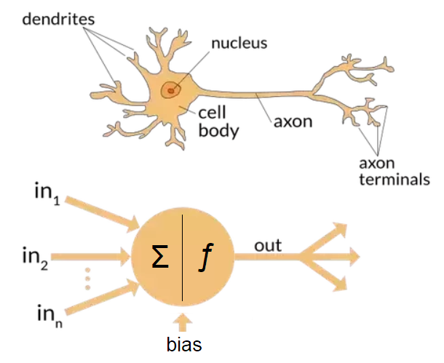

Figure 6: Human Cell of Neuron Structure

The human brain has a massive parallel connection with quick fault-tolerant, the capability for adapting to surroundings, the generalized form is known priorities more than collective behaviors renter than individual behaviors. The final grade prediction based on the limited initial data of students and courses is a challenging task because, at the beginning of undergraduate studies, most of the students are motivated and perform well in the first semester, but as time passed, there might be a decrease in motivation and performance of the students. The study also demonstrated that timely prediction of each student's performance would allow instructors accordingly (Meier, Xu, & Van, 2016) According to their findings, the undergraduate performance of the students could explain 54% of the variance in graduate-level performance.

(Agoritsa & George, 2019) argues that a student's performance in a subset of the earlier courses can be used to predict how well he/she will perform in future courses. Here researcher query is to develop a grade prediction method called course-specific regression that predicts the grade. A student will achieve in a specific course linear combination of the grades that the student obtained in past courses using historical student course grade information to accurately estimate how well students rely on the neighborhood-based collaborative, iterative model. The researcher proposed low-rank matrix factorization is the best performing scheme, based on course specifics regression, achieves an RMSE across the different courses of 0.632, whereas the best competing method achieves an RMSE of 0.661 per cent accuracy. However, the researcher used only three-semester grades of students of 2,949 students records.

Similarly, (Yupei, Yue, Huan, Jiaqi, & Xuequn, 2020) used a majorization minimization algorithm to analyzed 1325 students of higher education data sets. This research used decision tree logic regression and support vector machine methodology. This process used non-negative matrix factorization (NMF) was used to integrate the non-negativity of student grade matrix is an implicitly low rank, low-rank matrix factorization (LRMF) investigated in data sets from the online learning platform in work (Lorenzen, Pham, & Alstrup, 2017). The family information background, such as their parents' economic situation and educational level, influences the scope of student knowledge (Brecko, 2004). (Emaan Abdul, 2016) machine-learning approaches predict student marks and grades before the final examination for 2500 student course records of an institute of higher education suggest that the grade of more than 96% of students can be accurately predicted.

Similarly, (Tair & Alaa, 2012) conducted a study to identify the attributes impacting student performance the most. They used only a genetic algorithm on a sample of 120 students. Their analysis model considers quantitative factors such as theoretical, mathematical, practical, and other departmental marks were used as independent components. They applied only the ID3 algorithm of 50 students to identify the attributes that affected the students' performance (Hijazi & Naqvi, 2006) used linear regression on a sample of 300 students (225 males, 75 females) from a group of colleges affiliated with University of Punjab. They used social and demographic variables alongside the students' grades found that the mother's education and student's family income were highly correlated with the student's academic performance. A similar finding was reported using Naïve Bayes classification on a similar sample of 300 students course records of eight semesters obtained for the undergrad programs from the different semesters. For each semester, 25 to 30 courses with an aggregate enrolment of 800 to 1000 students. Therefore, no model could produce a hundred per cent accuracy on these data set because the weightage of the final exam varies from 25% to 50% of the total marks, which is quite a high weightage cannot model these types of variables. Therefore, it is less realistic to predict the final grade with 100% accuracy (Maghari, 2017).

(Bhardwaj, 2011) proposed a research work that any pattern could be useful as the strongest prediction for students' performance at the UNWE university based on pre-university and personal characteristics. The results showed that the decision tree performs the best accuracy, followed by the KNN classifier, whereas the Bayes classifiers had the lowest accuracy. The authors analyzed the data gathered from colleges student performance prediction by using MATLAB tools. Their study showed that the student's performance does not always depend on the student's effort, but other factors can affect their performance.

Recently, researchers (Hamsa, Indiradevi, & Kizhakkethottam, 2016) conducted a study to predict the performance of academic students in both master's and Bachelor's degrees using classification algorithms and different subjects. However, a few efforts applied classification algorithms on educational datasets of secondary schools in the Gaza Strip. Our study applied major kinds of classification techniques KNN and Naïve Bayes, to help the ministry of education predict the performance of new students and improve results for the next year. (Agoritsa & Karypis, 2016) Present future course grade prediction methods based on sparse linear and low-rank matrix factorization models specific to each course or student–course tuple.

Therefore, this study tries to conduct a neural network to predict student grades using background information of Bachelor of engineering student grade prediction for better improvement. The association of variables of SLC, Pluto, parents' educations, and internal marks relationship signals were being passed to predict conversed neural networks for prediction grade. However, it needs more data sets and program-wise analysis using background and current student achievement to predict student GPA before the final examination.

# **Chapter 3: Methodology**

## **Methodology**

This study design includes a mixed (retrospective and non-interventional) study, including quantitative and qualitative aspects of marks prediction using a neural network. The model comparison using various parameters forward and backward traversing. The hypothesis testing, multinominal logistic regression and correlation were calculated for the describing independent variables significance.

**Study Setting:** This study was conducted in the Pokhara University under the School of Engineering. Where there were eight groups of civil engineering classes and four groups of electrical and electronic, one group of each in civil and rural, Computer and software engineering classes are currently being running in constitute college under the director of the school of engineering comprises total study universe. Whose current fall 2019 were collected in even semester-end program composed of I, III, V, VII and VIII students were the sample population.

**Study Population:** Regarding internal marks prediction of all civil and electrical and electronics groups, Computer, Software and civil and rural student (48*13~624), composite the study population with CGPA collected as the equal number of pass and fail students of each program.

**Duration of the study:** May 2019 to May 2020.

**Sample Size:** Although SOE Pokhara university being currently being running 13 groups of under bachelor programs in faculty of science and technology in constituent campus, out of them all sample clusters were selected (4 Civil and 4 Electrical and Electronic, 1 Civil and Rural and one from Computer and one from Software and two last semesters) with the consideration of each batch representation.

**Sampling Techniques:** A stratified random sampling procedure was selected among 13 groups of SOE where both successful students in their final examination selected completely in the same ratio (290) of fail students were selected by random order, no repetition were taken as sample composed 580 sample machine learning analysis a primary study.

**Data Collection Tools and Techniques:** Vermiculated structured questionnaire was being used to collect the data regarding the previous background information like high school, parents' education, and their plus to grades with physics, math chemistry, and bio total scores were collected and validate with administrative records. Besides, a focus group discussion with CR with guidelines questions was used as data collection tools. Data were collected through an individual questionnaire of the sampled student ratio of passed and failed students. Informed consent was taken from each of the participants before the data collection. The principal investigator and class representative were involved in data collection.

**Data Management and Analysis:** Collected data were managed carefully by considering safety in the first Excel program. Editing, coding, and data cleaning were maintained. The data were analyzed using the R software application. The appropriate descriptive statistics such as percentage, standard deviation, max, and min were applied to conclude the research.

**Data Acquisition and Preprocessing:** Similarly, regression analysis, performance measures, decision tree classification, random forest algorithm, and Boruta algorithm were ruffianly analyzed and explained to predict internal marks and final grade points. Thematic analysis was used for the qualitative data. This study tries to apply supervised machine techniques, i.e., decision tree classifiers and Boruta algorithm, as data preparation and neural network classifiers to predict dependent variable GPA. Similarly, the correlation coefficient after the multicollinearity test of internal and final marks was calculated and explained using R programming. The relationship between each sample program was analyzed.

**Validity and Reliability:** The validity and reliability of the study were maintained by the following techniques. A structured and pre-tested questionnaire was used for the data collection. The expert advice was explored using pre-testing of the tools was carried out amongst 10% of samples.

## **The Study Area**

The semester-end result of engineering students of various programs regularly notified to the student but the analysis on them was not been carried out in higher education engineering student in Nepal. Out of 11 engineering programs currently being running in Pokhara university the five programs are currently being running in SOE. There are 624 regular students were appeared in the final examination fall 2019 out of them 280 were completed with CGPA scored composed of 47.44 percentage. However, the overall university pass ratio of these programs is low 11.25 percentage with considering regular or retake examination result in the fall 2019. When considering program wise pass ratio, the CIVIL VIII students had the highest score 52.38 percentage whereas Computer I, CIVIL l VII and Civil V were the second highest and rural students have lowest pass ratio 12.28 percentage. The Electrical III semester students have a better result than Civil III semester students. Civil V and VII have the highest pass ratio and Elex V had least pass ratio is 8 percentage in 2019 result of SOE. Similarly, university wise comparison of program CIVIL V and Elex V has mismatched the university passed ratio as compared SOE results. The data analysis using machine learning model of 280 pass student’s records, as well as same amount of failed student’s records, were collected and verified from the school of engineering administration office records where 580 questionnaire surveys were collected for neural network model design with the help of student enumerators constitute the database.

|  |  |  |  |  |  |  |  |
| --- | --- | --- | --- | --- | --- | --- | --- |
| Program | Total | Pass | Percentage | SOE | PASS | Percentage | Total sample |
| Civil I | 2818 | 232 | 8.232789 | 156 | 24 | 15.38462 | 48 |
| Civil III | 2788 | 162 | 5.810617 | 172 | 20 | 11.62791 | 40 |
| Civil V | 2320 | 154 | 6.637931 | 176 | 46 | 26.13636 | 92 |
| Civil VII | 1743 | 208 | 11.93345 | 148 | 40 | 27.02703 | 80 |
| Civil VIII | 1269 | 458 | 36.09141 | 147 | 77 | 52.38095 | 154 |
| Computer I | 1012 | 136 | 13.43874 | 47 | 17 | 36.17021 | 34 |
| Civil/Rural I | 94 | 12 | 12.76596 | 48 | 6 | 12.5 | 12 |
| Software I | 340 | 59 | 17.35294 | 47 | 9 | 19.14894 | 18 |
| Elex I | 327 | 33 | 10.09174 | 82 | 12 | 14.63415 | 24 |
| Elex III | 328 | 28 | 8.536585 | 96 | 13 | 13.54167 | 26 |
| Elex V | 302 | 20 | 6.622517 | 75 | 6 | 8 | 12 |
| Elex VII | 218 | 20 | 9.174312 | 64 | 8 | 12.5 | 16 |
| Elex VIII | 210 | 28 | 13.33333 | 68 | 12 | 17.64706 | 24 |
|  | 13769 | 1550 |  | 1326 | 290 | 21.87029 | 580 |
| 13*48 |  | 11.257 |  | 624 | 0.464744 |  |  |

Table 1: University Result Summary Fall 2019 Examination

This table represents the result program wise comparison with percentage as compared national and school of engineering based on result 2019. The overall university campuses results had 25% better result than other campuses located in Nepal.

## **Theoretical Framework**

These studies try to find out the association of student final grade based on neural networks from student’s background information’s like schools’ information, colleges grades, and internal marks of each semester for the predict student achievement (Junemann, 2007) . Here researcher apply various artificial neural networks model to estimate future student grade performance based on students’ family background (parents education status) characteristics as inputs parameter to predict student grade using forward and backward neural network model prediction validation. After model formation of passed and fail student of each neural network model further validate final university results.

GPA

SLC, plus two, Math’s, Physics, Bio Chemistry

parent’s education status

Unit test score

Assignment mark

Internal score

Attendance

Extracurricular activities

School from, Parent education

SLC, +2 Grades

Machine learning

Model

Verification

Actual

Predicted

Figure 1: Conceptual Framework of Research Design

As the teaching-learning process is a mixture of various dimensions this research tries to find out neural network prediction of various input variables to predicate GPA will again further validated with university final GPA student for the model validation using misclassification errors.

## **Data Acquisition and Preprocessing**

This primary study used 580 student data sets of Pokhara University engineering students, whose final grade points were collected from an online result sheet pdf published in various months in 2020 which is available under download section of university home page. Similarly, the second part of their respective internal marks of sample student were collected from the school of engineering internal examination sections of all 580 sampled students. The 50/50 (Pass/ Fail) student data of their background information’s like their percentage parents’ educations were collected from primary datasets from the selected student enumerator to complete questionnaire for datasets for machine learning neural network analysis which completes with VLOOKUP function in excel to complete data sets and integration with internal marks. The data were carefully reviewed preprocessed and organized in excel data base before loading into r console. The incomplete and irrelevant data were being eliminated. The respective GPA of all semester student records of first, third, fifth, seventh, and final eight semesters of each respective course comprised datasets. This final dataset includes internal marks of their respective six subjects were collected in each row fashion. The student's school-leaving grades and their +2 grade were being collected with primary subjects like Physics, Chemistry, and Biology and their final grade point average GPA were collected through questionnaire survey. Similarly, the student background of the institution of learned from i.e., government school or private boarding schools were collected through a selected enumerator and codded. The parent educations status of both first and second parents’ highest academic achievements were collected for the purpose for predicating bachelor grade of students. The parent highest education level was collected in 1 for SLC completion, 2 for Plus two completion 3 for Bachelor completion, and 4 for Master and above level education. The GPA and marks of each student were converted and uniformly organized based on the following table. The parent highest education level was collected in 1 for SLC completion, 2 for Plus two completion 3 for Bachelor completion, and 4 for Master and above level education.

|  |  |  |  |  |  |  |
| --- | --- | --- | --- | --- | --- | --- |
| SLC and +2 Grading | | | | Bachelors | | |
| Grade | Grade Point | % | Description | Grade | Grade Point | % |
| A+ | 3.6- 4.0 | >=90 | Outstanding | A | 4.0 | >=90 |
| A | 3.2-3.6 | >=80&&<90 | Excellent | A- | 3.7 | >=85 |
| B+ | 2.8-3.2 | >=70&&<80 | Very Good | B+ | 3.3 | >=80 |
| B | 2.4-2.8 | >=60&&<70 | Good | B | 3.0 | >=75 |
| C+ | 2.0-2.4 | >=50&&<60 | Above Average | B- | 2.7 | >=70 |
| C | 1.6-2.0 | >=40&&<50 | Average | C+ | 2.3 | >=65 |
| D+ | 1.2-1.6 | >=30&&<40 | Billow Average | C | 2.0 | >=60 |
| D | 0.8-1.2 | >=20&&<30 | Insufficient | C- | 1.7 | >=55 |
| E | <=0.8 | >=0&&<20 | Very insufficient | D+ | 1.3 | >=50 |
|  |  |  |  | D | 1.0 | >=45 |
| Table 2: Final Grade Conversion Table | | | | F | 0.0 |  |

*Note: The cumulative grade point is the average grade point of all the semester which is calculated as CGPA= cumulative total honor points earned/ cumulative total number of credit hours taken*.

The high school information of sampled student was stored in school column with 1 for private school and 2 for government school from and the parent education of each sampled student were stored in 1 for SLC, 2 for +2, 3 for Bachelor and 4 for Master degree completion categorical data. Altogether there were 49 columns of records with 580 composed of 28,420 cells record of the student information for GPA predication. The percentage and GPA conversion on table 2 was truly based on Higher School Center Board (HSCB) grade table of government of Nepal and Pokhara University grade conversion or vice versa for the purpose of data transformation were required.

## **Model Design and Setup**

The R powerful opensource tools offer a wide variety of classification and prediction methods used to build the test of student marks prediction. A neural network algorithm implementation of the bachelor degree grade prediction algorithms. Each classifier is evaluated using the holdout approach i.e., train the model using 70% of the data while on evaluate it on the remaining 30% sample data which is referred to as the testing data whose sample were taken as unseen sample data. This is done for avoid overfitting phenomenon that arises when the evaluation model on the same set of primary records. Similarly, the Boruta algorithm and random forest model were sufficiently analyzed to separate unwanted columns of research out of 49 columns for the purpose required variables only feeding as input to the machine learning model.

Classification

Model

Dataset

Testing

Training Data

Data mining

Algorithm

Results

Validation Verification

.

Figure 7: Data Organization and Management

The figure clearly indicates the initial two separations of training and test data sets whose predicts the training and test output accuracy then further evaluate university results for further verification.

## **Data Correction and Management using Boruta Algorithm**

Here researcher used many ways of feature selection and finding out the best important features before further data analysis. The first the Boruta algorithm was used for feature engineering for the purpose to eliminate large variables to get accurate output due to many reasons and associativity of relationship with many independent variables. The Boruta algorithm apply when there were a large number of features i.e., 49 predictor independent variables which delimitates time and constraints to form the best model accuracy. However, it is always necessary to find out some shadow attributes do not require for the model best fit which shuffled all values then generate the model including very insignificant importance for the rebuild final model. The reason behind using Boruta algorithm for the preparation of data before model development to reduced unimportant and tentative insignificant independent variables omission for best prediction of student GPA. The final data structure presented here with twenty-eight thousand records of 580 student as.

|  |  |  |  |  |  |  |  |  |  |
| --- | --- | --- | --- | --- | --- | --- | --- | --- | --- |
| 1 | 2 | 3 | 4 | 5 | 6 | 7 | 8 |  | 49 |
| SN | Prog | SLC | School | Plus | Physics | Math | Chemistry | FinalGPA |
| 1 | Civil I | 79.84 | 1 | 78 | 85 | 72 | 85 | 80 |
| 2 | Civil I | 83.5 | 1 | 74.2 | 76 | 84 | 76 | 75 |
| 3 | Civil I | 76 | 2 | 73.35 | 75 | 75 | 84 | 85 |
| 4 | Civil I | 85 | 2 | 76 | 80 | 90 | 70 | 75 |
| 5 | Civil I | 86 | 2 | 76 | 80 | 90 | 70 | 80 |
| 6 | Civil I | 87 | 1 | 74 | 76 | 78 | 70 | 65 |
| …………… | | | | | | | | | |
| 578 | ELEX VIII | 55 | 2 | 65 | 55 | 58 | 75 |  | 0 |
| 579 | ELEX VIII | 55 | 1 | 55 | 75 | 80 | 75 | 0 |
| 580 | ELEX VIII | 60 | 1 | 55 | 85 | 90 | 85 | 0 |

Table 3: Data Sets in Normal Sample

|  |  |  |  |  |  |  |  |  |  |
| --- | --- | --- | --- | --- | --- | --- | --- | --- | --- |
| SN | 2 | 33 | 4 | 5 | 6 | 7 | 8 |  | 49 |
| 1 | Prog | SLC | School | Plus | Physics | Math | Chemistry |  | FinalGPA |
| 2 | Civil I | 0.69 | 0 | 0.833 | 0.810 | 0.519 | 0.789 |  | 1 |
| 3 | Civil I | 0.791 | 0 | 0.722 | 0.567 | 0.75 | 0.552 |  | 1 |
| 4 | Civil I | 0.583 | 1 | 0.694 | 0.540 | 0.576 | 0.763 |  | 1 |
| 5 | Civil I | 0.833 | 1 | 0.777 | 0.675 | 0.865 | 0.394 |  | 1 |
| 6 | Civil I | 0.861 | 1 | 0.777 | 0.675 | 0.865 | 0.394 |  | 1 |
|  | Civil I | 0.888 | 0 | 0.722 | 0.567 | 0.634 | 0.394 |  | 1 |
|  |  |  |  |  |  |  |  |  |  |
| 578 | ELEX VIII | 0 | 1 | 0.472 | 0 | 0.25 | 0.526 |  | 0 |
| 579 | ELEX VIII | 0 | 0 | 0.194 | 0.540 | 0.673 | 0.526 |  | 0 |
| 580 | ELEX VIII | 0.13889 | 0 | 0.194 | 0.810 | 0.865 | 0.789 |  | 0 |

Table 4: Data Sets in Normalized Sample

The first table describes the database structure without normalized and second table describes the normalized data of designed database of student records. After loading Boruta, mlbench, caret dplyr and tidverse library data management packages the database loaded into r console using read, csv command into the working directory as data=read.csv ("D:/dataanalysisfinal/SOE/rcode /Dataanalysiscsv.csv") then database converted into data frame format for data in 2d matrix structure for further analysis. The first the null value and missing attributes were omitted if incase present to the database using na. omit (S) function or sometimes researcher used mutate function using mean substation to the database in case there were missing values substitution to be complete database. The data having various information with data frame describes 580 observation of student records of 49 independent variables needs to select only those which were significant to formed the model before features selection and model development.

$ SNN: int 1 2 3 4 5 6 7 8 9 10 ...

$ SN: int 1 2 3 4 5 6 7 8 9 10 ...

$ Prog: char “Civil I" "Civil I" "Civil I" "Civil I" ...

$ Roll: char “2018-1-04-0836" "2018-1-04-0840" "2018-1-04-0846" "2018-1-04-0849" ...

$ Registration: int 19040243 19040247 19040253 19040256 19040257 19040259 19040263

$ Name: char “Anish Shrestha" "Ashok Ban stola" "Baikal Boral" "Bimal Jaisi" ...

$ SLC: num 79.8 83.5 76 85 86 ...

$ School: int 1 1 0 0 0 1 0 1 1 1 ...

$ Plus: int 78 74 73 76 76 74 66 66 66 69 ...

$ Physics: int 85 76 75 80 80 76 83 83 83 56 ...

$ Math: int 72 84 75 90 90 78 62 62 62 68 ...

$ Chemistry: int 85 76 84 70 70 70 56 56 56 61 ...

$ Bio: int 85 75 70 70 70 80 48 48 48 0 ...

$ Parent1: int 1 4 3 2 2 4 1 1 1 2 ...

$ Parent2: int 3 4 4 4 4 4 4 4 4 3 ...

$ X1: int 44 47 49 40 50 42 36 44 45 46 ...

$ X2: int 39 39 44 41 41 36 40 44 44 45 ...

$ X3: int 39 35 39 48 48 44 32 33 40 40 ...

$ X4: int 44 41 43 36 38 36 38 46 42 45 ...

$ X5: num 42 48 39 36 45 46 40 39 42 39 ...

$ X6: int 42 40 41 32 42 34 42 32 47 47 ...

$ Roll: int 19040243 19040247 19040253 19040256 19040257 19040259 19040263

$ X11: char “A-" "B" "A-" "A" ...

$ X22: char “B" "A-" "A" "A" ...

$ X33: char “B+" "C+" "A-" "B+" ...

$ X44: char “A" "B+" "A-" "C+" ...

$ X55: char “A" "B-" "A" "C-" ...

$ X66: char “B" "B-" "A-" "A-" ...

$ School.1: char “Private" "Private" "Govt" "Govt" ...

$ Parent1.1: char “SLC" "Master" "Bachelor" "2" ...

$ Parent2.1: char “Bachelor" "Master" "Master" "Master" ...

$ Gap: char “A-" "B+" "A" "B+" ...

$ GPA: num 3.45 3.01 3.82 3.26 3.48 2.48 2.53 3.36 3.38 3.59 ...

$ Rill: int 19040243 19040247 19040253 19040256 19040257 19040259 19040263

$ X111: int 85 75 85 90 85 65 60 80 85 90 ...

$ X222: int 75 85 90 90 85 75 70 90 90 90 ...

$ X333: int 80 65 85 80 75 60 70 75 80 70 ...

$ X444: int 90 80 85 65 90 70 65 75 65 65 ...

$ X555: int 90 70 90 55 85 65 70 70 85 85 ...

$ X666: int 75 70 85 85 70 65 70 85 70 90 ...

The above structure of data dimension described the total row and columns (580*49) the field data structure and their properties with various pattern of research data. The following points need to be considered while doing so.

**Sub Setting Data**

After loading tidverse and deplyr package in r console the real independent variables which have many associative variables to be predict student grade could be easily grouped up using S % > % select (GPA, SLC, School, Plus, Physics, Math’s, Chemistry, Bio, Parent1, Parent2, X1, X2, X3, X4, X5, X6, X111, X222, X333, X444, X555, X666) from large database while doing so we may use verities of category like whose GPA whose value is grater then 0 indicates only passed students for model development %>% filter (GPA>0) to design half model.

The machine learning model sometimes always necessary to convert selected values needs to be in normalization because this column-wise normalization makes the values ranges six intervals using as.data. frame (apply (ss [, 1:22], 2, function (x) (x – min (x)) / (max (x)- min (x)))) structure formed the normalization table of 22 independent variables using sub setting. Whose summary values like min, max, median,1stquatrail 3rd quartile after converted were displayed using summary (Sr) function as.

GPA SLC School Plus Physics Math Chemistry

Min. :0.0000 Min. :0.0000 Min. :0.0000 Min. :0.0000 Min. :0.0000 Min. :0.0000 Min. :0.0000 1st Qu.:0.0000 1st Qu.:0.4444 1st Qu.:0.0000 1st Qu.:0.4722 1st Qu.:0.2973 1st Qu.:0.4423 1st Qu.:0.3882 Median :0.2487 Median :0.6694 Median :1.0000 Median :0.6667 Median :0.5405 Median :0.5962 Median :0.5263 Mean :0.4073 Mean :0.6072 Mean :0.5862 Mean :0.6031 Mean :0.5161 Mean :0.6002 Mean :0.5190

3rd Qu.:0.8244 3rd Qu.:0.7694 3rd Qu.:1.0000 3rd Qu.:0.7778 3rd Qu.:0.6757 3rd Qu.:0.7692 3rd Qu.:0.7171 Max. :1.0000 Max. :1.0000 Max. :1.0000 Max. :1.0000 Max. :1.0000 Max. :1.0000 Max. :1.0000

The write.csv (Sr, file ="D:/dataanalysisfinal/SOE/rcode/SSeeeee.csv") command is used to again rewrite the normalized data specific location for future purposes. Then the Boruta algorithm applied to all 22 selected independent variables for the prediction of student GPA score of eight categories stored in variable Boruta=Boruta (GPA~., data = Sr, doTrace = 2, maxRun = 400). This model runs 400 iterations default to converse the output for the finding out important, tentative important, and non-important categories to produces the best output described as 1. run of importance source... 2. run of importance source...12. run of importance source. After 12 iterations, + 5.8 secs: confirmed 14 attributes were Bio, Chemistry, Physics, Plus, X1 were being declared from the model and 9 more; rejected 1 attribute: X3; still have 6 attributes left.398. run of importance source... 399. run of importance source. This process print (Boruta) out of 21 predictor variables declared 17 conformed important for model, 2 unimportant, and 1 tentative significant in 2.61 minutes runs on 400 iterations (Boruta conformed while performed 399 iterations in 2.757619 mins). Therefore, out of 22 independent variables the algorithm declared with similarities value to formed the model 17 significant attributes confirmed important were SLC, Plus, Physics, Math’s, Chemistry, Bio, Parent1, X1, X2, X4, X6, X111, X222, X333, X444, X555, and X666 all internal scored. Similarly, 3 attributes confirmed unimportant were Parent2, School, X3, finally, 1 tentative attribute left is X5 variables of internal score whose contributing factor might managed form other internal or either another variable with similar values already contributed to formed the model.

The plot described the three categories of variable the red indicates is tentative significant whereas the blue variable indicates is not significant and the rest 17 plots were the very significant association to predict model plots plot (Boruta, las=2, cex. axis=0.7) command.

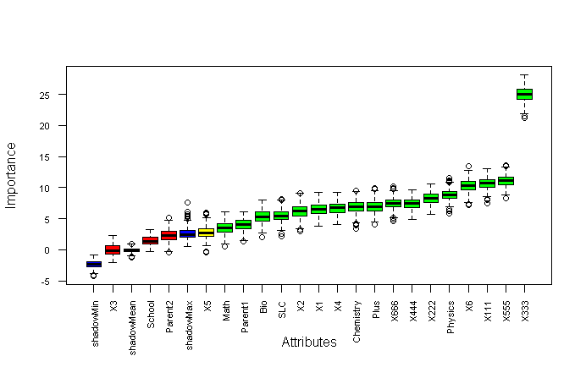

Figure 8: Output of Boruta Algorithm

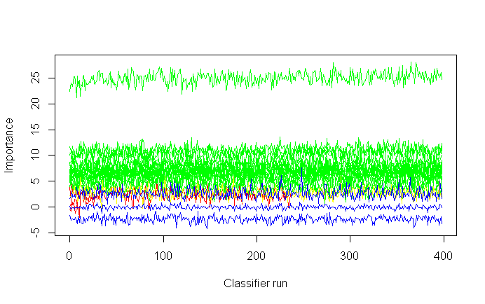

Figure 9: Important, Tentative Important and Non important Plot

From the above line graphs, it is concluded that there were 17 variables significantly associated for the model development using plotImpHistory (Boruta) command. When using tentative fixed test further rejected tentative variables could be verified bor=TentativeRoughFix (Boruta) rejected four variables unimportant Parent2, School, X3, X5 were calculated. This type of rejection of input variables describes statists of all variables using variables using attStats (Boruta) command as.

meanImp medianImp minImp maxImp normHits

SLC 5.523187753 5.4931231 2.1647344 8.133079 0.97243108

School 1.424280858 1.3000044 -0.3183249 3.328378 0.01002506

Plus 6.956021117 6.9350844 4.1107703 9.965286 0.99749373

X555 11.066508610 11.1027908 8.2696448 13.640935 1.00000000

X666 7.456300397 7.4291433 4.6689392 10.213021 0.99498747

Which finally tells to concludes the decision that the variable SLC is confirmed to required whereas School information of either private or government had least predictability to GPA become rejected, X5 tentative and plus confirmed to all independent variables. Finally, the getConfirmedFormula (Boruta) finalized 17conformed GPA ~ SLC + Plus + Physics + Math + Chemistry + Bio + Parent1 + X1 + X2 + X4 + X6 + X111 + X222 + X333 + X444 + X555 + X666 seventeen variables out of 22 independent variables before forming to the model.

## **Random Forest Methodology for Large Feature Selection**

Random forest methodology aggregate trees applied here for feature engineering which can be applied in both classification as well as regression for avoiding overfitting large features selection which can deal with large numbers of features helps to reduced feature selection based on importance of features and user friendly because only two parameters would be given tree and mtry variable as hyperparameter. The default tree is 500 and mtry is 4 initially. The hyperparameter mtry is sampled as a parameter at each split default sqrt (p) features for classification and p/3 for regression based on predictor variables. Where p is features of ntree bootstrap sample where each bootstrap sample grows on the unpruned tree by choosing the best split based on a random sample of mtry predictor at each node and predict new data using majority votes for classification and average for regression based on ntree for final prediction of the model. After loading library caret, random forest in r console the database is again selected using data=read.csv ("D:/dataanalysisfinal/SOE/rcode/ Dataanalysiscsv.csv") command and split its data-based into the working table using tidyverse packages. After doing the ss=S %>% select (GPA, GPAA, GPAAA, SLC, School, Plus, Physics, Math’s, Chemistry, Bio, Parent1, Parent2, X1, X2, X4, X5, X6, X111, X222, X333, X444, X555, X666) % > % filter (GPA>0) is used for filtering only those records of passed student 290 final result of engineering student. Then after omitting na values and converting response variable with factor category as table command describes as table(S$GPAA) produced as A (49) A-(96)B+(65)B(39)B-(35)C+(5) and C-(1). Similarly, the table(S$GPAAA) groups the real factor data of student grade of 2019 result describes with their respective groups of dependent variables.

 A A- B+ B B- C+ C

 49 96 65 39 35 5 1

After making seed and data frame of selected data items the sample of 70 and 30 percent split of data sets with test and training data sets split of 211 and 79 data sets of passed students using sample (2, nrow (S), replace=T, prob=c (.7,.3)), train=S [ind==1,] 211 and test = S [ind == 2,] 79 out of 290 passed student for the model validation and testing accuracy purposes to the model.

The random forest provides only two free parameters for the segregation of a large number of features of 22 independent variables. The model rf22=randomForest (GPAAA~., data=train, nodesize=5, ntree= 500) applied for calculation. Here the GPAA being categorical variable with numerical representation of all student grades 1 for A,2 for A-,3 for B+,4 for B,5 for B-,6 for C+,7 for C- and 8 for Fail categories in GPAA and vice versa. All variables model prediction and confusion matrix were based on OOB (Out of Bag) indicates error rate is 2.37% indicates 97 % accuracy of the model to predict student accurate grade. The print (rf22) commands plot in mtry chart which indicates the errors has drastically decreased after 3.2 steps.

A A- B+ B B- C+ C

49 96 65 39 35 5 1

After making seed and data frame of selected data items of 70 and 30 percent split of student records with test and training data sets split into 211 and 79 data sets of passed students using sample (2, nrow(S), replace=T, prob=c (.7,.3)), train=S[ind==1,]211 for a pass only and test=S[ind==2,] 79 out of 290 passed student. For model validation and testing accuracy purposes plots the out of bag errors.

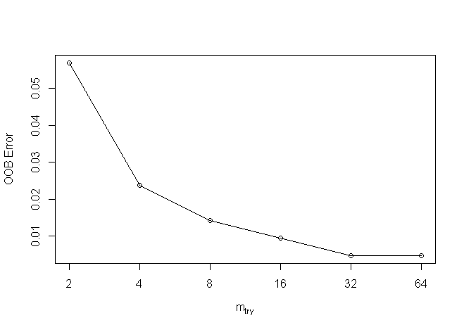

Figure 10: OOB Plot of Random Forest

The random forest is a classification model with the number of trees is 500 defaults of the variables tried at further split into 4 and OOB estimate of error rate is 2.37% indicates confusion matrix with errors as.

Reference

Prediction A A- B B- B+ C C+

A 34 0 0 0 0 0 0

A- 0 70 0 0 0 0 0

B 0 0 30 0 0 0 0

B- 0 0 0 25 0 1 0

B+ 0 0 0 0 48 0 0

C 0 0 0 1 0 0 0

C+ 0 0 0 0 0 0 3

This output describes the overall statistics accuracy of random forest model is 0.9953 percent when 95% confidence accuracy indicates the very the strong model. The information rate is 0.3318 and p-value is less than 2.2e-16(0.05) indicates the model has significance. This is similarly explained by using the Kappa test is 0.9939 percent too.

The sensitivity and specificity values in each grade column were calculated based on the confusion matrix as the accurate prediction divided by total misclassification in each grade cluster. However, the grade C indicates prediction has some errors in the model.

Class: A Class: A- Class: B Class: B- Class: B+ Class: C Class: C+

Sensitivity 1.0000 1.0000 1.0000 1.0000 1.0000 0.000000 1.00000

Specificity 1.0000 1.0000 1.0000 0.9946 1.0000 1.000000 1.00000

Pos Pred Value 1.0000 1.0000 1.0000 0.9615 1.0000 NaN 1.00000

Neg Pred Value 1.0000 1.0000 1.0000 1.0000 1.0000 0.995261 1.00000

Prevalence 0.1611 0.3318 0.1422 0.1185 0.2275 0.004739 0.01422

Detection Rate 0.1611 0.3318 0.1422 0.1185 0.2275 0.000000 0.01422

Detection Prevalence 0.1611 0.3318 0.1422 0.1232 0.2275 0.000000 0.01422

Balanced Accuracy 1.0000 1.0000 1.0000 0.9973 1.0000 0.500000 1.00000

As compared OOB errors for each bootstrap iteration describes tree prediction error using data not in bootstrap sample is called OOB is estimated classification accuracy and regression using RMSE. Similarly, the confusion matrix and prediction of test data of grade calculated using as confusionMatrix (pp, test$GPAAA) function as.

The plot model describes the overall model normalization when it goes more than 200 trees it will normalized constant then after eliminates errors terms.

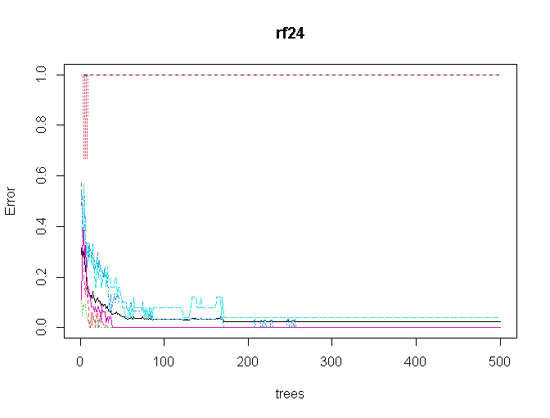 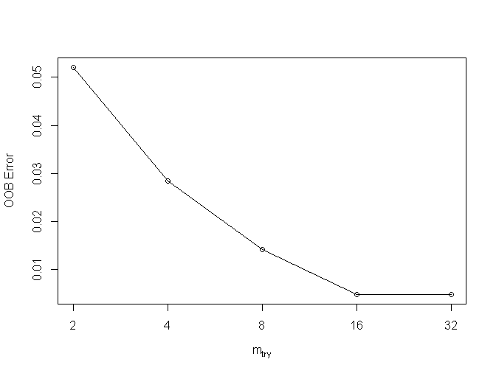

Figure 11: Error Vs Trees and Mtry Plot

From the above error and mtry figures the mtry value using finetune using tuneRF (train [, -1, -2], train [,3], stepFactor = 0.5 plot=TRUE, ntreeTry = 300, trace = TRUE, improve = 0.05) function. This factor improves in each tree to out-of-bag errors and the mtry influenced either positive or negative to the model. The second tune plot determine the final value of mtry conversed at after 16 steps for normalization. Therefore, from the above random forest model becomes more adequate accurate for final prediction using ntree is more than 200 iteration and mtry become normalized after 16 proximities true for the final model as. The rff=randomForest (GPAAA~., data =train, ntree = 200, mtry=16, importance = TRUE, proximity = TRUE). This is finally printed using as print(rff) produces the OOB estimate of error rates 0.47% has largely improvement after 200 and 16 mtry than earlier whose confusion matrix using confusionMatrix (p, train$GPAAA)

Reference

Prediction A A- B B- B+ C C+

A 34 0 0 0 0 0 0

A- 0 70 0 0 0 0 0

B 0 0 30 0 0 0 0

B- 0 0 0 25 0 0 0

B+ 0 0 0 0 48 0 0

C 0 0 0 0 0 1 0

C+ 0 0 0 0 0 0 3

This confusion matrix predicts 100% accuracy on training data with 98% confidence level with test p value were less than 0.05 significant statists as.

Class: A Class: A- Class: B Class: B- Class: B+ Class: C Class: C+

Sensitivity 1.0000 1.0000 1.0000 1.0000 1.0000 1.000000 1.00000

Specificity 1.0000 1.0000 1.0000 1.0000 1.0000 1.000000 1.00000

Pos Pred Value 1.0000 1.0000 1.0000 1.0000 1.0000 1.000000 1.00000

Neg Pred Value 1.0000 1.0000 1.0000 1.0000 1.0000 1.000000 1.00000

Prevalence 0.1611 0.3318 0.1422 0.1185 0.2275 0.004739 0.01422

Detection Rate 0.1611 0.3318 0.1422 0.1185 0.2275 0.004739 0.01422

Detection Prevalence 0.1611 0.3318 0.1422 0.1185 0.2275 0.004739 0.01422

Balanced Accuracy 1.0000 1.0000 1.0000 1.0000 1.0000 1.000000 1.00000

Similarly, the test confusion matrix is calculated using confusionMatrix (pp, test$GPAAA) function produces the confusion matrix with more accuracy as before.

After complecting the final random tree model, the histogram of number of nodes could plotted using hist (tree size(rff), main="Number of Todisco="green") function describes that data of nodes of 290 passed students.

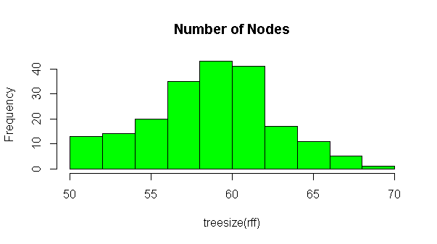 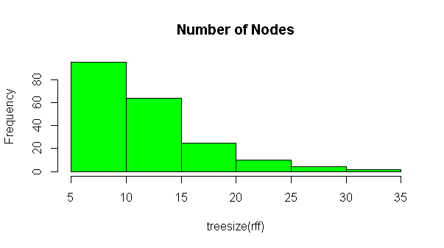

Figure 12: Nodes and Number of Trees Histogram

The first histogram describes the number of trees in 6 to 8 trees with 80 nodes in each cluster whereas there are 4 to 6 trees with 40 nodes respectively and few trees were in14 to 16 nodes there are overall 290 nodes of tree distributed in between 4 to 18 nodes of passed students in 2019 with their mark’s weightage. After completing the final model, the varImpPlot (rff, sort=T, n.var=21, main="Variables Weights ") function plot two plots explaining the overall variable importance for the model significant of all independent variables with their contribution percent accuracy so that researcher may deselect the variable in model forming for final model design.

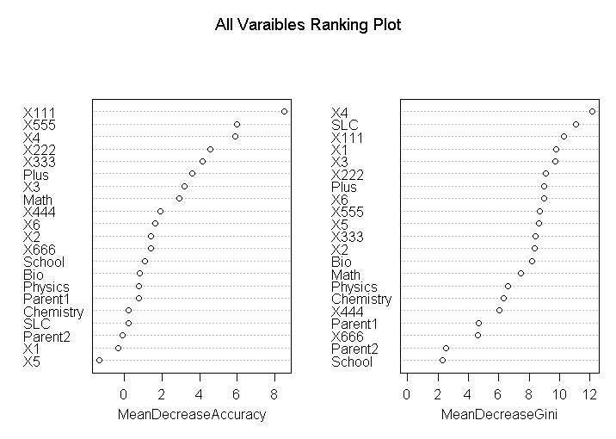

Figure 13: Mean Decrease Accuracy and Ranking Plots

This first plot describes the total accuracy due to the presence of specific variables and their percentage when removing each variable in top to bottom and the second plot described its meaning decreases when eliminate each variable. This plot output describes similar type result as Boruta algorithm above with tentatively rejected some independent variables as X5, X1, and Parent2 variables because of very low rank with zero significance results contribution around zero percent. However, the first plot describes its contribution model weightage. When considering without final GPA of each internal marks grade the X4 and Plus2 and X3 results have the most significance of having more than 4 percent weighted of a single variable. Therefore, it is concluded that to score a good GPA bachelor's grade based on the final grade of the first subject has very significant implies Mathematics grade of plus two has strong positive results. The grades X111(Math’s) and X555(programming) subjects of final grade have the strong role for scoring the highest Bachelor grade. When considering with internal grade only X4 core engineering subject X3 has the greatest role for scoring Bachelor grade highest grade. The SLC grade has less significant than the Plus grade and the mathematics scored of plus2 than Chemistry, Bio, and Physic scores were in low contribution for bachelor’s grade prediction. Similarly, the second plot describes the Gini how pure the tree decreases when removing the associative variables. The X4 internal grade and SLC his significant association for decreasing Gini model. Whereas school and parent qualification have no much association for predicting bachelor GPA. Similarly, the importance(rff) model describes its percentage of all associative variables in the model. The importance(rff) produces the table with the respective percentage that could describe and chosen the associative variables.

A A- B B- B+ C C+ MeanDecreaseAccuracy MeanDecreaseGini

SLC -0.222953 1.045989 -0.85129 0.751304 -0.72162 0 0.0000 0.18854 11.0624

School -0.317582 1.803325 2.08448 0.308938 -1.02065 0 0.0000 1.07695 2.3114

Plus -0.351939 4.043537 -0.82929 1.345535 1.02309 0 -1.0025 3.61981 00269

Physics 0.796682 0.889672 1.56792 -0.770135 -1.33302 0 1.0025 0.77283 6.6280

X555 8.907967 1.248824 0.18731 0.23283 1.37419 0 1.0025 5.96817 8.6822

X666 0.617318 0.283206 -0.19839 2.49528 0.1725 00.0000 1.39306 4.6537

Similarly, the function versed (rff) describes first to end times occurred in the model of all variable times in second as 709 187 607 534 545 509 598 361 248 715 667 698 722 654 669 643 597 552 452 521 362 iterations to formed the final model. These highest values indicate its highest associativity to model the second previous school information has least association for marks prediction of higher education scoring with good grade.

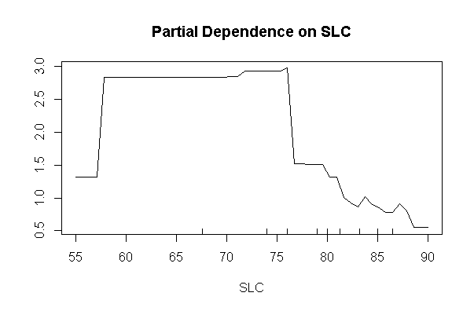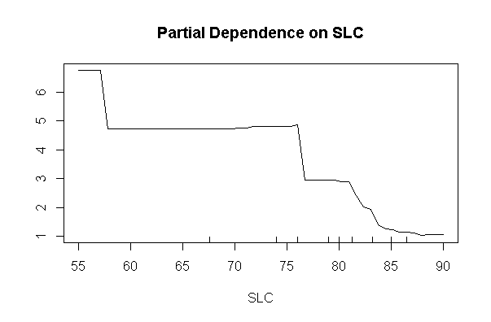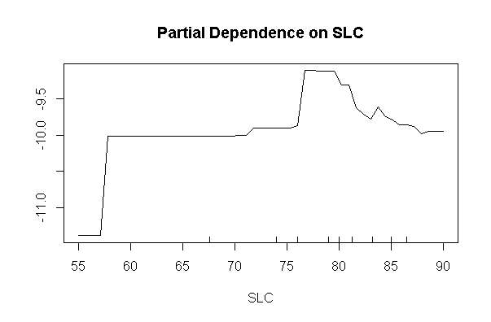

Figure 14: Partial Dependency Plots

The partial dependency plot describes the marginal effect of each category of special class could be easily when partialPlot (rff, train, SLC,"A") partialPlot (rff, train, SLC,"B") partialPlot (rff, train, SLC, "C") predicts the probability value when comparing individual SLC grade. The first plot implies that it is more chance when SLC score is 75 he/she could score grade A in Bachelor of engineering. Likewise, when SLC grade is below 80 could score B in bachelor degree and when SLC grade is in-between 60 to 75 he/she could score C grade in bachelor degree. Similar type output could be prediction to all 22 independent variables could be easily predicted.

Similarly, the highest importance variable to formed the model of having mathematics subject grade whose association with different variable described in partial plots to indicates bachelor grade plotted using partialPlot (rff, train, X111,"A") partialPlot (rff, train, X111,"A-") as.

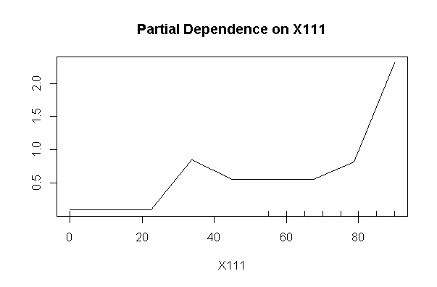 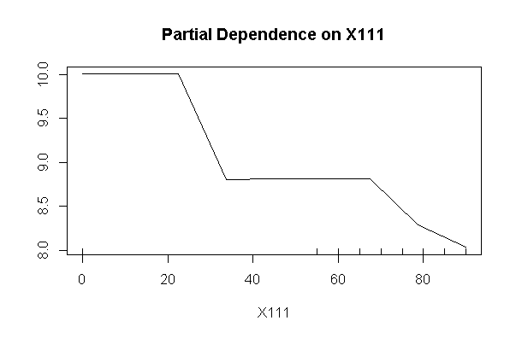

Figure 15: Partial Dependency Plot of Internal Grade

The first partical dependency plots when mathematics marks to predict bachelor grade scored to predict Bacehlor grade A grade in final has high when marks in math is higher than 80 percent. Similarly the second plots implies same mathmatics marks however another association to predict B- might less probability of scoring B- bachelor grade had not significent when. This command plots all independent combination of data all possible grades of students.

Similarly, the random forest terminal node could be visualized using getTree (rff,1,labelVar = TRUE) function. The first tree started first -1 status indicates terminal node whose left daughter and right daughter were absent and so on respectively.

left daughter right daughter split var split point status prediction

1 2 3 GPA 3.710 1 <NA>

2 4 5 GPA 3.305 1 <NA>

3 0 0 <NA> 0.000 -1 A

4 6 7 GPA 3.005 1 <NA>

5 0 0 <NA> 0.000 -1 A-

11 0 0 <NA> 0.000 -1 B

14 0 0 <NA> 0.000 -1 C+

15 0 0 <NA> 0.000 -1 B-

Similarly, the mean density plots MDSplot (rff, train$GPAAA) plots describes the whole trees values in scatter with differ colors of differed GPA grade clustering of student.

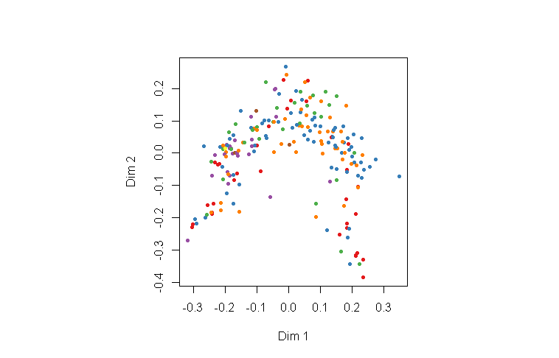

Figure 16: MDS Plot of All GPA Points

The color indicates the GPA grades. Therefore, random forest methodology here is apply for data preparation with their respective explanation to conclude research.

## **Plus, two Back Propagation Grade Prediction using Random Forest**

After using random forest methodology for the prediction student grade here researcher tries to predict plus2 results using random forest with including bachelor grade using the real concept of backpropagation methodology. The plus2 grade of student having less category as compared bachelor 10-grade point in Nepal. After converting respective grade marks into grade point using grade if (grade >90 A, if(grade>80, if (grade, A- if(grade>70, B+, if(grade> 60, B, if (grade >50, C+ if(grade>40, C, if(grade>25, D else E. Which is based on exactly accordance with higher school centerboard grading criteria in Nepalese system. From the data the different histogram of bachelor and plus2 grading summarized as.

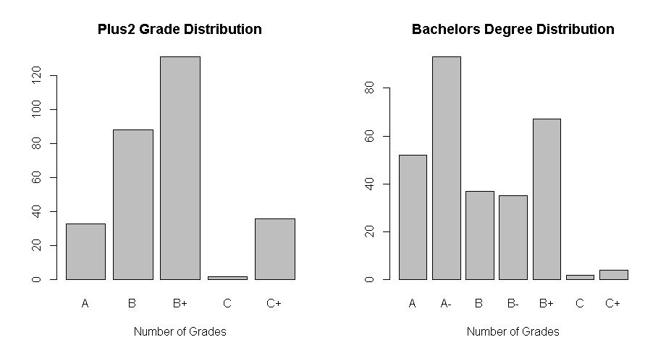

Figure 17: Histogram of Plus to and Bachelor Grade Distribution

According to Nepalese plus2 grading points, letters grading is A, B, B+, C, C+, and D+. Although the D+ student could not be getting enrollment in the engineering program. Similarly, the grade points of Bachelor of engineering students have 10 scale grade points like (A, A-, B+, B, B-, C+, C, C-, D+, D- and F grades. However, there were not scoring students in their final bachelor students. The backward propagation of internal marks of bachelor degree were used to predict plus2 tested for model validation development produced the confusion matrix as.

A A- B B- B+ C C+

A 3 17 3 4 6 0 0

B 20 23 9 9 24 1 2

B+ 24 46 17 14 29 0 1

C 0 1 0 0 1 0 0

C+ 5 6 8 8 7 1 1

This cross-tabulation presents the records of Bachelor final grade to plus2 grade of sample data. After sub setting selected columns of these information whose scored grade in the final examination of plus to and their respective final grade in random forest model validation with test and training split of 70 and 30 percent of passed 290 students. When using final=randomForest (PlustoGrade ~., data = train) model produced to its 98 percent accuracy. Although this concept is very retrospective thinking to predict backward to Plus to.

The final tree and mtry plots determine after 200 tree and with 3 mtry the output became constant. Similarly, mtry become 3 for the final model for better increasement of prediction to the backward model. The histogram perfectly bell-shaped curved indicates that samples were in uninformedly distributed while model prediction.

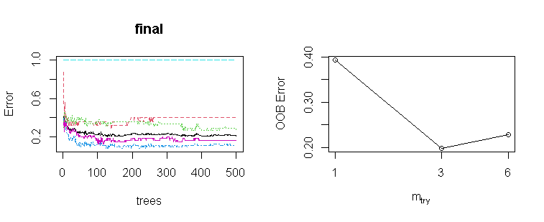

Figure 18: Trees and Mtry Plot

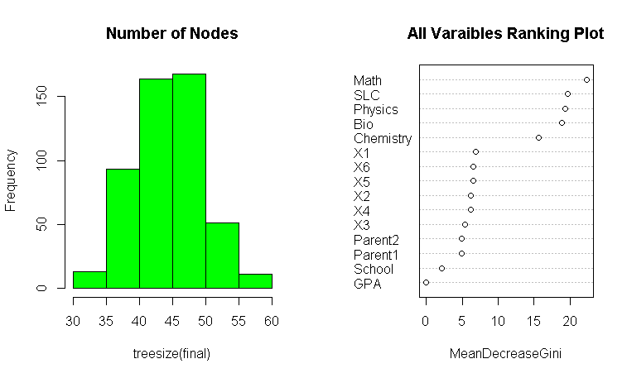

Figure 19: Histogram Nodes and Gini Decrease Plot

From the mean decrease Gini plot the Math and SLC, Physics have greatest dominant attributes for prediction plus2 grade using backward propagation whereas parent education, school’s information and final GPA were least significantly formed random forest model. Thus, final model final=randomForest (PlustoGrade ~ SLC + School + Physics + Math + Chemistry + Bio + Parent1 + Parent2 + X1+ X2+ X3 +X4 +X5 +X6, data= train, ntree = 500, mtry = 3, importance = TRUE, proximity = TRUE). Which produced the more accurate output 97 and 77 percent respectively accuracy suggests mtry at 3. Therefore, the ultimately the mean decreased plots were plotted describes the math, SLC, Bio Physics Chemistry were the dominant association rather than school information, parents’ education and internal marks.

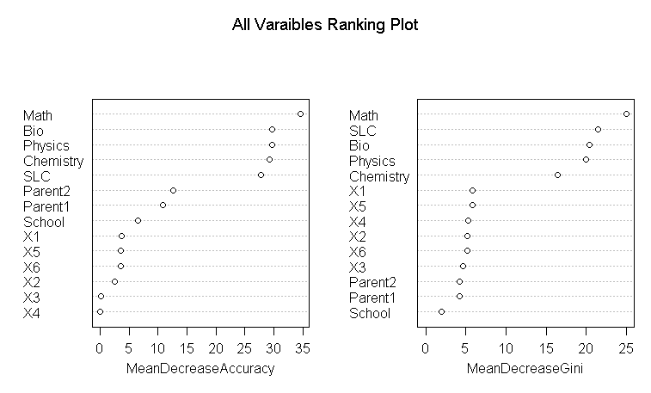

Figure 20: Mean Decrease Accuracy and Gini Decrease Plot

The variable significance while using backward propagation mean decreased accuracy plots indicates that Mathematics SLC, and Physics Chemistry had highest percentage contribution as compared parent2 and school information to predict plus2 grade. Similarly, the bachelor’s internal marks would not have least significant than 5 percent for prediction plus to grade. this indicates internal marks of bachelors won’t have much significant to predict pus two grade.

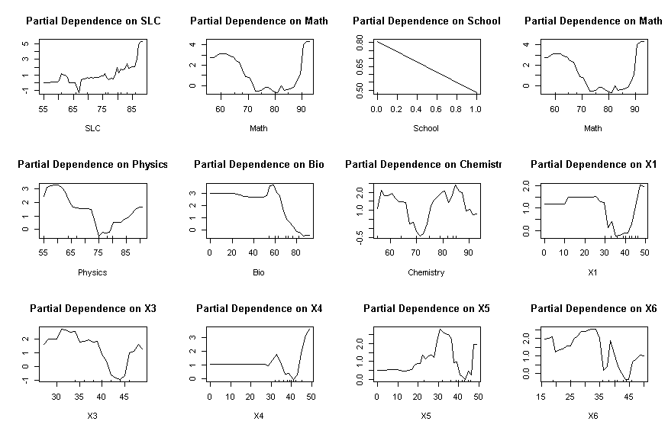

Figure 21: Partial Dependency Plot of Plus2 Grade

Similarly, the partial plot of these variables implies that the bachelor’s internal grades won’t have a positive association to predict final grade of plus2. However, Math, SLC, Physic and Bio, and Chemistry score were mixed perdition to predict plus2 A grade when grade more than 80 percent.

**Neural Network Result Prediction using Single Layer**

The fully connected neural network conversed at fixed point to predict dependent variable after calculating its weighted sum with bios in each subsequent layer. The result of student grade is either fail or passed a binary numerical variable of all grades before final results. The result of passed student and their high school, intermediate levels their internal and their final grade of each student are the independent variable to predict whether the student has passed grade or not. After loading the library tidyverse packages the subset of data with 21 interdependent variables were passed to the neural network model after normalized independent variables sample 580 students with 401 as training and 179 are testing data sets. The neural network n=neuralnet (pf~ SLC +Plus +Physics+ Math + Chemistry+ Bio+ Parent1 +X1+X2 +X3+X4+ X5+X6+ X111+ X222+ X333+ X444+X555+ X666, data=training, hidden= c (1), err.fct="ce", linear. output= FALSE) produces the plots as.

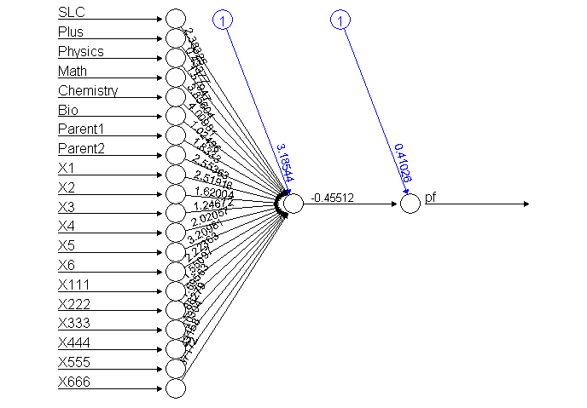 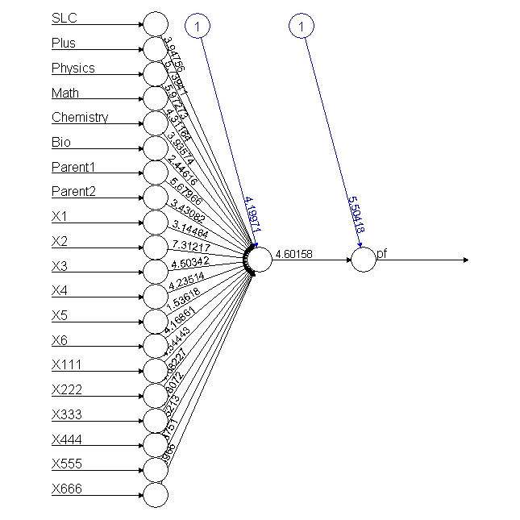

Figure 22: Neural Network of 21 Independent Variables

After computing model, the value generated at end node were plotted separately in two histograms with training and test data, the prediction confusion matrix with output data plots the histogram as. 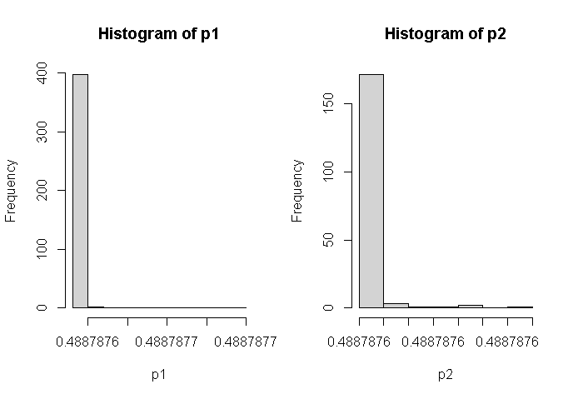

Figure 23: Histogram of Conversed Output Values

The test and training data output are further categorized with the pass and fail of 401 training data predicts 205 and 196 with using 1-sum(diag(tab1))/sum(tab1) produces the model accuracy is 0.4887781 percent. Similarly, the test 179 data sets calculate with pred2 variables of passed and fail student (both) is 85 to 94 using 1-sum(diag(tab2))/sum(tab2) function. The miss classification errors are better scored 0.525139. Here the result of each student based on 21 independent variables has needed of model improvement using various hyperparameter.

Similarly, the data only using passed student of 290 records apply to predicts the above model produces 100% accuracy on both model with the model of 20 independent variables as n= neuralnet (pf~ SLC + Plus + Physics + Math+ Chemistry+Bio+Parent1+ Parent2+X1 +X2+X3+ X4+X5+ X6+X111 +X222 +X333+ X444+ X555+ X666, data = training, hidden = c (1), err.fct ="ce”, linear. output = FALSE). The confusion matrix prediction with produced using 209 passed student in training data sets with evaluation 1-sum(diag(tab1))/sum(tab1) produces 100 accurate results. Similarly, the accuracy of testing data predicts 81 data of sample 100 percent accurately plots in histogram because all passed student predicts accurately using half model.

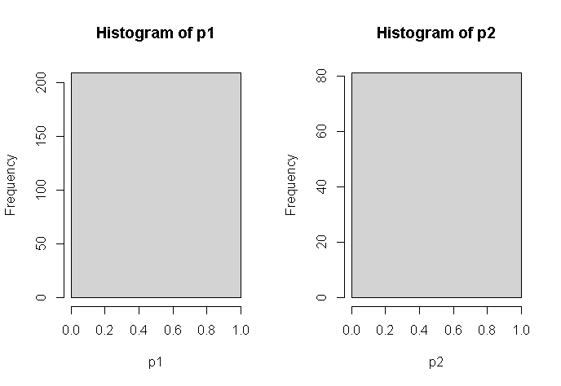

Figure 24: Histogram of Half Model Passed Student

From the above histogram of model produced 100 accurate predictions when using 21 independent sample when using passed student of 290 student records.

## **Before Examination Grade Prediction using Random Forest**

As we know the last examination is the compositive mixture of previous grades and courses completed by the student from academic institution. This means that the internal and previous academic achievement may either play a positive role to score in upcoming grade. The final grade is the mixture of internal grade and previous scores this study eagerly tries to find out the association between (background information) SLC grade, Plus2 grade, either school from private or government, their major score like physics, bio, chemistry, and mathematics association with internal score grade score of their six ongoing subjects. Therefore, the new random forest model tries to predict with categorical variables. While doing so the sub setting the database training and test splits were designed for before model execution. The label command of dependent variables with (“A" "A-" "B" "B-" "B+" "C" "C+"). The first model final= randomForest (GPAAA ~., data = train) produces the accuracy prediction. After loading the caret package, the training prediction predicts the accuracy is achieve 97 percent on training data sets with significant with 98 percent confidence interval as.

Reference

Prediction A A- B B- B+ C C+

A 37 0 0 0 0 0 0

A- 0 62 0 0 0 0 0

B 0 0 23 0 0 0 0

B- 0 0 0 23 0 0 0

B+ 0 0 0 0 50 0 0

C 0 0 0 0 0 2 0

C+ 0 0 0 0 0 0 2

Similarly, the test data confusion matrix produces 96 percent accuracy with 99 percent confident interval. This implied that model is good enough when using non normalized data, however, the grade C prediction with some minimum mismatched prediction. The tunerf function predicts at 10 m try and total trees with 400 in the model design for testing purpose. Similarly, the histogram of tree size indicates there were 55 trees with 80 nodes. The varImpPlot describes all variables associated to form the above model.

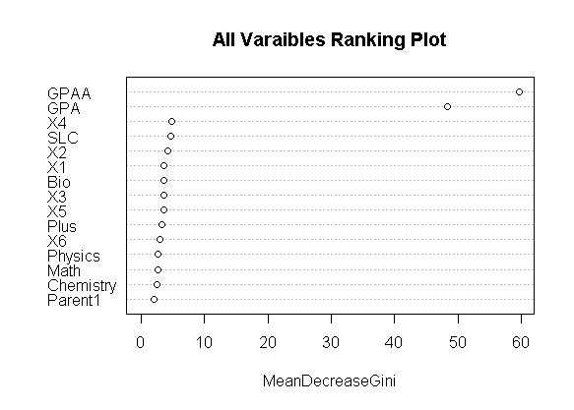

Figure 25: Mean Decrease Gini Plot

The mean decrease Gini plot describes in its percentage accuracy of increase probability however this model needs to exclude with GPAA and GPA variable for final prediction this could predict information is exactly matched with var used model as random forest model. Whose accuracy output is further evaluate using the partial plot describes each prediction to achieve any prescribed final grade GPA based on mathematics plus to marks.

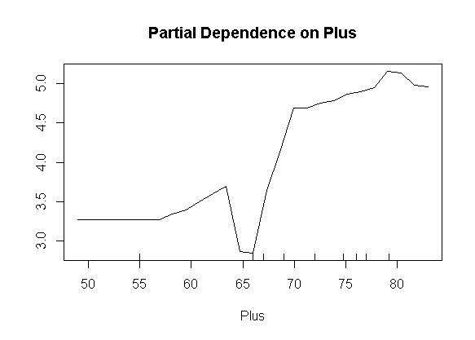 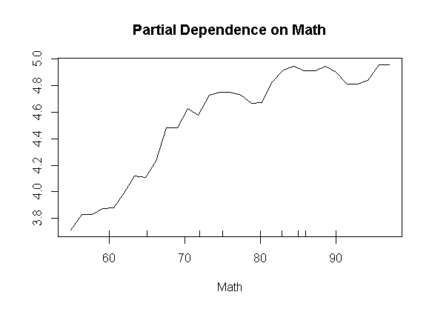

Figure 26: Partial Plot of Math’s and Plus2 Grade

From the first partial dependency plot indicates a positive association to predict bachelor grade A when evaluating plus to scored. This had very low predication when marks around 65 percent in plus to mathematics. Similarly, the plus to mathematics score has more potential to predict bachelor grade with A grade when his/her score in more than 75 percent. Similarly, when martial plot between mathematics with bachelor grade A has very high when after 70 scored in plus to mathematics. The tree function that describes the root and left and right daughter of each node sides.

However, the final model after removing the unimportant columns on real marks describes using randomForest (GPAAA ~SLC+ School+ Plus+ Physics +Math+ Chemistry+ Bio+Parent1+ Parent2+ X1 + X2 +X3 +X4 +X5 + X6, data = train, ntree = 500, mtry = 4, importance = TRUE, proximity = TRUE) with only previous values. Whose confusion matrix of training sets is 98 percent accuracy significant however the test accuracy had not signed with accuracy is lower than percent at mtry become 10 with 80 nodes tree within the top level of 80.

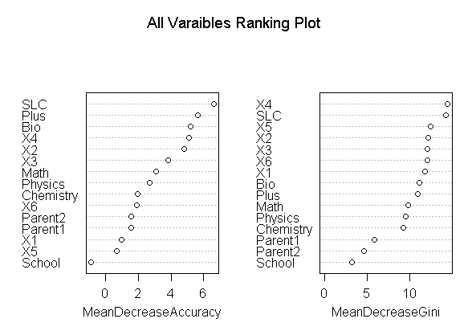

Figure 27: Mean Accuracy and Gini Decrease Plot

The varImpPlot command describes the highest to lowest association from the final model with the percentage of decreasing accuracy when eliminating each predator variable to the model. Thus, when comparing both mean dependency plot indicates accuracy when eliminating each input variables int model accuracy decrease percentage respectively. Therefore, it is concluded that the internal grade, SLC, plus two, Bio X4, X3, Math has strong non negated independent components to model formation. Whereas students from private school or government schools have the least role to predict bachelor grade when using random forest prediction using non normalized data sets. Thus, the school information and parent2 education information could be removed for better prediction. Similarly, the partial plot of six internal grade plots describes the similar association to bachelor grades as.

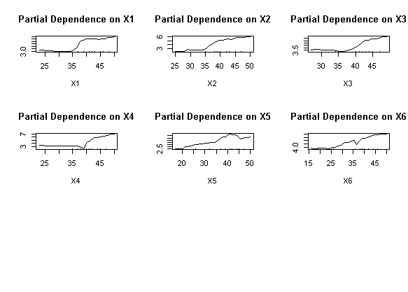

Figure 28: Partial Plot of Internal Marks

When calculating partial plots with internal marks of student. The first partial plots predict to achieve grade A in final grade has only positive association after scoring more than greater than 35 towards 50. Similarly, however the internal marks column of X5 could score A grade at bachelor level when internal marks above 40 but not above 45. when student scored more than 45 had -ve association to scored grade in A in bachelor grade accurately predicted with bachelor grade.

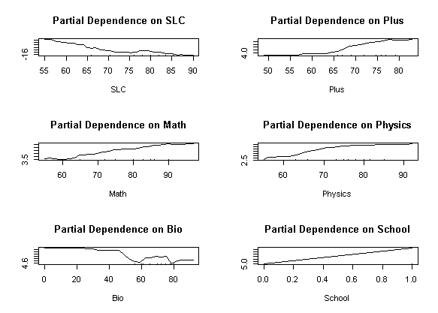

Figure 29 : Partial Plot of Previous Grade

Similarly, when using non normalized values the previous grades of partial plots of SLC has completely negative to predict A grade. This SLC having 75 and 85 has same potential to score A grade. Similarly, the Plus two score has positive increased association after 60 marks in plusto for prediction A grade in Bachelor degree. The math and physics have similar incasement to predict grade incasement after having more than 70 in their plus to marks Similarly the Bio marks indicates the -ve association to predict Bachelor A grade. Conclude that those students who were form non bio group form their plusto had scored A in bachelor grade. And the graduation form school has nonlinear association implies unimportant to the model. Thus, the SLC grade to predict bachelor A has -ve association whereas plus two, Math, Physics, has the positive score and the Bio and School of private and government have less prediction to bachelor grade.

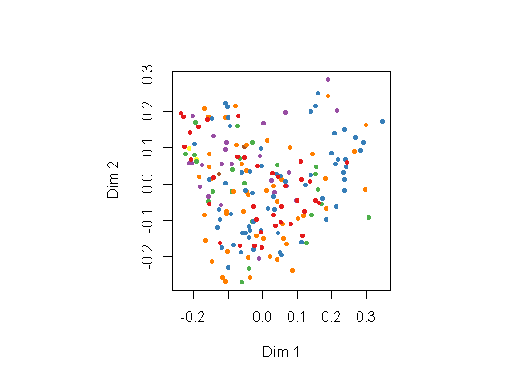

Figure 30: MDS Plot of Grades

Similarly, the mean density plots with color mean density plot describe GPA different grades to display all variables used when predicating before examination independent components. Similarly, the internal marks with score rank ("1" "2" "3" "4" "5" "6" "7") produces similar output using final=randomForest (GPAA ~., data=train) with considering original model and another final=randomForest (GPAA ~SLC+ School+ Plus+ Physics+ Math+ Chemistry+ Bio+ Parent1+ Parent2+ X1+ X2+ X3+ X4+ X5 + X6, data = train, ntree = 500, mtry = 4, importance = TRUE, proximity = TRUE) with correction more than 95 percent accuracy with significant result. However, the second corrected result produces 98 percent to 37 percent for final accuracy of both test and training data describe as.

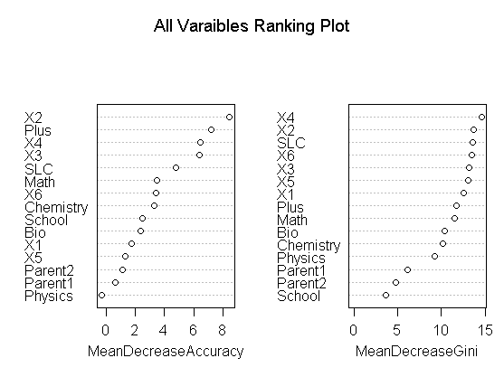

Figure 31: Mean Accuracy and GINI Decrease Plot

This time model predicts school and physics marks of internal evaluation has least accuracy to contribute GPA grade where as X2 and plus2 grade have highest contribution to formed the model A grade. The prediction of values is as.

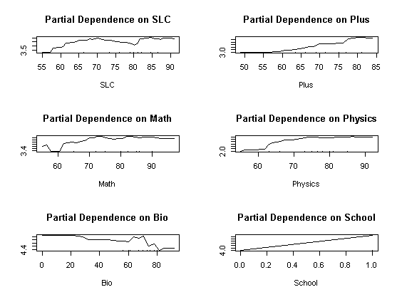 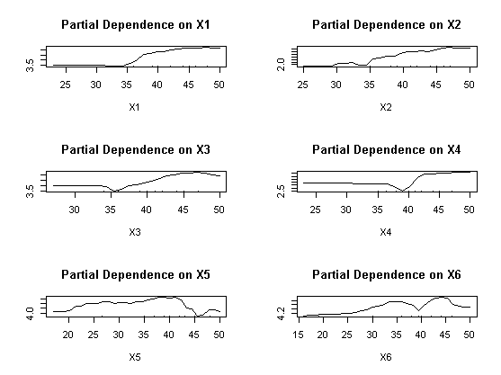

Figure 32: Partial Plot of Internal Grades

From the above partial plot predict the second grade A- have linear association after 60 % percent of SLC, plus2 Math and Physics however Bio and internal marks of have better to score A- prediction. The high school background information has not association to predict A- grade in Bachelor level. Similarly, the mathematics and physics major subject have a positive association after 65 in their grade to predict A- grade in Bachelor level.

These partial plots concludes that marks scored more than 40 predict and less than 45 has most accurate to predict A- grade in bachelor level largely accurate than other grades.

# **Chapter 4: Results and Discussions**

## **Neural Network of Pass/Fail Prediction using Single Layer**

As we know neural network model works only in numeric variables, the dependent variable GPA represents with 0 for Fail,1 for A-grade,2 for A- Grade, 3 for B+ grade, and so on having 8 categories respectively is single dependent variable of 22 predictor variables. Based on predictor variable neural network model used error factor as cross-entropy with the large number of dependent variables which includes high school score marks, plus two marks, school either from private or government, highest academic of their parent1 and parent2 and six internal grades of running score in bachelor degree and their final scored are the independent inputs for prediction to final bachelor grade GPA of student.

After loading libraries neuralnet, tfruns, keras and tensorflow, dplyr packages in r console. The read csv command used to load data in programming workspace. The tydeverse package used to select dependent and independent variables for the purpose of selecting 20 independent variables from the student database. Here the explanatory result GPA variable having eight final grade score grade of final result. After excluding predicator variable all other independent variables were normalized using min- max function and whose output is again converted into data frame for analysis purpose to another variable as Sr=as.data. frame (apply (ss [-1, 1:20], 2, function (x) (x - min (x)) / (max (x)- min (x)))). After setting seed value in two samples of training and test are determined using sample with 70 and 30 percent sample partition of data as ind = sample (2, nrow (Sr), replace = T, prob=c (.7, .3)) and training=Sr [ind == 1,1:20] and test= Sr [ind == 2, 1:20]. Here twenty predicator variables in normalized numerical values passes the neural network model is determined with n=neuralnet (pf ~ SLC +Plus +Physics +Math+ Chemistry + Bio +Parent1 +Parent2 +X1+ X2+ X3+ X4+ X5+ X6+ X111+ X222+ X333+ X444+ X555 + X666, data = training, hidden = c (1), err.fct="sse”, linear. output = FALSE) conversed as.

These neural network models are designed using training data with single hidden layer in between. Similarly based on categorical predicator variable error factorial is set out cross- entropy when linear out become false for accurate prediction. The plot n function prints the network diagram as above.

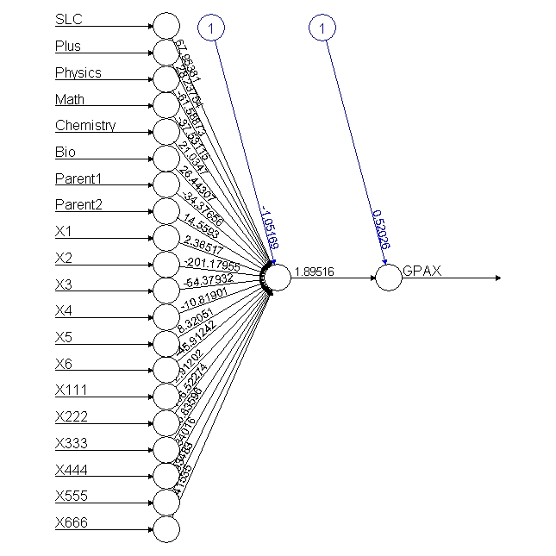 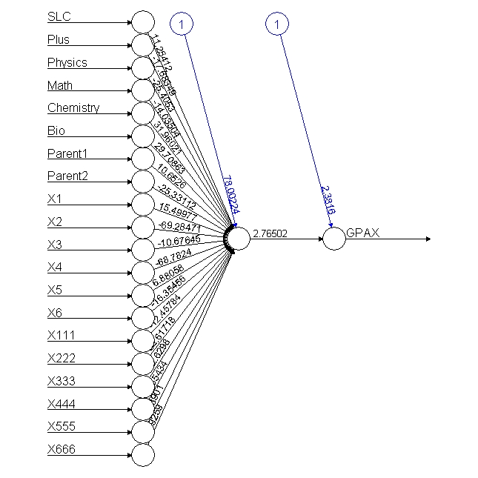

Figure 33: Neural Network Singe Layer of All Result

The names’ function displays all the independent variable to formed such model with name. After computing test data with model data using d1=ifelse (p2>=2.2,1, ifelse (p2>=1.83,2, ifelse (p2>=1.5,3, ifelse (p2>=1.2,4, ifelse (p2>=.80,5, ifelse(p2>=.5,6, ifelse (p2>=0.1,7, 0))))))) condition to categorized output form final node of all grades for the appropriate grade prediction with consideration output of following grade points of GPA. The model output of result in histogram is further categorized with respective GPA.

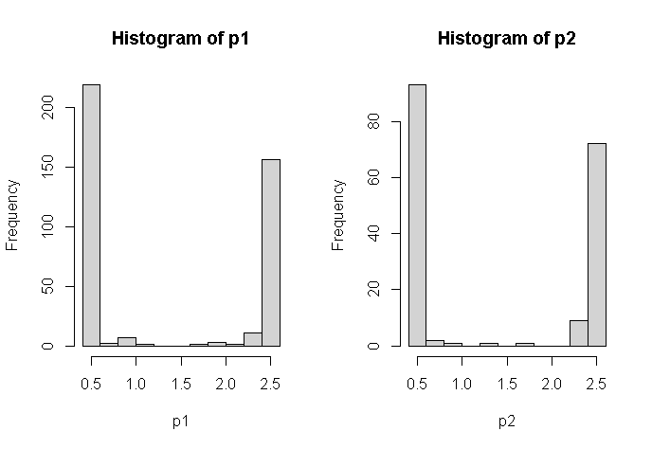

Figure 34: Histogram of Training and Test Conversed Output

While doing so the independent variable like school information were not included according to from random forest model suggestion for better prediction. Thus, there were 20 predictor variables to predict bachelor grade of student whether the student has passed or fail grade using a single middle neuron. While conversing to 20th node input vector value and its network weight of every single input using 20th node input weight of each weight values were forward using the sigmoid function to another input layer again calculated output to another 21 neurons for prediction final either student result grade. This model exactly used as passed to the signal impulse from various organs of the human body to the brain. The neuralnet: compute (n, training [, -1]) function computes its output using net. Result function while both values could be compared with excluding predictor variable. The confusion matrix of data outputs as.

pred2 0 1 2 3 4 5 6

1 28 6 21 11 8 6 1

3 0 0 0 0 1 0 0

4 0 0 1 0 0 0 0

5 1 0 0 0 0 0 0

6 56 6 10 11 5 7 0

The above test and training confusion matrix display the eight category of GPA numerical values whose accuracy is missed classified other than diagonal values produce the test accuracy after using 1-sum(diag(tab2))/sum(tab2) is 0.8100559 percent accuracy is good model prediction.

Similarly, when the result with different grading “1" "2" "3" "4" "5" "6" "7" points of the same student with half model conversed for the neural network. After having sub setting using GPA grade is greater than 0 passed students. The ss=data2 %>% select (GPAX, GPA, SLC, Plus, Physics, Math’s, Chemistry, Bio, Parent1, Parent2, X1, X2, X3, X4, X5, X6, X111, X222, X333, X444, X555, X666) %>% filter (GPA>0) and the sample of 70percent and 30 percent split ratio of 290 passed student records after normalization. The independent variables neural model is designed with seven categories of grades scored of respective grade equivalence number. After computing, half model output with training data of 209 data sets and 81 test datasets produces the output histogram based on the neural network model describes in seven numerical categories of model different seven grade started with highest to lowest grades of students.

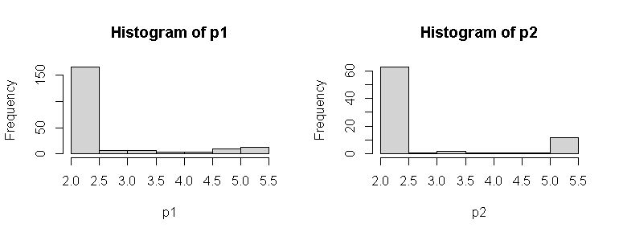

Figure 35 : Histogram of Half Neural Network Model

While calculating each grade scale of model output GPS prediction, the output from the last node further categorized pred2=ifelse (p2> =4.6,1, ifelse (p2> =4.8,2, ifelse (p2>=3.8,3, ifelse(p2>= 3.4,4, ifelse (p2>=2.9,5, ifelse (p2>=2.5,6,7)))))) condition for GPA output grades produces the confusion matrix of both sets of training and test sets are as.

pred2 1 2 3 4 5 6

1 0 2 3 3 5 0

3 0 2 0 0 0 0

4 0 0 0 1 0 0

5 1 0 0 0 0 0

6 0 1 0 0 0 0

7 12 23 11 9 6 2

This above confusion matrix describes the error other than diagonal values of each category. The test prediction accuracy formed confusion matrix as using cross diagonal sum of its confusion matrix 1-sum (diag (tab2))/ sum (tab2) is 0.9506173 accuracy respectively implies model were good enough of 209 records of student.

## **Neural Network Correction with Single Layer with Five Neurons (N=5)**

Similarly, fully connected neural network model analyzed 22 independent variables to predict student grade whose accuracy further evaluated using various model to get the best model for research recommendation. Therefore, more than a single hidden layer in between input and output variables the new model might test and analyzed for grade prediction of 580 records of Pokhara University Nepal used five neurons. After loading data, the dependent and independent variables like high school grade, plus2 grade with mathematics, physics bio and chemistry with parent education and whether the student is derived from government schools or private schools and their bachelors’ internal grade for five hidden layers for prediction of student grade are selected using tydeverse package in r console. After selecting 14 independent variables to predict GPA grade. After using seed value for more reputability, the two samples with 70% for training and 30% for testing purpose 401 and 179 records separated using sample command. As we know the independent variables GPA with includes 0 for fail, 1 for A,2 for A- and so on eight grades ("0" "1" "2" "3" "4" "5" "6" "7") of student scored in result 2019. The model n = neuralnet (GPAA~SLC +Plus+ Physics+ Math+ Chemistry+ Bio+ Parent1+ Parent2+ X1+X2+ X3+ X4 + X5+ X6, data = training, hidden = 5, err.fct = "sse", linear. output = FALSE). The model here used an error factor with the sum of a square and its hidden layer is 5 nodes for predicting student grade result conversed and plotted as.

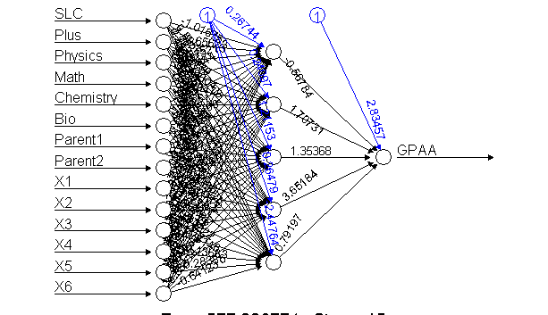 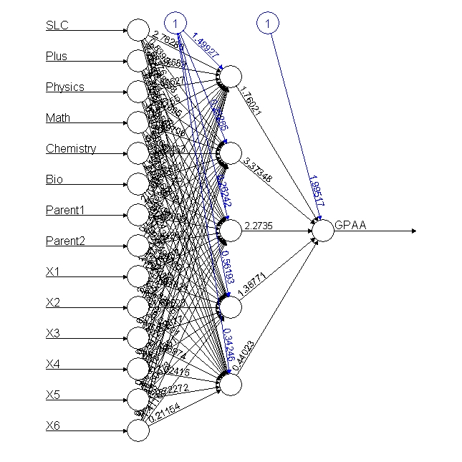

Figure 36: Neural Network with Single Layer 5 Neurons

After the fully connected neural network model conversed output is further computed using neuralnet: compute (n, training [, -1]) function and its predicated output printed in r console using output$net. result model function. The prediction value of GPA output neuron further categorized on GPA categories of student in histogram.

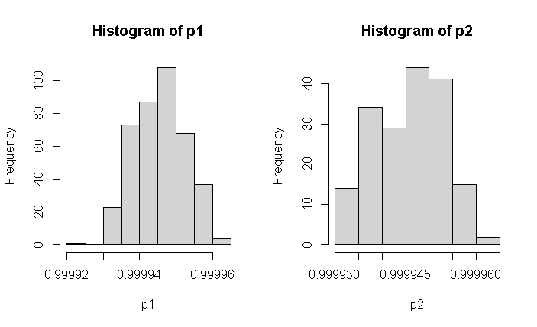

Figure 37: Histogram of Conversed Output of Single Layer 5 Neurons

After selecting training and test output the histogram predict total values are grouped into eight numerical categories of output neuron weight, using ifelse (p2> =.999955,1, ifelse (p2 >=.99995,2, ifelse (p2>=.999945,3, ifelse (p2>=.99994,4, ifelse (p2>=.999935,5, ifelse (p2>=.99993,6, ifelse (p2> =.999925,7,0))))))) condition of each training 401 and 179 test samples of 580 records full model. The values other than diagonal in confusion matrix indicates miss classification errors in both models.

pred2 0 1 2 3 4 5 6

1 10 1 4 0 2 0 0

2 17 3 10 5 2 3 1

3 19 5 4 7 4 5 0

4 14 2 4 4 3 2 0

5 14 1 10 6 1 2 0

6 11 0 0 0 2 1 0

Similarly, the test data of 179 sample accuracy and confusion matrix error using 1- sum (diag (tab2)) /sum (tab2) is 0.8715084 percent implies best model using full model.

Similarly, the half model is further analyzed those who had passed results (half model) after sub setting the succussed GPA student 290 passed student 209 and 81 training and testing data using n=neuralnet (GPAA~ SLC+ Plus+ Physics + Math + Chemistry+Bio+Parent1 +Parent2+ X1+X2 +X3 +X4+ X5+ X6, data = training, hidden =5, err.fct ="sse", linear. output = FALSE) plots the output as above second plot. Thus, the numerical categorical variable with "1" "2" "3" "4" "5" "6" "7" seven categories of GPA student scored marks is further computed and predicated with model output as with training and test plots histogram of both training and test as.

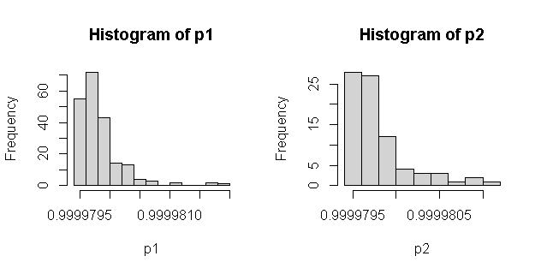

Figure 38: Histogram of Single Layer Conversed Output of 5 Neurons

For the purpose of seven categories data GPA, the respective GPA values the histogram final predicated value is further calculated using ifelse(p2>=.9999802,1, ifelse (p2>= .9999801, 2, ifelse (p2> =.9999799,3, ifelse (p2 >= .9999798, 4, ifelse (p2>= .9999797, 5, ifelse (p2 >= .9999796, 6, 7)))))) condition to get proper confusion matrix of GPA. The testing confusion validate using similar formula produced the accuracy is 0.9382716 percent accuracy of model using 5 hidden neurons as.

pred2 1 2 3 4 5 6

1 0 4 1 1 4 0

2 0 1 0 0 0 0

3 0 5 0 2 1 0

4 2 1 1 2 0 1

5 6 2 5 1 2 0

6 1 5 3 1 1 0

7 4 10 4 6 3 1

From the above both single and five neuron model comparison of their accuracy five neuron model produced the best result of student GPA.

## **Neural Network of Two Hidden Layer (N=7, 3)**

For the purpose model improvement evaluation, the two hidden layers can be designed using two hidden layers of 7 and 3 in between single dependent and 13 independent variables to predict final GPA having various "0" "1" "2" "3" "4" "5" "6" "7" eight category GPA grades of 580 student records (full model). After loading subset full data with pass and fail records in final grade 401 training and 179 testing sample of normalized data separation for model testing. After loading neural network package, n=neuralnet (GPAA ~ SLC + Plus+ Physics + Math +Chemistry +Bio+Parent1 +Parent2 +X1+ X2+ X3+ X4+ X5+ X6, data = training, hidden = c (7, 3), err.fct ="sse”, linear. output = FALSE) conversed and plots respectively model as.

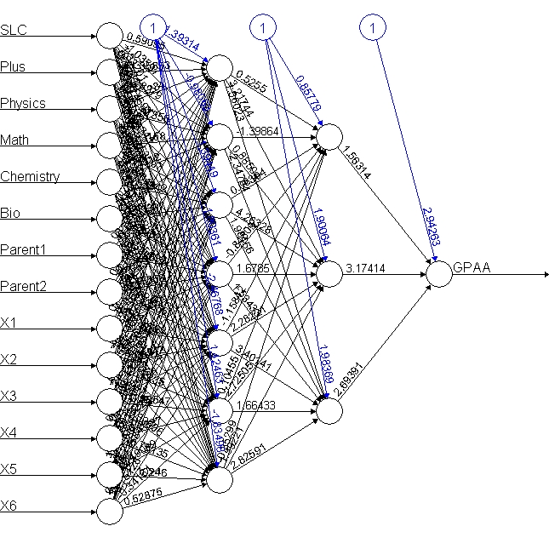 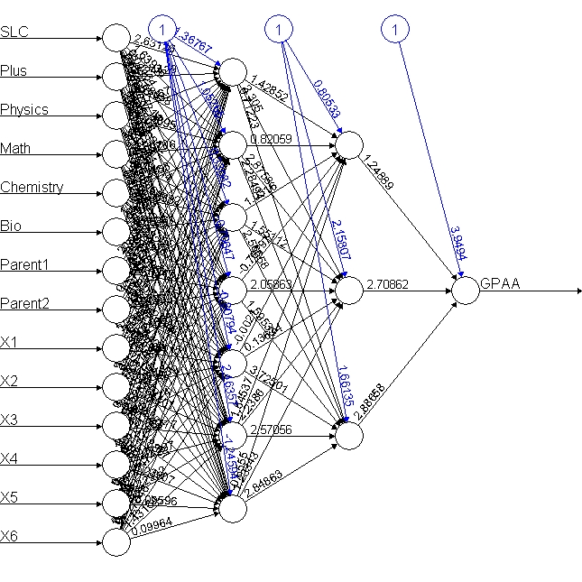

Figure 39: Neural Network of Two Hidden Layers ( 7,3)

After computing the neural network model output available at last node whose value is further separated using the condition of ifelse(p2>=.999944,1, ifelse(p2>=.999942 ,2, ifelse (p2>= .999943, 3, ifelse (p2>=.999940,4, ifelse (p2>= .999938,5, ifelse (p2 >=.999936,6, ifelse (p2>= .999936, 6,0))))))) function, whose output weight of confusion matrix respectively predicts as

pred2 0 1 2 3 4 5 6

0 1 0 0 0 2 0 0

1 15 0 3 1 2 1 0

2 17 2 3 6 0 1 0

4 37 8 19 11 5 7 1

5 11 2 5 4 3 1 0

6 4 0 2 0 2 3 0

The confusion matrix output other than diagonal elements were misclassification. The accuracy using 1-sum(diag(tab2)) /sum(tab2) is 0.8826816 percent accuracy of model seems good because both accuracies were more than 80 percent.

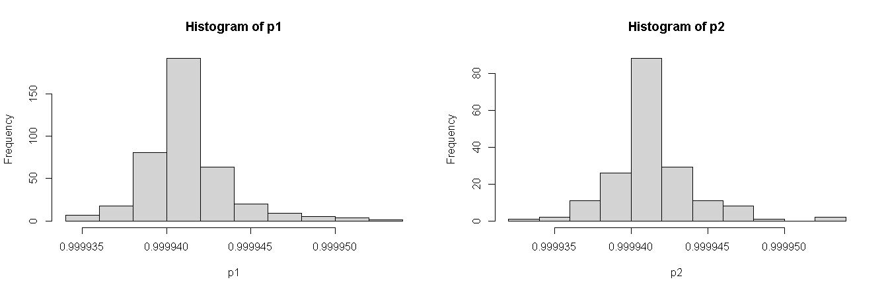

Figure 40: Histogram Output of Test and Training Data of Two Hidden Layer

Similarly, the half model of fully connected neural network with grade of seven grades "1" "2" "3" "4" "5" "6" "7" of those passed student converse formed the model after subletting the 14 independent and GPA predictor variable of two training sample of 70 and 30 percent test sets is evaluated using of 209 and 81 data sets of 290 passed student in the final examination in 2019. Plotted the neural network model as second plot above and its histogram after applying seven category of neuron output plotted as.

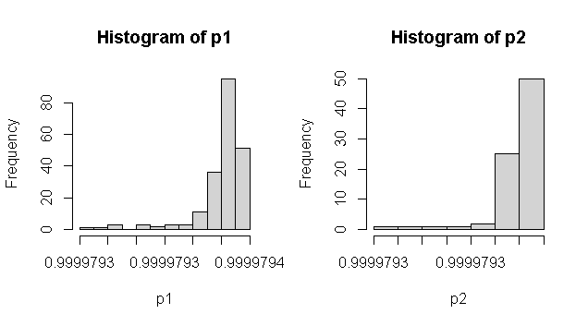

Figure 41: Histogram Output of Training and Test

After plotting the net. Result command in the training histogram and test histogram the seven GPA marks are evaluated their confusion matrix using table command of respective whose accuracy error is further calculated the elements other than diagonal elements sampled data as.

pred2 1 2 3 4 5 6

1 3 12 3 1 3 1

2 8 12 10 8 6 0

3 0 2 0 1 0 1

4 1 0 1 1 1 0

5 0 1 0 1 0 0

6 1 1 0 1 1 0

The accuracy is further calculated 1-sum(diag(tab2)) /sum(tab2) is 0.8024691 percent respectively. Therefore, half model is far better than full model.

## **Neural Network with Three Hidden Layers (N= 7, 3, 2)**

As neural network model is further increased using three hidden layers large model for conversing the predication of student information input to the dependent variable with the help of some constant bios and the sum of each input signal and its weight in fully connected neurons in the forward direction. In each node first calculated before the node and the activation function using a sigmoid function with bios, and 'tanh' are possible for the logistic function and tangent hyperbolic is selected for movement in further prediction. The first neural network model used the formula with dependent and list of independent variables in the model with data on the training sample. The threshold optional parameter a numeric value specifying the threshold for the partial derivatives of the error function as stopping criteria. The step max parameters use to reaching maximum leads to a stop of the neural network's training process.

Therefore, three or more hidden layers are used for testing their prediction. However, when act. fact="tanh" become true the linear.out parameter needs to be TRUE to get output conversion. When the hidden layer becomes 7,3,2 the model won’t have conversed other than “tanh”. While selecting the first hidden layers and more the neural network needs to conversed 97 and the error is 566.01552 and 0.59 secs otherwise the prediction accuracy of the model could not select. Similarly, the output based on reputation will be printed using rep=specified numbers. When hidden layers (7,3,1) and linear out become TRUE the model algorithm did not converge in 5 of 5 repetition(s) within the step max otherwise it will be. However, the model accuracy and confusion matrix are significant for the model evaluation.

After selecting sub setting data using ss=data2 %>% select (GPAA, SLC, Plus, Physics, Math, Chemistry, Bio, Parent1, Parent2, X1, X2, X3, X4, X5, X6) from large data base then test and training data using ind=sample (2, nrow(ss), replace=T, prob=c (.7,.3)) splits data 401 for training and 179 as test sets for neural network model with three hidden layers. After loading library(neuralnet) package the model n=neuralnet (GPAA~ SLC+ Plus+ Physics+ Math+ Chemistry+ Bio +Parent1+ X1+X2+X3+X4+X5+X6, data=training, hidden=c (7,3,2), err.fct="sse”, linear. output=FALSE, lifesign='full’, rep=5, algorithm="rprop+”, stepmax = 10000). This model used three hidden layers in between as (7,3,2) and linear. output equal FALSE otherwise the model wont conversed produced output thresh: 0.01 rep: 1/5 steps: 1000 min thresh: 1.15857355426732. the repetition step is 5 indicates that the model as.

hidden: 7, 3, 2. thresh: 0.01 rep: 1/5 steps: 36 error: 577.00933 time: 0.05 secs

hidden: 7, 3, 2 thresh: 0.01 rep: 2/5 steps: 34 error: 577.00915 time: 0.04 secs

hidden: 7, 3, 2 thresh: 0.01 rep: 3/5 steps: 26 error: 577.0094 time: 0.02 secs

hidden: 7, 3, 2 thresh: 0.01 rep: 4/5 steps: 31 error: 577.00874 time: 0.03 secs

hidden: 7, 3, 2 thresh: 0.01 rep: 5/5 steps: 41 error: 577.00957 time: 0.06 secs

The plot final output will be selected whose output found minimum time as. plot (n, rep=3) case chooses to get output.

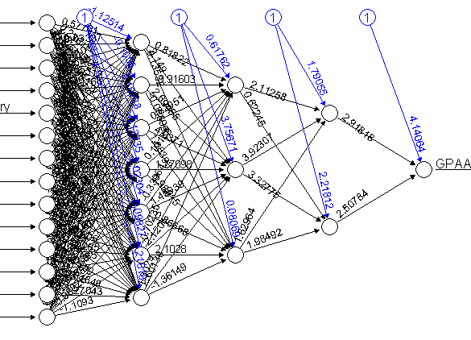 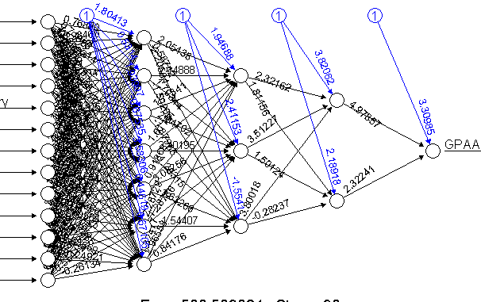

Figure 42: Neural Network Model of Three Hidden Layers

After conversed with parameters 5 repetitions, the best model is selected and computed its output=neuralnet: compute (n, training [, -1], rep = 3) is computed with respect training model for accuracy and confusion matrix prediction of all 580 student records. After computing using output=neuralnet: compute (n, training [, -1], rep=3) function. The categorical GPA values with different levels as "0" "1" "2" "3" "4" "5" "6" "7" could be plotted in histogram for the calculation confusion matrix and model test and training accuracy.

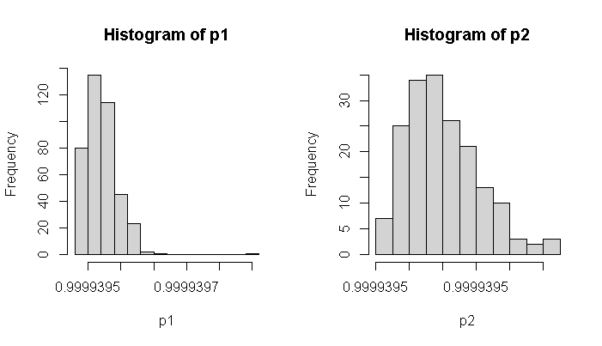

Figure 43: Histogram of Test and Training Output

After evaluating histogram of data conversed, the confusion matrix and model accuracy of training and test sets (401 and 179) sample datasets using pred1= ifelse (p2> =.999944,1, ifelse (p2>=.999942,2, ifelse (p2 >= .999943,3, ifelse (p2>=.999940,4, ifelse (p2>=.999938,5, ifelse(p2>=.999936,6, ifelse(p2>=.999936,7,0))))))) condition. The text accuracy is calculated using tab1=table (pred1, training$GPA) based on network model in different eight GPA grade the confusion and accuracy.

pred2 0 1 2 3 4 5 6

2 85 12 32 22 14 13 1

From the above confusion matrix, the test accuracy is 0. 5251397 respectively. This accuracy is quite low this model therefore this model is rejected to GPA prediction because this model only matched 52 percent of 580 student records.

Similarly, the half model of same model data is prepared using library(tidyverse) package and select only those columns using ss=data2 %>% select(GPAA,GPA,SLC, Plus, Physics, Math, Chemistry, Bio, Parent1, X1,X2, X3, X4, X5, X6) %>% command then split into two training and test at ratio 70 and 30 (209: 81) then feed these data using model n=neuralnet (GPAA~ SLC+ Plus+ Physics+ Math +Chemistry+ Bio+ Parent1+ X1+ X2+ X3+ X4+ X5+ X6, data=training, hidden=c(7,3,2), err.fct="sse", linear.output=FALSE, lifesign='full', rep=5, algorithm ="rprop+”, stepmax=10000)produces the output as

hidden: 7, 3, 2 thresh: 0.01 rep: 1/5 steps: 41 error: 500.50669 time: 0.06 secs

hidden: 7, 3, 2 thresh: 0.01 rep: 2/5 steps: 30 error: 500.50908 time: 0.02 secs

hidden: 7, 3, 2 thresh: 0.01 rep: 3/5 steps: 36 error: 500.50753 time: 0.02 secs

hidden: 7, 3, 2 thresh: 0.01 rep: 4/5 steps: 44 error: 500.50897 time: 0.03 secs

hidden: 7, 3, 2 thresh: 0.01 rep: 5/5 steps: 33 error: 500.50792 time: 0.02 secs

From this model the output print plot (n, rep=2) function as above second model. After computing output=neuralnet: compute (n, training [, -1], rep=2) function the training and test accuracy with confusion matrix plotted two separate histograms as.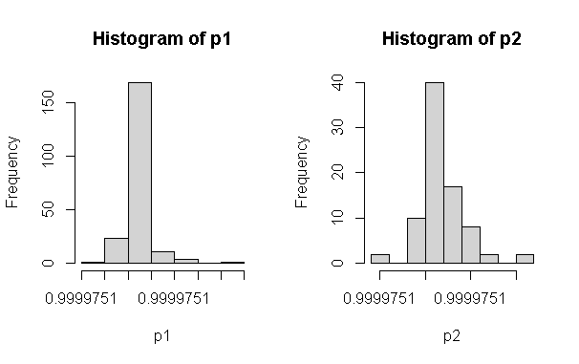

Figure 44: Histogram of Training and Test Data

After selecting same model, the computed output with training and test data describes predicated output. The confusion matrix is achieved using ifelse (p2 > =.9999722,1, ifelse (p2 >= .9999721 ,2, ifelse (p2>=.9999720,3, ifelse (p2> = .9999719,4, ifelse (p1>=.9999718,5, ifelse (p2> =.9999717,6,7)))))) condition. The output of model confusion matrix is as.

pred2 1 2 3 4 5 6

1 13 28 14 13 11 2

After using 1-sum(diag(tab2))/sum(tab2) test data accuracy is 0.8395062 percentage accurately prediction implies the best model. Similarly, the head (training [,],88) function compared test with actual and model as.

GPAA GPA SLC Plus Physics Math Chemistry

1 2 3.45 0.6900000 0.8333333 0.81081081 0.5192308 0.78947368

2 3 3.01 0.7916667 0.7222222 0.56756757 0.7500000 0.55263158

3 1 3.82 0.5833333 0.6944444 0.54054054 0.5769231 0.76315789

4 3 3.26 0.8333333 0.7777778 0.67567568 0.8653846 0.39473684

6 5 2.48 0.8888889 0.7222222 0.56756757 0.6346154 0.39473684

7 5 2.53 0.8611111 0.7777778 0.67567568 0.8653846 0.39473684

8 2 3.36 0.5555556 0.5000000 0.75675676 0.3269231 0.02631579

9 2 3.38 0.5833333 0.5000000 0.75675676 0.3269231 0.02631579

Therefore, from the above output on original GPA with respect GPAA variables were largely mismatched. The second record had accurately matched the other records model prediction and test accuracy with original students’ records were mismatched. This model has large misclassification varies from .488 to 82 percent accuracy.

## **Neural Network with Original Datasets (N=7 ,3 ,2)**

The another thought of model formation and validation using neural network with original data sets with three hidden layers comprises (7,3,2) in between before predictor variables of GPA with numerical category of eight different grades of student marks. After loading the data set into r console the preprocessing of data sets with converting as number pattern if the required data sets grouped data2 %>% select (GPAA, SLC, Plus, Physics, Math, Chemistry, Bio, Parent1, X1, X2, X3, X4, X5, X6) with tidyverse package then split into 70 and 30 splits sample of 401 and 178 random samples. After taking seed values for repeatability the neural network of three hidden layers nn=neuralnet (n=neuralnet (GPAA~ SLC+ Plus+ Physics+ Math+ Chemistry+ Bio+ Parent1 +X1+ X2+X3+ X4+ X5 + X6, data=training, hidden=c (7,3,2), err.fct="sse”, linear. output=FALSE, lifesign ='full’, rep=5, algorithm ="rprop+”, stepmax=10000) model.

$ SLC: num 79.8 83.5 76 85 86 ...

$ School: int 1 1 0 0 0 1 0 1 1 1 ...

$ Physics: int 85 76 75 80 80 76 80 83 83 56 ...

$ Math: int 72 84 75 90 90 78 90 62 62 68 ...

$ Chemistry: int 85 76 84 70 70 70 70 56 56 61

$ Bio: int 85 75 70 70 70 80 70 48 48 0 ...

$ Parent1: int 1 4 3 2 2 4 1 1 1 2 ...

$ Parent2: int 3 4 4 4 4 4 4 4 4 3 ...

$ X1: int 44 47 49 40 50 42 50 44 45 46 ...

$ X2: int 39 39 44 41 41 36 41 44 44 45

Sample Original Data

Here researcher used default algorithm resilience propagation with five possible repetitions is 5 the error factor is set as the sum of a square and step max is 10000 iterations. The correction takes place default algorithm is rprop+ default activation logistic. This model displays all the information with reached.

hidden: 7, 3, 2 thresh: 0.01 rep: 1/5 steps: 38 error: 576.00928 time: 0.04 secs

hidden: 7, 3, 2 thresh: 0.01 rep: 2/5 steps: 27 error: 576.00805 time: 0.03 secs

hidden: 7, 3, 2 thresh: 0.01 rep: 3/5 steps: 31 error: 576.00722 time: 0.03 secs

hidden: 7, 3, 2 thresh: 0.01 rep: 4/5 steps: 41 error: 576.00792 time: 0.04 secs

hidden: 7, 3, 2 thresh: 0.01 rep: 5/5 steps: 29 error: 576.00938 time: 0.03 secs

After evaluation of network output the plot of neural network is plot using plot (n, rep=2) or plot (n, rep=3) or plot (n, rep=5) plots as.

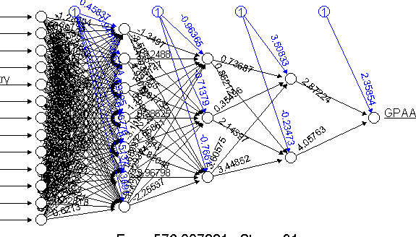 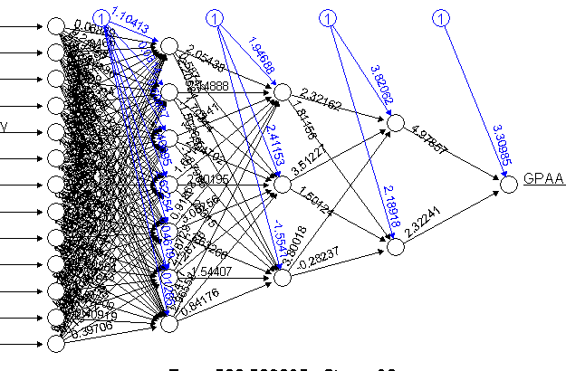

Figure 45: Neural Network Model of (7,3,2) with Original Data

After computing the model using output = neuralnet: compute (n, training [, -1], rep=3) command on selected data, the output of the final GPA is further plotted with the histogram of the eighth-grade categorized as using ifelse(p2>=.9999,1, ifelse(p2>=.9998,2, ifelse(p2>=.9997,3, ifelse(p2>=.9996,4, ifelse(p2>=.9995,5, ifelse(p2>=.9994,6, ifelse(p2>=.9993,7,0))))))) command testing histogram.

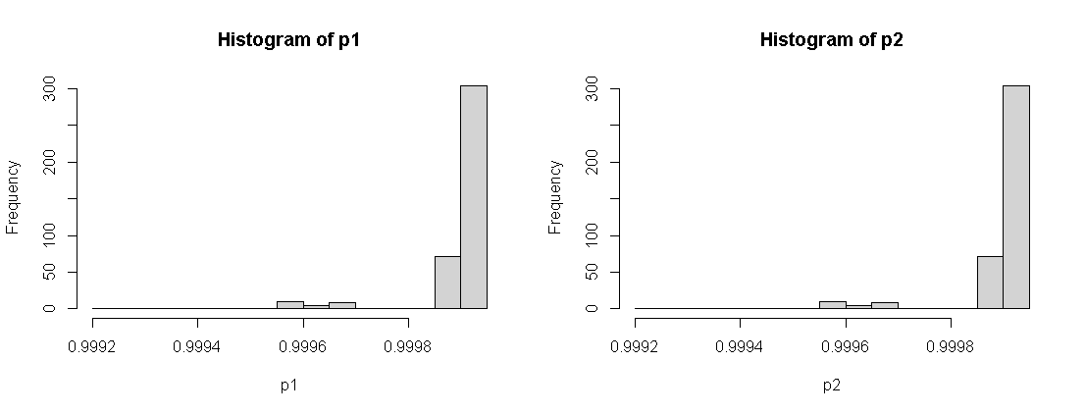

Figure 46: Histogram of Training and Test of Original Data

After histogram the accuracy production of test data using ifelse(p2>=.9999,1, ifelse (p2>=.9998,2, ifelse (p2>=.9997,3, ifelse(p2>=.9996,4, ifelse (p2>=.9995,5, ifelse(p2>=.9994,6, ifelse (p2>=.9993,7,0))))))) condition of histogram for eight different grade prediction. The table of matrix of confusion display as.

Pred2 0 1 2 3 4 5 6 7

0 2 0 0 0 0 0 0 0

1 144 26 55 36 23 15 2 2

2 40 11 5 8 0 7 1 0

3 0 0 1 0 0 0 0 0

4 12 1 0 0 0 0 0 0

5 7 2 0 1 0 0 0 0

The model and the misclassification are again compared with original values gives the percent of errors with test data using 1-sum(diag(tab2)) /sum (tab2) is 0.8938547 percentage is quite improvement.

Similarly, the half model of original data of three hidden the above design after grouping passed student record using tidyverse function. The data splitting 70:30 percent splits 209 and 81 sampled whose model plot is plotted after plot (n, rep=2) evaluation above diagram. The training neuralnet: compute (n, training [, -1], rep =2) and test neuralnet: compute (t.test [, -1], rep=2) computation using ifelse(p2>=.99,1, ifelse(p2>=.8,2, ifelse(p2>=.7,3, ifelse(p2>=.6,4, ifelse(p2> =.5,5, ifelse (p2>=.4,6,7)))))) condition of both sets plots the histogram as.

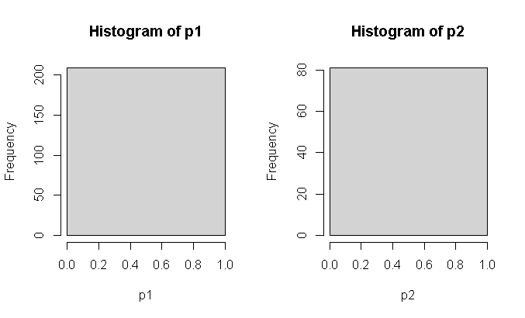

Figure 47: Histogram of Three Hidden Layers with Original Datasets

The confusion matrix and test accuracy were calculated respectively using table (pred1, training $GPAA) function whose prediction accuracy is evaluated using 1-sum(diag(tab2)) / sum (tab2) function respectively. The training accuracy confusion matrix as.

pred2 1 2 3 4 5 6

1 14 27 15 12 11 2

Which produces test accuracy is 0.8271605. That implies this model has best as compared above model with normalized data three hidden layers with equal test accuracy. The further commands in model output describes its converse with fixed steps the bias terms make greater role to converse average of output. And the plot(n) plots all five possible network plots separately respective weight model formed. The last result indicates each steps error, threshold with respect other variables as. error 502.506696433 502.509034718 502.507491262 502.508920992 502.507875680

reached. Threshold 0.006696345 0.009034558 0.007491151 0.008920836 0.007875559

steps 41.000000000 30.000000000 36.000000000 44.000000000 33.000000000

Intercept.to.1layhid1 0.054168304 1.104125759 -0.943756709 -2.037907228 1.918519241

SLC.to.1layhid1 2.771775079 0.068886056 -2.682168438 0.920408542 0.951375898

Plus.to.1layhid1 -0.349863963 0.284661860 -1.454400609 0.719360861 0.742296172

Physics.to.1layhid1 -1.392210963 -1.969335711 -2.110365322 -1.170741178 0.732048862

Math.to.1layhid1 -0.756881174 -0.196151625 -0.899326340 0.256693833 0.358515170

Chemistry.to.1layhid1 -0.351140566 0.758284045 -2.519944863 -1.822276517 0.322513743

Bio.to.1layhid1 1.578623977 1.122742620 -0.986965968 0.997086131 -1.141343270

Similarly, the summary(covariate) and summary (n$result. matrix) commands the descriptive statists of the model as

summary (n$result. matrix)

V1 V2 V3 V4 V5

Min.: -3.2440 Min.: -2.2058 Min.: -2.6822 Min.: -2.8807 Min.: -2.0316

1st Qu.: -0.4227 1st Qu.: -0.2122 1st Qu.: -0.2330 1st Qu.: -0.3728 1st Qu.: -0.2313

Median: 0.2268 Median: 0.4416 Median: 0.6247 Median: 0.5976 Median: 0.5456

Mean: 4.3319 Mean: 4.4751 Mean: 4.9417 Mean: 4.5588 Mean: 4.7872

3rd Qu.: 1.0754 3rd Qu.: 1.3312 3rd Qu.: 2.3169 3rd Qu.: 1.3883 3rd Qu.: 1.7071

Max. :502.5067 Max. :502.5090 Max. :502.5075 Max. :502.5089 Max. :502.5079

summary(covariate)

SLC Plus Physics Math Chemistry Bio Parent1

Min.:55.00 Min. :49.00 Min.:55.0 Min.:55.00Min.:55.00Min.:0.00Min.1.000

1st Qu.:75.60 1st Qu.:66.00 1st Qu.:69.0 1st Qu.:69.001st Qu.:70.001st Qu.:60.001st Qu.:2.000

Median :80.0 Median :73.0Median :76.0Median :80.0Median :78.0Median :70.0Median :2.0

Mean:78.37 Mean:70.83 Mean:75.3Mean:77.07Mean:75.95Mean:65.25Mean:2.278

3rd Qu.:84.253rd Qu.:77.003rd Qu.:81.03rd Qu.:85.003rd Qu.:84.003rd Qu.:75.003rd Qu.:3.000

Max.:90.00Max.:84.00Max.:92.0Max.:97.00Max.:93.00Max.:92.00Max:4.000.

So that each model output could be analyzed respectively. From the above five different models with normalized and non-normalized data values whose output based on accuracy indicates the single layer with /2 neuron in hidden layers is suitable for student grade predication.

**Back Propagation of One Single Layer**

The reversed propagation of neural network traversed for the calculation of student GPA predication in reversed order after first traversed in reversed for the neural network's training. The learning rate is a numeric value specifying used by traditional backpropagation. The life sign is a string specifying how much the function will print during the calculation of the neural network. 'none', 'minimal' or 'full’. There are some possible: backprop, rprop+, rprop-, sag refers to backpropagation, 'rprop+' and 'rprop-' refer to the resilient backpropagation with and without weight backtracking, while 'sag' and 'slur' induce the usage of the modified globally convergent algorithm (rprop). The error factor is used for the calculation of the error. When the error rate is set to act. fact=” tnha” than linear. output becomes true.

The exclude option may exclude the matrix row and column for the model. The likelihood parameter is logical. If the error function is equal to the negative log-likelihood function, the information criteria AIC and BIC will be calculated (Anastasiadis, Stefan, & Frauke, 2005). Furthermore, the usage of confidence. the interval is meaningful. The result a list containing the overall result of the neural network for every repetition (Riedmiller & Braun, 1993) the confidence. interval, a method for objects of class nn, typically produced by a neural net. The confidence intervals of the weights and the network information criteria (Murata, 1994). If this assumption is violated, the results will not be reasonable. Therefore, three or more hidden layers are used for testing their prediction. However, when act. fact="tanh" become true the linear.out parameter needs to be TRUE. When the hidden layer becomes 7,4,2 the model won’t be conversed. While selecting the first hidden layers and more the neural network needs to convert the 97 and the error is 566.01552 and time is 0.59 secs otherwise the prediction accuracy of the model could not select. When hidden layers (7,3,1) and linear out become TRUE the model algorithm did not converge in 5 of 5 repetition(s) within the step max otherwise it will be conversed either (50,14,7,4,1) as many as middle layers. However, the model accuracy and confusion matrix are significant for the model evaluation. Here researcher try to explore single neuron network using backward traversed. After loading tidyverse package the selected variables of independent and dependent in another database before model design then converted into numeric pattern. The full model grouped into two training and test sample (401:179) splits sample.

After taking set. seed (112) the neurol network with back propagation as n=neuralnet (GPAA~ SLC +Plus +Physics+ Math+ Chemistry+ Bio+ Parent1+X1+X2+ X3+ X4+X5 +X6, data = training, hidden=c (1), learning rate = 0.01, err.fct = "sse", linear. output = FALSE, lifesign = 'full’, rep = 5, algorithm = 'backprop’, stepmax =10000). Here all 14 independent columns of student records with data having single neuron with error factor is sum of square error with repetition using algorithm backpropagation with stepmax=10000 because output variable is categorical so output is true and the default algorithm is rprop+ default activation logistic regression. This model generates the output of five cases then select the best model display as.

hidden: 1 thresh: 0.01 rep: 1/5 steps: 1000 min thresh: 0.0497338019864384

2000 min thresh: 0.0249254114993073 3000 min thresh: 0.0166314321580569

4000 min thresh: 0.0124793501363943 4994 error: 576.01 time: 1.18 secs

hidden: 1 thresh: 0.01 rep: 2/5 steps: 1000 min thresh: 0.049688784713512

2000 min thresh: 0.0249141041753707 3000 min thresh: 0.0166263979159323

4000 min thresh: 0.0124765157533581 4993 error: 576.01 time: 1.22 secs

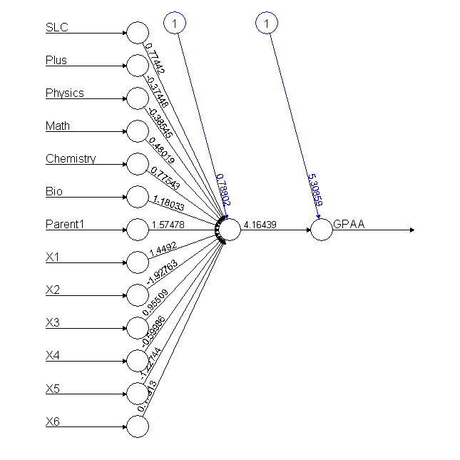 

Figure 48: Single Layer Backpropagation Neural Network

After fully conversed neural network model whose output further divides last node output using pred1= ifelse (p3 >= .9,1, ifelse (p3>=.8,2, ifelse (p3>=.7,3, ifelse(p3>=.6,4, ifelse(p3> =.5,5, ifelse (p3>=.2,6,0)))))) condition.

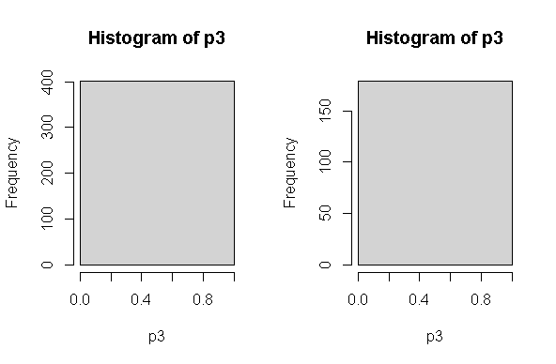

Figure 49: Histogram of Single Hidden Layer Backpropagation

The histogram of test and training sets value of after back propagation reversed calculated. The test data miss classification and accuracy using 1-sum(diag(tab3)) /sum(tab3) is 0.4887781 and the misclassification

pred2 0 1 2 3 4 5 6

1 85 12 32 22 14 13 1

The in prediction calculated using error=mean (training$GPAA! = pred1) the misclassification is again compared with original values gives percent of errors (remember here the neural network model may not produce same output when another time run due to random weight initially taken part while calculation) is 0.9002494 is the worst model similarly the test accuracy and misclassification were 0.5251397 and 0.9329609. Therefore, both test and training output predicts this model has 50 percentage accuracy while using single neuron model. As compared the single neural network forward direction back propagation is less accuracy in full model.

Similarly, when using half model in reversed propagation with passed student information 290 student the training and test sets of 209 and 81 sample splits using the same model back propagation as n=neuralnet (GPAA~ SLC + Plus +Physics+ Math+ Chemistry+ Bio+ Parent1+X1+X2+ X3+ X4+X5 +X6, data = training, hidden=c (1), learning rate = 0.01, err.fct = "sse", linear. output = FALSE, lifesign ='full’, rep=5, algorithm='backprop’, stepmax=10000). After conversed the plots of network plots using plot =plots(rep=3).

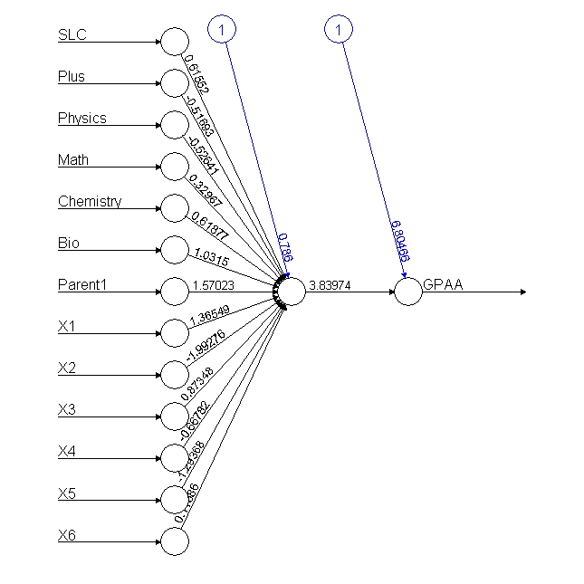 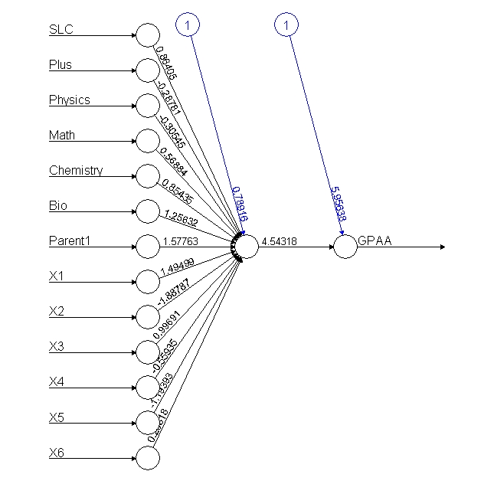

Figure 50: Neural Network of Single Layer Backpropagation

After computing original with output using neuralnet: compute (n, training [, -1]) and test neuralnet: compute (nn, testing [, -1]) using ifelse (p3>=.9,1, ifelse (p3>=.8,2, ifelse(p3>=.7,3, ifelse(p3>=.6,4, ifelse(p3>=.5,5, ifelse (p3> =.2, 6, ifelse (p3>=.1,7,0))))))) condition produced the histogram of both test and training output as.

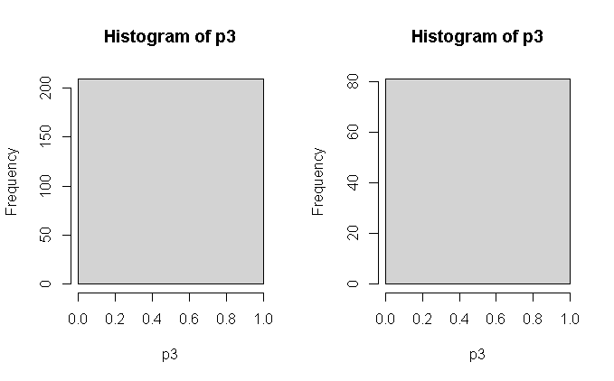

Figure 51: Histogram of Single Layer Conversed Value

The confusion matrix and test and training accuracy of the model are as

Pred2 1 2 3 4 5 6

1 14 27 15 12 11 2

Due to single category dependent variables the cross-miss classification diagonal elements won’t be calculated. After using calculating accuracy on test accuracy is 0.8271605 both models exactly same accuracy is best model in half data. Whose mismatched and matched indexed output after cbind (training$GPAA, pred2) function describes each induvial student records.

5 2 1

14 3 1

16 1 1

26 3 1

60 1 1

61 1 1

66 2 1

72 2 1

From the above backward neural network of single hidden layer is less accuracy as compared forward calculation.

## **Back Propagation of Five Hidden Layers (N=5)**

The reversed propagation calculation using five hidden layers in between input and output nodes. After taking set. seed (112) the neurol network with back propagation as n=neuralnet (GPAA~ SLC +Plus +Physics+ Math+ Chemistry+ Bio+ Parent1+X1+X2+ X3+ X4+X5 +X6, data= training, hidden=c (5), learning rate = 0.01, err.fct = "sse", linear. output = FALSE, lifesign='full’, rep=5, algorithm='backprop’, stepmax=10000). Here all 14 independent columns of student records with data only training sets having single neuron with error factor is sum of square error with repetition using algorithm backpropagation with stepmax=10000 because output variable of categorical so output is true backprop activation logistic regression. This model generates the output of five cases then select the best model produce the output as

hidden: 5 thresh: 0.01 rep: 1/5 steps: 1000 min thresh: 0.019666708909702

1983 error: 858.01 time: 1.13 secs

hidden: 5 thresh: 0.01 rep: 2/5 steps: 1000 min thresh: 0.0261156887868856

2000 min thresh: 0.013494926120734 2737 error: 858.0083 time: 1.6 secs

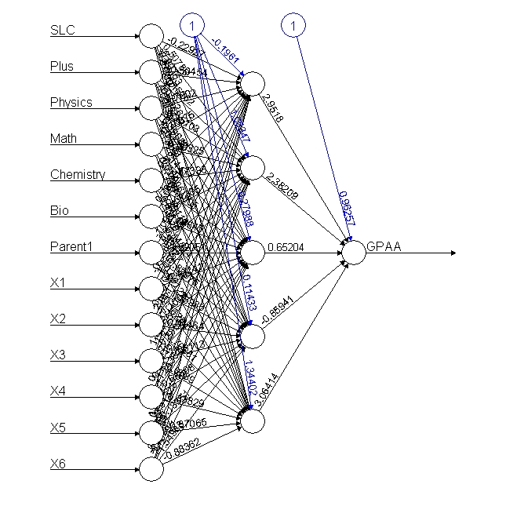 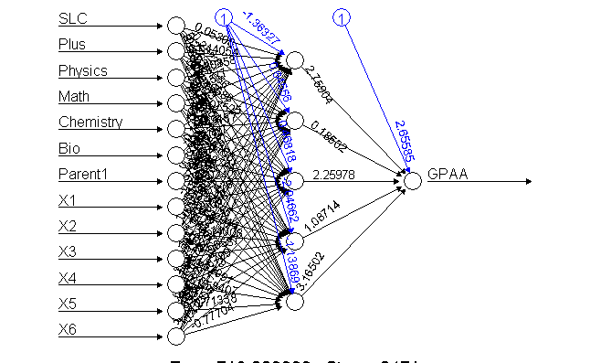

Figure 52: Full and Half Model Neural Network of Single Layer 5 Neuron

After neural network conversed the output at last node of the student grading of search grouped up using ifelse(p3>=.9,1, ifelse(p3>=.8,2, ifelse(p3>=.7,3, ifelse(p3>=.6,4, ifelse(p3>=.5,5, ifelse(p3>=.2,6, ifelse(p3>=.1,7,0))))))) condition of respective student grades. Whose final value in histograms of test sets are as.

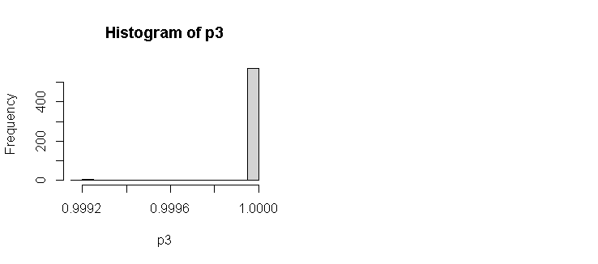

Figure 53: Full Model Histograms of 5 Neuron Single Layer

The confusion matrix of training and test accuracy with single dependent variables of back propagation neural network model.

pred2 1 2 3 4 5 6 7

1 52 93 67 37 35 4 2

The misclassification is again compared with original values gives percent of errors (remember here the neural network model may not produce same output when run another time due to random weight initially taken part) is 0.9103448 is the still worst model in training case.

Similarly, when using half model with passed student information 290 student the training and test sets of 209 and 81 splits using the same model back propagation model n=neuralnet (GPAA~ SLC + Plus +Physics+ Math+ Chemistry+ Bio+ Parent1+X1+X2+ X3+ X4+X5 +X6, data = training, hidden=c (5), learning rate = 0.01, err.fct = "sse", linear. output = FALSE, lifesign ='full’, rep=5, algorithm='backprop’, stepmax=10000). After conversed the plots training$GPA = plots (rep =3) produced. After neuralnet: compute (n, training [, -1]) and test neuralnet: compute (nn, testing [, -1]) using ifelse(p3>=.9,1, ifelse(p3>=.8,2, ifelse(p3>=.7,3, ifelse(p3>=.6,4, ifelse(p3>=.5,5, ifelse (p3 >= .2,6, ifelse (p3>=.1,7,0))))))) condition produced the histogram of both training and test cases output as.



Figure 54: Half Model Histogram of Training and Test data

The confusion matrix and test and training accuracy of the models produced on the basic of single dominant variable as.

pred2 1 1 2 3 4 5 6

1 14 27 15 12 11 2

After calculating accuracy using training) accuracy is 0.8206897 using 1-sum(diag(tab3))/sum (tab3. The both models exactly same accuracy is best model in half student data using backward traversing. Whose mismatched output after cbind (training$GPAA, pred1) function describes each induvial student records.

## **Back Propagation of Two Hidden Layers (N = 7, 3)**

After loading full data base, the sub setting of data with 14 independent and 1 independent variable using tidyverse library with all 580 sample student data. Then training (401) and test 179 data random sample using sample split of 70:30 ratio. After using seed set. seed (222) the neural network with back propagation with two hidden layers of 7,3 as nn=neuralnet (GPAA ~ SLC+ Plus +Physics+ Math+ Chemistry +Bio +Parent1 +X1+ X2+ X3+ X4+ X5 + X6, data = data, hidden = c (7, 3), learning rate = 0.01, err.fct ="sse”, linear. output = FALSE, lifesign='full’, rep=5, algorithm='backprop', stepmax = 10000).

After setting learning rate in each iteration is 0.01 and algorithm is backprop satisfied five iteration tests with stepmax is 10000 conversed at.

hidden: 7, 3 thresh: 0.01 rep: 3/5 steps: 1000 min thresh: 0.0263606432485815

2000 min thresh: 0.0130459729524676 2601 error: 858.01 time: 2.42 secs

hidden: 7, 3 thresh: 0.01 rep: 4/5 steps: 1000 min thresh: 0.0192861629359062

2000 min thresh: 0.010537316400092 2121 error: 858.01 time: 1.83 secs

hidden: 7, 3 thresh: 0.01 rep: 5/5 steps: 1000 min thresh: 0.0341629139786731

2000 min thresh: 0.0169608886403354 3000 min thresh: 0.0112709333735587

3379 error: 858.01 time: 2.98 secs

From the above iteration conversed and produced the output the best model plot is chosen to using print (n, rep =3) incase third iteration is less time completion to model formation final conversed single output.

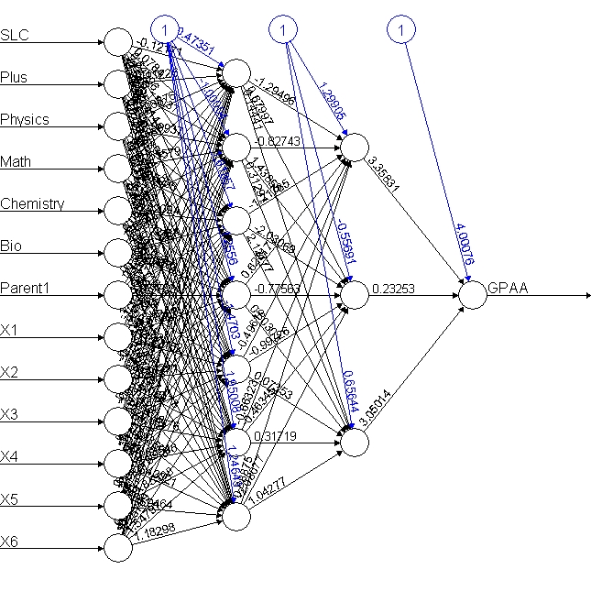 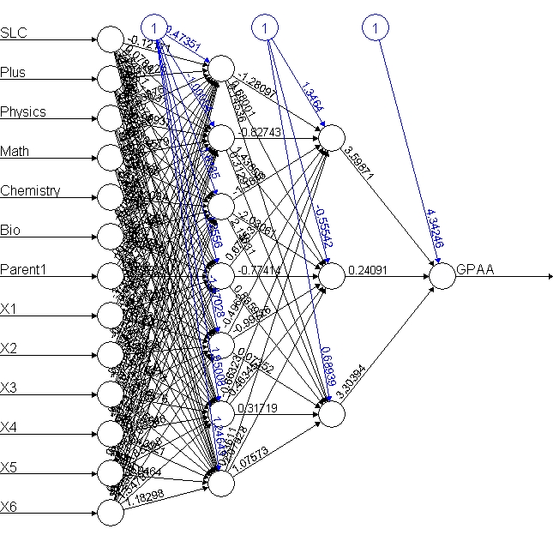

Figure 55 : Neural Network with Two Hidden Layer N = 7,3

After model conversed the compute function compute using neuralnet: compute (nn, data [, -1]) function. After using output$net. result function the output plots histogram describes the dependent variables having student different grades.

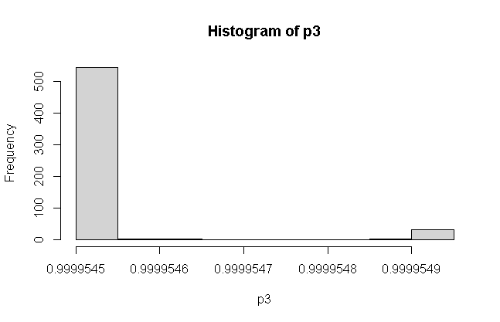

Figure 56: Histogram of Conversed Using Two Layers

After using ifelse(p3>=.99995485,1, ifelse(p3>=.99995480,2, ifelse(p3>=.99995475,3, ifelse(p3>=.9999547,4, ifelse(p3>=.99995465,5, ifelse(p3>=.9999546,6, ifelse (p3 >= 99995455,7,0))))))) conditions of the last output node to separate different grades of student marks in GPA variable. The confusion matrix is describing training and test accuracy as.

pred2 0 1 2 3 4 5 6 7

0 271 47 90 63 36 33 4 2

1 18 5 3 4 1 2 0 0

6 1 0 0 0 0 0 0 0

The confusion of different grades describes the miss classification of remaining diagonal elements missed matched. The full model accuracy using 1-sum(diag(tab3))/sum(tab3) function is 0.5241379. Whereas the half model training accuracy is 0.7689655 increased largely and the mis classification is again compared with original values gives percent of errors using cbind (data$GPAA, pred1). Therefore, this model is only predicting 52 percent whose model prediction and input were largely unmatched the model predicts failed but student grade is A- so on missed matched as [10,] 2 0 [11,] 1 1 [12,] 2 1 [13,] 5 1 [14,] 5 0 [15,] 3 1 [16,] 2 0 and [31,] 3 1 [32,] 4 6.

## **Back Propagation of Three Hidden Layers (N= 7,3,2)**

Back prorogation is the concept of reverse traversing for the purpose of balancing each neuron weight between input and output weight so that the model converse quickly requires the learning rate as hyperparameter to dropout some learning rate value quickly in each step repetition. After using the same data sets. nn=neuralnet (GPAA~ SLC+ Plus +Physics+ Math+ Chemistry +Bio+ Parent1+ X1+X2+ X3+X4+ X5+ X6, data = ss, hidden = c (7,3,2), learning rate=0.01, algorithm = 'backprop' err.fct ="sse", linear. output = FALSE). Back prorogation conversed very faster than forward traversing and produced as the similar output of each neuron calculation because each iteration the learning rate (0.01) in each parameter reduced with drop out and their respective weight calculation adjusted when reverse traversing.

The nn model describes its error rate threshold and steps as SLC.to.1layhid1 -1.650261e+00

Plus.to.1layhid1 -3.660134e-01 Physics.to.1layhid1 -3.162966e-01 Math.to.1layhid1 -198817e-01 Bio.to.1layhid1 -6.228716e-01 Parent1.to.1layhid1 -3.340415e-01 variables with start weights [1,] 0.6687143 0.27589340 -0.26063939 -0.83758243 -0.1984163 0.70073352 -0.6061511 [2,] -1.6501009 0.50627262 -0.41441971 and plots the conversed neural network as.

.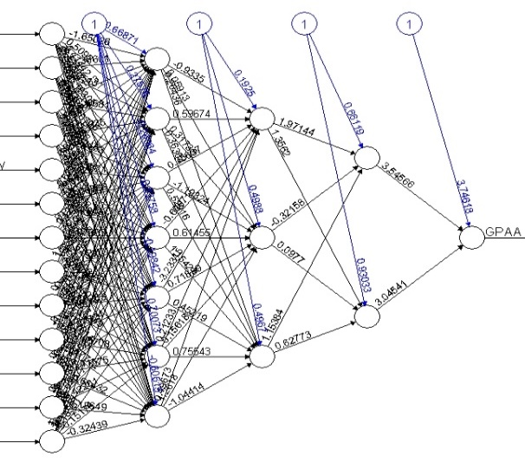 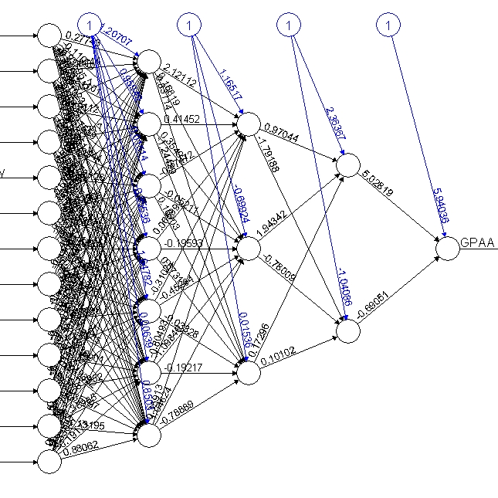

Figure 57: Full and Half Neural Network Model using N= 7,3,2

The final plot conversed as above however this neural network conversed all others model with increasing hidden numbers but our primary concern is to converse in a single prediction. The model $net. result display the final weight generated at last GPA node further computed using compute with original full data for the histogram plot.

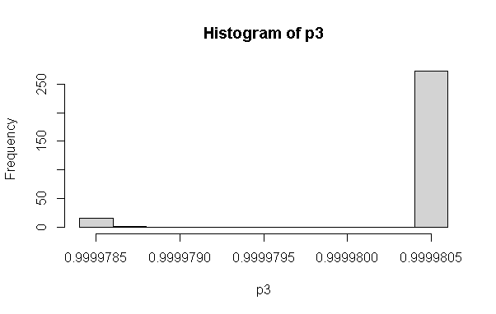

Figure 58: Full and Half Model Histogram of Neural Network

The model output from the neuron network is further categorized on histogram data sets

pred1=ifelse(p3>=.9999544,1, ifelse(p3>=.9999540,2, ifelse (p3 >=.9999535,3, ifelse(p3> =.9999530,4, ifelse(p3>=.9999527,5, ifelse(p3>=.9999525,6, ifelse(p3> 9999520,7,0))))))) condition. The concept of all records and confusion matrix is generated using tab3=table (pred1, ss$GPAA) describes the miss classification respectively.

Pred2 0 1 2 3 4 5 6 7

0 20 3 4 2 1 0 0 0

1 253 45 88 61 34 34 4 2

2 12 3 0 2 1 1 0 0

3 2 1 0 1 1 0 0 0

4 1 0 0 1 0 0 0 0

5 2 0 1 0 0 0 0 0

When using 1-sum(diag(tab3))/sum(tab3) produce full model accuracy is 0.8862069 percent total accuracy whose mis classification using mean (data$GPAA! = pred1) is 0. 8862069.. Then after using cbind (data$GPAA, pred2) to compare individual miss matched data as [478,] 0 1 [479,] 5 1 [480,] 3 1 [481,] 3 0 [482,] 2 1 [483,] 4 1 [286,] 3 1 [287,] 1 1[288,] 3 1 [289,] 2 1 [290,] 3 1 the mismatched model prediction vs actual grades of sample students.

Here researcher tries to predicts with model output of other students’ grades based on their pass and fail grade of eight grade variable of new predication based on model. The new. output=neuralnet: compute (predication based = matrix (c (1,1,1,1,1,1,1,1,1,1,1,1,1,

1,1,1,1,1,1,1,0,0,0,0,0,0,

1,1,1,1,1,1,1,1,1,1,1,1,0,

1,1,1,0,0,0,0,0,0,0,0,0,0),

byrow = TRUE, ncol = 13))

As from the model takes 13 different input signals formed the output after converse in single point model the new. output$net. result interpretation results with percentage of above input values in percentage of accuracy [,1] [1,] 0.9999804 [2,] 0.9999800 [3,] 0.9999804 [4,] 0.9999799 suggest that first three individual input is higher than the last input lowest scored as compared with fourth candidate whose 13 input values are in the range of (0 to 1) grades of GPA values.

Similarly, the testing with real value could be calculated when applying special eight grade points of student scored in respective columns as new. output=neuralnet:

compute (nn, covariate = matrix (c (1,1,1,1,1,1,1,1,1,1,1,1,7,

1,1,1,7,1,1,1,1,1,1,1,6,1,

1,1,1,1,1,1,1,1,1,1,5,1,1,

1,1,1,1,1,1,1,1,1,1,1,1,1),

byrow = TRUE, ncol = 13))

Which produced new. output$net. result indicates the result with percentage of above input values are [,1] [1,] 0.9999805 [2,] 0.9999771 [3,] 0.9999804 [4,] 0.9999804 percentage respectively.

When comparing real student marks of 13 inputs using covariate function produces their respective percentage of accuracy as using new. output=neuralnet: compute (nn, covariate = matrix (c ( 80,70,55,70,70,68,1,40,45,45,45,45,40,

60,1,60,60,1,60,1,30,30,0,30,1,30,

88,80,0,60,60,60,1,35,35,35,35,35,30,

1,1,1,1,1,1,1,1,1,1,1,1,1),

byrow = TRUE, ncol = 13))

The new. Output$net. result# interpretation result with percentage of above input values are [,1] [1,] 0.9999805 [2,] 0.9999771 [3,] 0.9999804 [4,] 0.9999804 percentage receptively.

## **Neural Network with Four Hidden Layers (N= 25, 12, 7, 3)**

The neural network with four hidden layer test for accuracy result prediction. After loading data sets of original data base, after having pre-processing is the input data designed to converted into numeric data only passed in grade students using four hidden layer neural model (25,12,7,3The model as nn=neuralnet (GPAA ~SLC+ Plus+ Physics + Math+ Chemistry+ Bio+Parent1+ X1+ X2 +X3+ X4+X5+X6, data = data, hidden =c (25,12,7,3), learning rate=0.01, algorithm='backprop', err.fct="sse", linear. output =FALSE). The model produces all the weights and calculation of each weight of intermediator layers neurons as 3layhid6.to.4layhid3 6.500746e-01 Intercept.to.GPAA 4.283506e+00

4layhid1.to.GPAA 8.516410e-01 4layhid2.to.GPAA 5.310168e+00

4layhid3.to.GPAA 5.215656e-01 and the plot of neural network conversed as

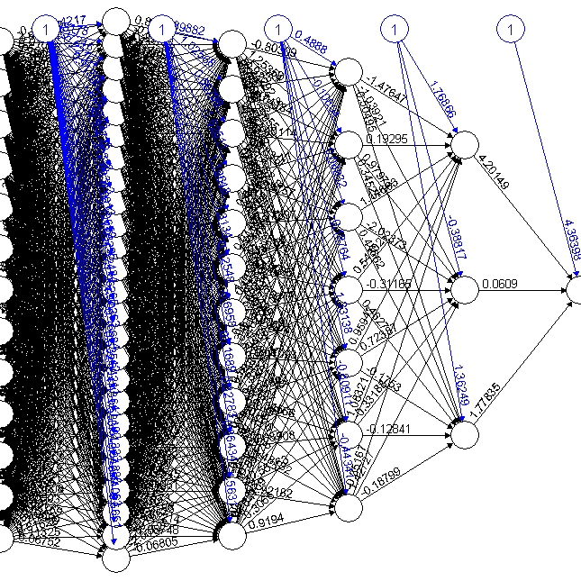 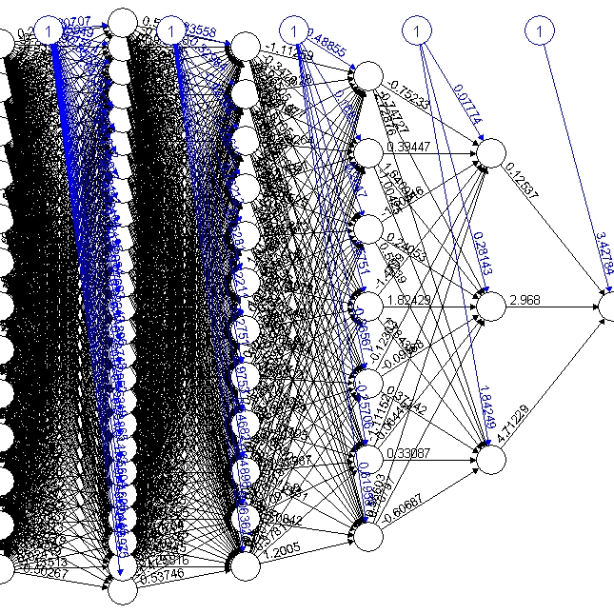

Figure 59: Full and Half Model Neural Network of (N= 25,12,7,3)

This model converses quickly with the output at last node [576,] 0.9999556 [577,] 0.9999553

[578,] 0.9999565 [579,] 0.9999560, [580,] 0.9999548 indicates the various grade of student. After output=neuralnet: compute (nn, data [, -1]) and p3=output$net.result the histogram.

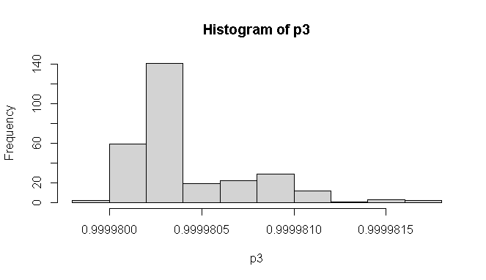

Figure 60: Histogram Output Neuron of Four Layer Network

After calculating the predication using pred1= ifelse (p3>=.9999565,1, ifelse (p3>=.99995627,2, ifelse (p3>=.99995585,3, ifelse (p3>=.99995542,4, ifelse (p3>= .9999550,5, ifelse (p3 >= .9999546, 6, ifelse (p3>=.9999542,7,0))))))) condition to separate their respective grade. The prediction is computed with confusion matrix tab3=table (pred1, ss$GPAA) of each training and test sets are as.

pred1 0 1 2 3 4 5 6 7

0 55 6 17 8 3 5 0 0

1 5 0 0 1 0 0 0 0

2 1 0 0 2 0 0 0 0

3 11 4 1 1 0 2 0 0

4 19 2 8 4 0 3 0 1

5 19 2 2 1 2 0 0 0

6 35 3 10 6 3 5 2 0

7 145 35 55 44 29 20 2 1

The confusion matrix appears in off diagonal are considered as error in the output. The total accuracy using full model 1-sum(diag(tab3))/ sum(tab3) is calculated [1] 0.8982759 percent accuracy and half model is 0.9586207 percentage. However, there were mismatched records [213,] 5 6 [214,] 2 7 [215,] 4 6 [216,] 2 6 [217,] 4 7 [218,] 5 6 [86,] 4 4 [87,] 4 4 [88,] 4 7 [89,] 5 6. Therefore, while calculating neuron in between input to output neuron, it is always recommended to use the square root of neuron needs to be selected in between neural network model formation. So that more accurately produced. Likewise, if the model eliminates the variables like school, parent2 and X5 in the model there is more result inaccuracy will be achieved.

Therefore, it is concluded that the model of different types could be designed for the selection of recommended model based on their accuracy performance of each student grade prediction.

## **Hypothesis Testing**

Hypothesis testing is an essential procedure in statistics and research that always assumed pre informative statements after model formation with confidence intervals. A hypothesis test evaluates two mutually exclusive statements about a population to determine which statement is best supported by the sample data (Anusiewicz & Patrician, 2021). This finding is statistically significant based on a hypothesis test. The variables used in association with other variables are concerning their confidence or not. The null hypothesis and alternative hypothesis are statements regarding the differences or effects that occur in the population. A test of significance is a formal procedure for comparing observed data with a claim that the truth is being assessed. The researcher sets out whether students internal marks and final marks were similar or not first hypothesis and all subjects internal marks were similar second hypothesis for the completion of this research.

After loading the dataset, the final GPA with respective marks and GPA with eight-level categorical numerical values only passed grade were analyzed. The t-test with average grade between internal with final grade further tested. The t.test (ss$Int, ss$FinalGPA, alternative ='two. sided’, mu=0) with two-sided tested. Which produces the output Welch two-sample t-test data as ss$Int and ss$FinalGPA t = 9.1437, df = 484.33, p-value < 2.2e-16. And the alternative hypothesis is a true difference in means is not equal to 0. 95 percent confidence interval is 5.479536 8.479085 and sample estimates is mean of x to mean of y 83.25517 of internal marks mean and 76.27586 is final marks mean implies internal marks is 7 marks higher than final marks scored of SOE student. The p-value is significant than the reject null hypothesis is that internal and final marks are large differences between when two side tests. After making factorial variables of the different program of 13 currently running Pokhara University the one-way ANOVA test in various groups data the ANOVA is analysis in group data.

Using ano=aov(sss$FinalGPA~sss$Prog) and summary(ano) produces the result as.

Df Sum Sq Mean Sq F Value Pr(>F)

sss$Prog 12 1547 128.92 2.944 0.000715 ***

Residuals 277 12131 43.79

The final GPA marks of13 programs of the school of engineering apply in one-way ANOVA test indicates there is significance when comparing its p values conclude that there is no random chance to become such association between internal and final grade therefore further analysis is taken as Tukey test. Tukey multiple comparisons test of each means within 13 programs 95% family-wise confidence level produces the output with lower and upper range.

diff lwr upr p adj

Civil III-Civil I 0.04166667 -6.654460 6.7377932 1.0000000

Civil V-Civil I 3.32427536 -2.244791 8.8933420 0.7354310

Civil VII-Civil I -1.08333333 -6.793809 4.6271425 0.9999891

Civil VIII-Civil I 0.74945887 -4.420983 5.9199004 0.9999995

Computer-Civil I -4.98774510 -11.998742 2.0232518 0.4630066

Elex III-Civil I -2.22756410 -9.843819 5.3886912 0.9989535

Software-ELEX VIII -4.30555556 -14.058050 5.4469386 0.9603802

Rural-Elex 4.16666667 -6.891622 15.2249556 0.9890248

Software-Elex -1.38888889 -11.141383 8.3636053 0.9999996

Software-Rural -5.55555556 -17.212016 6.1009045 0.9309362

Therefore, final p adjusted values indicate each program wise association of p values have not found significant indicates these variables among various groups have association but not significant with comparing p value with <0.05 confidence.

## **Multi-nominal Logistic Regression**

The multinominal logistic regression is applied when a predictive variable is numeric with a dependent on more than one categorical target variable has not in order of grade and parent education status may play a significant role (Davidson, 2014).. The multinomial logistic regression predicts the categorical probability of category membership on a dependent variable based on multiple independent variables. The independent variables can be either dichotomous or continuous format.

After loading data in console using probity <- read.csv ("D:/dataanalysisfinal/SOE/rcode/ Dataanalysiscsv.csv", stringsAsFactors = TRUE). The str command display structure of the database. After using tidyverse package for sub setting of data those whose data type in numeric using select command. After converting data into a data frame, the predictor variable GPA is converted into a numeric ordinal factor of 0,1,2,3,4,5,6 and 7 (eight levels grades). After using seed value, the sample of 70, 30 percent split of training and test (410,170) respectively. To run multinominal regression the predictor variable needs to relevel based with fail 0 levels and so on. After loading nnet package the multinomial regression with training data set is executes as mymodel = multinom (GPAA ~ SLC + Physics + School + Plus + Physics + Math + Chemistry + Bio + Parent1 + Parent2 + X1 + X2 + X3 + X4 + X5 + X6, data = training). The model weights further categorized into 136 (112 variables) with initial value 852.571032, iter 10 value 635.228852, iter 20 value 623.903040, iter 30 value 617.383953 iter 40 value 601.397270, iter 50 value 574.168467, iter 60 value 560.407016, iter 70 value 554.530189, iter 80 value 543.392866, iter 90 value 533.969108, iter 100 value 520.413656. and the final value 520.413656, stopped after 100 iterations. This indicates initially the model has 852 percent accuracies when it reached 100 iteration it converses and minimized 520 accuracies in model development.

The summary model describes the coefficients and standard errors as.

(Intercept) SLC Physics School Plus Math Chemistry Bio Parent1

1 -10.9127982 0.029127015 -0.07860349 -0.9305316 0.01720708 0.03500580 0.044396725 -0.004091035 0.71126846 2 -10.7562741 0.021874206 0.04449264 -0.1189089 0.03321832 -0.04184734 -0.007991546 0.006490877 0.20853753 3 -9.4884325 0.006798686 0.01526304 0.4489333 -0.01672852 -0.01175935 0.017425611 -0.006293013 0.03648324

After comparing the coefficient of each variable with 0.05 threshold value, the model input for the prediction to student GPA is rejected to these variables are more than the p-value. The explanation is when log odds of category base zero and other components rise either + or - negative by the number of respective intercepts. The summary is calculated as z=summary (mymodel) $coefficients / summary (mymodel) $ standard. errors the z value of each variable to its coefficient and standard errors. The probability p=(1-pnorm(abs(z),0,1)) *2 0 means and 1 standard deviation 2 for two tail tests. Which produces each probability of with reference 0 fail value regression. If all values of variables are greater than 0.5 will be drop to create final model. The final model weights were adjusted at 104 (84 variable) conversed at 524 after 100 iterations. The summary command describes coefficient and standard errors. The prediction final model to training test data of 410 records with residual deviance is 1049.079 and AIC is 1217.079. The prediction of p=predict (mymodel, testing) accuracy and test accuracy are 0.5823529 is low enough.

p 0 1 2 3 4 5 6 7

0 212 25 56 39 24 26 0 0

1 0 4 2 2 0 0 0 0

2 3 5 4 1 1 0 0 0

3 0 0 0 0 0 0 0 0

4 2 0 0 0 0 0 0 0

5 1 0 0 0 0 0 0 0

6 0 0 0 0 0 0 2 0

7 0 0 0 0 0 0 0 1

However, the percentage calculated of each grade is calculated of its diagonal are (n/sum(n)

zero fail is 0.53, 1 A+ is 0.08, 2 A- is 0.15,3 B+ is 0.06,4 B is0.06 and B- is 0 respectively.

And training and test accuracy of each category GPA as.

p1 0 1 2 3 4 5 6 7

0 0.97 0.11 0.26 0.18 0.11 0.12 0.00 0.00

1 0.00 0.12 0.06 0.06 0.00 0.00 0.00 0.00

2 0.05 0.08 0.06 0.02 0.02 0.00 0.00 0.00

3 0.00 0.00 0.00 0.00 0.00 0.00 0.00 0.00

4 0.08 0.00 0.00 0.00 0.00 0.00 0.00 0.00

5 0.04 0.00 0.00 0.00 0.00 0.00 0.00 0.00

6 0.00 0.00 0.00 0.00 0.00 0.00 1.00 0.00

7 0.00 0.00 0.00 0.00 0.00 0.00 0.00 1.00

Therefore, from the above output, test accuracy of fail student using multinomial is 97 percent accuracy. The A grade student is 11 to 21 percent, A- is 26 to 33 percent, and so on. Thus, a multinomial test of regression is highly applicable in eight grade prediction of student grade prediction.

## **Correlation and Linear Regression**

The student GPA prediction of Bachelor of engineering-grade from their background information (the high school grade, plus to grade and their major science scored like Physics, Math's, Chemistry, Bio) and their semester internal grade performance scored. The student performance of the university student test using Pearson correlation shows a positive correlation between test and Cumulative Grade Point Average (CGPA) between HSSC and CGPA. The correlation coefficients (r) between the test with CGPA, HSSC and CGPA are very close, indicating that both entry and HSSC are equally important in predicting the CGP. The correlation coefficients measure how strong a relationship is between two variables (Iannaccone, Conte, Cortis, & Fusco, 2021). There are several types of correlation coefficients, but the most popular is Pearson. The Pearson's correlation is a correlation coefficient commonly used in linear regression. Pearson's correlation is utilized when you have two quantitative variables and a linear relationship between those variables. Our research hypothesis stating that one score affects the other in a certain way. The correlation is affected by the size and the sign of the linear regression is the next step up after correlation. The factor that is being predicted is called the dependent variable. The linear regression use lm () assumes that the error terms associated between the observation vector and predictor variables are independent and identically distributed with mean zero and constant variance. When using glm () specify the family that the observations fall under, and in the linear assumption that the random variable is normal (family=Gaussian).

After loading datasets, the average internal and final marks of GPA scored student background information were converted into their respective numbers of only successful of students of 290 sample datasets. The scatter plots are generally viewing before analyzing the data using plot (ss$FinalGPA, ss$Int/2, main="Scatterplot”, ylab = "GPA”, xlab = "Internal", las=1). The correlation between internal and final grade is calculated using cor (ss$Int, ss$FinalGPA, method ="Pearson") function intercept is 0.1183738 which indicates these two variables have a positive but not strong correlation. Similarly, the cor.test (ss$Int, ss$FinalGPA, method = "Pearson”, alt= "greater”, conf. level=.99) while calculating correlation use Pearson with confidence level also produce the similar output. The cor.test function display the output Pearson’s product on ss$Int and ss$FinalGPA variables is 2.0231, df is 288 and p-value is 0.02199 indicates these two variables are significant with 99 percent confidence interval lies in between -0.01838648 to 1.00000000 is 0.1183738 percent. The linear regression between them is calculated using model=lm(ss$FinalGPA~ss$Int) describes its descriptive statists and confident indicates both model and the internal variable is significant whose variability in model is 14 percent.

            Estimate Std. Error t value Pr(>|t|)

(Intercept) 70.12823 3.06518 22.879 <2e-16 ***

ss$Int 0.07384 0.03650 2.023 0.044 * ---

Residual standard error is 6.843 on 288 degrees of freedom, the multiple r-squared is 0.01401, adjusted r-squared is 0.01059, the f-statistic is 4.093 on 1 and 288 and model p-value is 0.04399 significant. After loading the corrplot library the correlation of all independent variables describes the internal marks of 6 subjects has the highest correlation with varying 71 % to 50 % association. The subject Chemistry, Bio, School from and Parent educations have least and -ve association among them which plots describes the overall correlation of research data. The final student GPA mean is 76.25 whereas the internal mean is 80.9 indicates the internal marks of the student are overall higher than the final student grade.

.

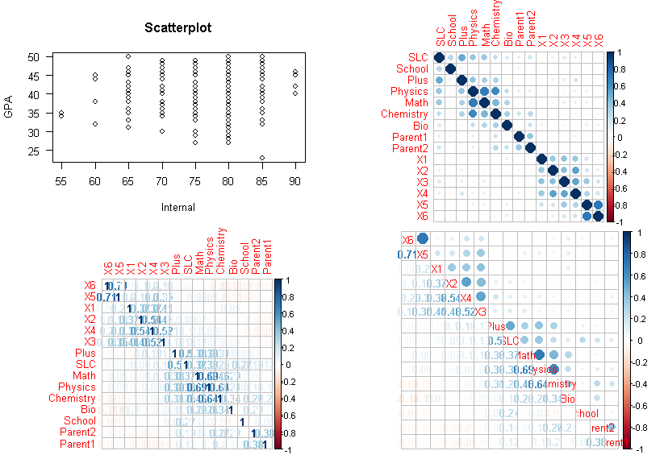

Figure 61: Correlation Plots

Thus, to the correlation between internal and final marks the internal marks need to be reduced up to 7 marks deflection of all internal subjects. After applying internal and final GPA marks in linear model produce’s the model plots indicate similar results.

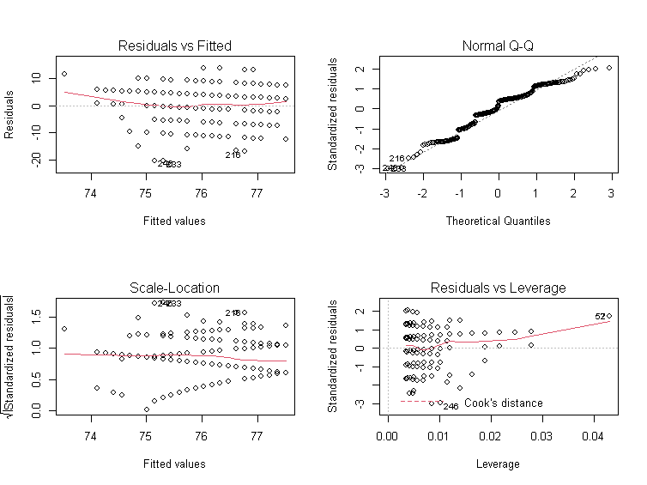

Figure 62: Residual and QQ Plots

After loading the catools package for splitting data into train and test set the sample. split command split data into 80% to 20 percent of 580 student records then the subset (463:117) for model evaluation. After omitting NA values from the database, the predictor variable pf stored 1 for passed student and 0 for fail students is the dependent variable to the model. The general regression model with two binary predictor variables with other 14 independent variables apply general linear regression model with binomial family. The model=glm (pf~ SLC + School + Plus + Physics + Math +Chemistry +Bio +Parent1 +Parent2 +X1 +X2 +X3 +X4 +X5 +X6, data = train, family = "binomial") is used for analysis its coefficient and intercept produce the output using summary model. The coefficients and descriptive statists describe as.

Estimate Std. Error z value Pr(>|z|)

(Intercept) -8.8560840 1.5933912 -5.558 2.73e-08 ***

SLC 0.0336644 0.0157239 2.141 0.03228 *

School -0.1063724 0.2175241 -0.489 0.62483

Plus 0.0063139 0.0143357 0.440 0.65962

Physics 0.0136562 0.0176905 0.772 0.44014

Math -0.0089775 0.0128445 -0.699 0.48459

Chemistry 0.0005617 0.0148844 0.038 0.96990

Bio 0.0013824 0.0059483 0.232 0.81623

Parent1 0.1446625 0.1052733 1.374 0.16939

Parent2 -0.0619289 0.1256502 -0.493 0.62211

X1 0.0638051 0.0195620 3.262 0.00111 **

X2 0.0496246 0.0216459 2.293 0.02187 *

X3 -0.0409040 0.0273335 -1.496 0.13453

X4 0.0562667 0.0254340 2.212 0.02695 *

X5 0.0184650 0.0188549 0.979 0.32742

X6 -0.0165861 0.0161270 -1.028 0.30373

From the above output, the -8.856 is intercepted (B0) each variable respective coefficient to predict student result. The -ve intercept variables whose intercept indicates the -ve association therefore the final model becomes less model=glm (pf~ SLC +Plus + Physics +Parent1 +X1 +X2 +X4, data = train, family ="binomial") become the model with the training set with eliminating non-significant values. From the above p-value, the internal marks of bachelor’s grade have the highest significance to variables like SLC, plus marks, physics and parent education have a strong association for the prediction to result in binary classification. After calculating prediction train and test with response the confusion matrix cmatrix=table (Actual = train$ pf, predicted = res>0.5) is compared with greater than 0.5 percent threshold accuracy. The accuracy is calculated using accuracy= (cmatrix [[1,1]] +cmatrix [ [2,2]])/sum(cmatrix) in training test is 0.6349892 percent and test set is 0.5897436 respectively.

Predicted

Actual FALSE TRUE

0 30 25

1 23 39

Predicted

Actual FALSE TRUE

0 146 89

1 80 148

The first prediction is 463 student records and second 117 of test data sets. Similar prediction is found in the output plots using model.

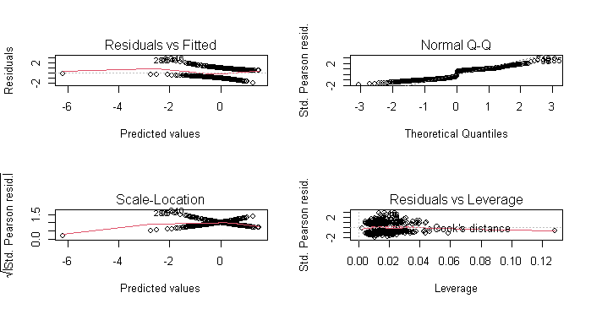

Figure 63: Residual and QQ Plot

Similarly, the program-wise data of each program regression could analyze after converting program data into factor of each program record. The table records of each program are displayed using a table(waterproof) command describes the total sample of program wise records.

Civil I Civil III Civil V Civil VII Civil VIII Comp Elex III Elex V Elex VII ELEX VIII ElexI Rural Software as 48 40 92 80 154 34 26 12 16 24 24 12 18.

The model dot matrix function creating tables of dummy variables for use in statistical.

Note: That there was no header row in the data file, so the variable name had to be added model. Matrix(~parasite-1) then header of converted dummy variables of each program is rewrite names(k)[names(k) == "data$ProgCivil I"] <-"CivilI”. For all 13 programs of Pokhara University engineering courses. The xtab detail information between GPA with program display as.

|  |  |  |  |  |  |  |  |  |  |  |  |  |  |
| --- | --- | --- | --- | --- | --- | --- | --- | --- | --- | --- | --- | --- | --- |
| GPAOR | Civil I | Civil III | Civil V | Civil  VII | Civil  VIII | Comp | Elex  III | Elex  V | Elex  VII | Elex  VIII | Elex I | Rural | Soft |
| (F)0 | 24 | 20 | 46 | 40 | 77 | 17 | 13 | 6 | 8 | 12 | 12 | 6 | 9 |
| (A)1 | 3 | 2 | 18 | 4 | 16 | 1 | 2 | 2 | 1 | 1 | 1 | 0 | 1 |
| (A-)2 | 9 | 9 | 13 | 16 | 24 | 3 | 3 | 1 | 3 | 3 | 3 | 4 | 2 |
| (B+)3 | 8 | 4 | 10 | 9 | 19 | 3 | 1 | 2 | 2 | 6 | 3 | 0 | 0 |
| (B)47 | 0 | 3 | 3 | 3 | 13 | 5 | 5 | 0 | 0 | 0 | 1 | 2 | 2 |
| (B-)5 | 4 | 2 | 2 | 6 | 4 | 4 | 2 | 1 | 2 | 2 | 3 | 0 | 3 |
| (C+6 | 0 | 0 | 0 | 2 | 1 | 0 | 0 | 0 | 0 | 0 | 0 | 0 | 1 |
| (C)7 | 0 | 0 | 0 | 0 | 0 | 1 | 0 | 0 | 0 | 0 | 1 | 0 | 0 |

Table 5: Summary Table by Program

After converting dummy variables of each program data sample split into test and training sets of 468 and 112 testing sets of 580 student records. Then the liner model with ordinal GPA with 13 programs. mod=lm (OrdGPA ~CivilI +CivilIII +CivilV +CivilVII + CivilVIII +Computer +ElexIII +ElexV +ElexVII +ElexVIII +ElexI +Rural +Software, data, data=train) used and display using summary statical as.

Estimate Std. Error t value Pr(>|t|)

(Intercept) 3.68750 1.07109 3.443 0.000628 ***

CivilI 0.72276 1.27197 0.568 0.570161

CivilI 0.04583 1.32631 0.035 0.972448

Civil 1.07566 1.17846 0.913 0.361839

CivilI 0.18015 1.19045 0.151 0.879784

CivilI 0.47083 1.14026 0.413 0.679859

Computer -0.28750 1.32631 -0.217 0.828485

ElexI 0.31250 1.40769 0.222 0.824416

Elex -0.18750 1.72708 -0.109 0.913595

ElexI 0.24583 1.53979 0.160 0.873223

ElexI 0.55060 1.42173 0.387 0.698734

ElexI 0.31250 1.45373 0.215 0.829890

Rural 1.31250 1.72708 0.760 0.447670

Software 1.31250 1.72708 0.760 0.447670

Residual standard error is 4.284 on 463 degrees of freedom. The multiple r-squared is 0.008771 and adjusted r-squared is -0.01692. The f-statistic: 0.3414 on 12 and 463 DF, p-value is 0.9811. The descriptive statists with min, max with coefficient explain the explain model in average the intercept of each program has change increase or decrease. And the program like Computer, ElexV and Software have -ve association with eliminating these columns for final model. The final p values implies that there is no significance program wise regression. However, training model accuracy is 0.8802521 and test accuracy is 0.9615385 percent respectively.

From the above the internal marks and final score have significant whereas program wise association between 13 running programs don’t have significant association.

# **Chapter 5: Major Findings and Conclusion**

## **Performance Measures**

As the final student grade GPA is the collective efforts of their previous and ongoing efforts of each semester may predict accurately using the neural network which receives the input weight of each matrix elements of variables to next neuron. The input background information from primary source is calculated though output of previous nodes weight sum with bias terms using sigmoid function which pushes for producing signal weight to converse GPA grades of the student while doing so the researcher first collects all the background information of bachelor of engineering student’s database of 580. The full model and half model of neural network were designed using various parameters to predict the best model. The full model includes all 580 student records where half model only includes 290 passed student in fall 2019 examination. The neural network input passes with single hidden layer first passes 22-input signal to predict GPA whose confusion matrix, accuracy of both training and test were predicated at output neuron. Based on the dependent variable in neural network model the output is further calculated in subdivision histogram grades. Due to the presence of some unimportant variable with similar pattern student marks to the model the prediction accuracy found varied in forward and back propagation summarized in the following bar plot.

Figure 64 : Half Neural Network Comparison

Figure 65: Full Model Comparison

This research completes with the design 24 different neural network models whose accuracy on training and test set samples were presented in the table explains the best model. However, based on data input and their weight neural conversed to predicts student grade can be more increased if we reject these variables according to suggestion form Boruta and Random Forest methodology. The three-layer backpropagations of original data of student scored prediction is more than 90 percent is a good result. When doing forward neural network with more variables as independent the GPA with categorical numeric model with single neuron is best recommended whereas at 13 input and the single layer with 5 neuron (n=5) is the best for both training and test accuracy.

## **Conclusion and Recommendation**

After applying random forest and boruta algorithm for feature engineering, student background information was passed machine learning algorithms with training and test of the full model, and half model of 580 and 290 student marks sample of the student. The researcher achieved a remarkable prediction performance (varying between 41-95 % accuracy using full model (73 to 95) using half model. Similarly, full model using backpropagation (52 to 91) per cent test accuracy and (73 to 84) per cent accuracy while using the half model of same data. This research completes 24(ANN models different neural networks model using 22, 13 input student signals with single and two, three four and many nodes between input and out nodes. This study has drawn the following useful conclusions:

Grade prediction model with 22 associative independent, associative variables predicts 95% accuracy when using a single hidden layer of student can be accurately predicted even with the result of the final exam different grades. Similarly, using 13 associative attributes input neurons with single layer (N=5) layers predicts (87 to 93) per cent accuracy of both halves or full student grade prediction. Similarly, when using two layers7,3 (83 to 83) per cent as forwarding network while using backwards, the neural network produces (52, 73) per cent accuracy in the full and half neural network model. Similarly, the using full and half model of (7,3) model (82-89) as forward and (80 -84) per cent accuracy of student GPA. Similarly, when using four neural (25,12,6,3) in between student input and their final marks GPA produced (73 to 84) accuracy. This implies that students' performance in various previous records before the final exam is highly correlated to their performance in the final exam except for second parent education status.

Another interesting point is that the F grade is the easiest to predict, followed by comparing the C grade, while B+ are the most difficult to predict with more errors in misclassification. Furthermore, the number of students whose grades perform on the final exam is more than those who improve it because of the final exam. The random forest methodology is used to test both classification and regression for data preprocessing whose output on test and training data sets is achieved 99 per cent accuracy validate the model. Likewise, the Boruta algorithm eliminates many associative variables to predicts strong associative variables suggest 17 very significant variables out of 22 variables to the model.

Similarly, random forest model partial predicts plot that the SLC student grades having more than 85 had higher chance to achieve the A grade in Bachelor of engineering whereas the mathematics score in their plus to have more than 85 have higher chance to score A in Bachelor in engineering. However, the physics marks in their plus to score with less than 65 had more chance to score A grade in Bachelor of engineer. Like Bio subject in plus to those who scored in 60 in their plus to had better graded in Bachelor A grade. those students scored greater than 75 per cent and less than 85 in their plus to chemistry had the chance to score an A grade with 99 per cent accuracy. Whereas first internal marks of mathematics scored in more than 40 could score A bachelor grade.

Similarly, confusion matrix of test sets when backpropagation of student marks with 98 per cent accuracy at mtry become 10 with 80 concludes that background information SLC, Parent educations, Chemistry and internal marks in column 5th had least significant to score bachelor grades.

Similarly, after using Borut algorithm, out of 22 independent variables declared, 17 significant attributes confirmed importance were SLC, Plus, Physics, Math's, Chemistry, Bio, Parent1, X1, X2, X4, X6, X111, X222, X333, X444, X555, and X666 all internal scored. Similarly, three attributes confirmed unimportant were Parent2, School, X3, finally, one tentative attribute left is X5 variables of an internal score whose contributing factor might be managed from other internal or another variable with similar values already contributed to forming the model.

Similar, output using Welch two-sample t-test data as ss$Int and ss$FinalGPA t = 9.1437, df = 484.33, p-value < 2.2e-16 implies the alternative hypothesis become a true difference in means is not equal to 0. 95 per cent confidence interval is 5.479536 8.479085 and sample estimates that mean of x to mean of y 83.25517 of internal marks mean and 76.27586 is final marks differs seven marks higher than final marks scored of SOE student. The p-value is significant than the reject null hypothesis because internal and final marks are large differences between when two side tests.

Similarly, multinominal logistic regression of student grade produces each probability of with reference 0 fail value regression. If all values of variables are greater than 0.5 will be drop to create the final model. The final model weights were adjusted at 104 (84 variables) conversed at 524 after 100 iterations. The summary command describes coefficient and standard errors. The final prediction model to training test data of 410 records with residual deviance is 1049.079, and AIC is 1217.079. The prediction of p=predict (model, training) with training data produce the confusion matrix is 0.4560976 accuracy, and test accuracy are 0.5823529 is low enough. This indicates that the program wise and categorical data like parent education have the least predictable significance to GPA.

This prediction helps students decide whether to drop a course or not, and lastly, counsellors can timely warn students if they are failing. In the future, we would like to extend our model to recommend the courses that would maximize his GPA. the type of the course, the teacher of the course, and his past performance in such courses.

**Limitation and Delimitation of the Study**

Inclusion and exclusion criteria: Respondents of the selected batch student which were currently being studying were included.

**Exclusion Criteria**

Denials of the sampled participation student were excluded. We note that the reported findings of this study have been based on the dataset of the performance of the undergraduate students from Pokhara university School of Engineering. The dataset used in the study is limited with GPAs available for students in the particular courses based on the result of fall 2019.

**Ethical Consideration**

This study is going to explore the grade prediction and correlation of internal and final marks of bachelor of engineering students. This observational and questionnaire survey study does not require any health-related issues of the respondent, therefore, the researcher himself will take first research consent from the School of Engineering, Pokhara University will be taken then multiple, choice questionnaire, short question answer and open questionnaire will be designed to measure the subject wise measurement of sample data.

## **References**

Adepoju, G., Ogunjuyigbe, S., & Alawode, K. (2007). Application of Neural Network to Load Forecasting in Nigerian Electrical Power System”. The Pacific Journal of Science and Technology.8(1):68-72.

Agoritsa, P., & George, K. (2019). Grade Prediction with Course and Student Speciic Model.

Agoritsa, P., & Karypis, G. (2016). Grade prediction with models specific to students and courses. *Received: 20 July 2016 / Accepted: 6 September 2016 / Published online: 22 September*.

Anastasiadis, A., Stefan, F., & Frauke, G. (2005). New globally convergent training scheme based on the resilient propagation algorithm. Neurocomputing 64, pages 253-270.

Anusiewicz, C., & Patrician, P. (2021). Measuring workplace bullying in a US nursing population with the Short Negative Acts Questionnaire. . *Research in Nursing & Health, 44(2), 319-328.*

Bhardwaj, B. (2011). “Data Mining􀯗: A prediction for performance improvement using classification. *Int. J. Comput. Sci. Inf. Secur., vol.*

Brecko, B. (2004). How family background influences student achievement. In Proceedings of the IRC-2004.

Brijesh Kumar, B., & Saurabh, P. (2012). Data Mining: A prediction for performance improvement using classification. *(IJCSIS) International Journal of Computer Science and Information Security, Vol. 9, No. 4, April 2011, pp 136-140*.

Brijesh Kumar, B., & Saurabha, P. (2011). E preceding of 4th Global summit. *Mining education Data Analyze student performance*.

Brinton, G., & Chiang, M. (2016). *Mining MOOC clickstreams: Video-watching behavior vs. in-video quiz performance.* Signal Process., vol. 64, no. 14, pp. 3677–3692, Jul.

Cohen, W. (1995). Effective rule induction. *Twelves international conference on machine larning*.

Daguang, W., & Xie, Z. (2017). Enhancing Teaching and Learning through. *Enhancing Teaching and Learning through Internal Quality Assurance Xiamen University, China*.

David, G., Rijt, G. v., Filip, D., & Janine, v. d. (2008). Students’ assessment preferences, perceptions. *High Educ (2008) 56:645–658*.

Davidson, J. H. (2014). Predicting persistence for first-time undergraduate adult students at four-year institutions using first-term academic behaviors and outcomes. *The Journal of Continuing Higher Education, 62(2), 78-89.*

El, M., & Yasser, M. (2008). Machine learning approaches for epitope. *Iowa State University*.

Emaan Abdul, M. (2016). GRADE PREDICTION USING SUPERVISED MACHINE LEARNING TECHNIQUES.

Filip, D. a. (2008). Students’ assessment preferences, perceptions. *High Educ (2008) 56:645–658 Open access*.

Fisher, J. (2014). Applied Learning in Online Education:A Comparative Study Employing. *Utah Valley University*.

Hamsa, H., Indiradevi, H., & Kizhakkethottam, J. (2016). Student Academic Performance Prediction Model Using Decision Tree and Fuzzy Genetic. *Procedia Technol., vol. 25, pp. 326–332,*.

Havan, A., & Harshil, M. (2015). Student Performance Prediction using Machine. *International Journal of Engineering Research & Technology (IJERT)*.

Hijazi, S., & Naqvi, R. (2006). Factors Affecting Student’s Performance: A Case of Private Colleges. . *Bangladesh e-Journal of Sociology. Vol. 3, No. 1.*

Iannaccone, A., Conte, D., Cortis, C., & Fusco, A. (2021). Usefulness of Linear Mixed-Effects Models to Assess the Relationship between Objective and Subjective Internal Load in Team Sports. . *International journal of environmental research and public healt*.

John, A., & Manabete, S. (2015). Procedural INflurance on Internal and External Assessment score of Undergraduage. *Journal of Education and Practices*.

Junemann, M. L. (2007). Neural networks to predict schooling failure/success. *Lecture Notes in Computer Science, Nature Inspired Problem-Solving Methods in Knowledge Engineering. Berlin: Sp*.

Kalejaye, B., Folorunso, O., & Usman, L. (2015). PREDICTING STUDENTS’ GRADE SCORES USING TRAINING FUNCTIONS OF ARTIFICIAL NEURAL NETWORK. *Journal of Natural Sciences, Engineering and Technology, Volume 14, 2015 (formerly ASSET Journal Series B)*.

Karamouzis, S. (2000). *Using Analogies to predict Student performance.* In Proc. IASTED’s Artificial Intelligence and soft comp. Banf, Canada, P.355-360.

Lima, K., Mohanan, D. T., & Harichandran, S. (2017). Association of class attendance and academic performance of MBBS. *National Journal of Physiology, Pharmacy and Pharmacology*.

Lorenzen, S., Pham, N., & Alstrup, S. (2017). On predicting student performance using low-rank matrix factorization.

Lykourentzou, G., Mpardis, G., & Nikolopoulos, L. (2009). Early and Dynamic Student Achievement Prediction in E-Learning Courses Using Neural Networks.

Lykourentzou, I., Giannoukos, I., Mpardis, G., Nikolopoulos, V., & Loumos, V. (2009). Early and Dynamic Student Achievement Prediction in E-Learning Courses Using Neural Networks. Journal of the American Society for Information Science and Technology, 60(2):372-380.

Maghari, A. (2017). Students Performance Prediction Using KNN and Naïve Bayesian.

Meier, Y., Xu, A., & Van, M. (2016). Predicting grades. IEEE Transactions.

Miranda, L., & Martin, A. (2013). Analysis of student performnce using genetic Algorithum,. *Computer Ccience Journal*.

Mubarak, A., & Umar, L. (2019). *Student Academic Performance Prediction using Artificial Neural Networks: A Case Study.* China: International Journal of Computer Applications.

Muhammad, A., & Aijaz Ahmed, G. (2007). CORRELATION BETWEEN MARKS OBTAINED BY STUDENTS. *Turkish Online Journal of Distance Education-TOJDE April 2007 ISSN 1302–6488, Volume: 8 Number: 2 Article: 10*.

Murata, A. (1994). Network information criterion - determining the number of hidden units for an artificial neural network model. IEEE Transactions on Neural Networks 5 (6), pages 865-871.

Naqui, H. S. (2006). Bangledesh E Journals . *Factors affecting student performance*.

Nikolopoulos, V. (2009). Dropout prediction in e-learning courses through the combination of machine learning techniques.

Nnodium, J. (1992). Multiple choice testingin anatomy. *PubMED*, J Med Educ. 1992;26:301–09.

Osmanbegović, E., & Suljić, M. (2012). *Data Mining Approach for Predicting students performances.* J. Econ. Bus., vol. X, no. 1, pp. 3–12,.

Pandey, U., & Pal, S. (2012). A prediction of performer using classification. *International jpurnal of computer science*.

Patel, C. (2017). STUDENT FINAL GRADE PREDICTION. *Indian Journal of Computer Science and Engineering (IJCSE)*.

Ramaswami, M., & Rasthnasbapathy, M. (2010). A CHAID Based Performance Prediction Model in Educatioal Data mining. *International Journal of computer Science*.

Ranjita, S., Sushobhan, P., Ananya, M., Nina, D., & Patralekha, R. (2014). A Study on the Performance of Medical Students in Internal Assessment and its Correlates to Final Examinations of 2nd MBBS Pharmacology Curriculum in a Medical College of Eastern India. *The new examination system reforms- A must. Studies High Educ. 2002;27:221–31.*

Riedmiller, M., & Braun, H. (1993). A direct adaptive method for faster backpropagation learning: The RPROP algorithm. Proceedings of the IEEE International Conference on Neural Networks (ICNN), pages 586-591. San Francisco.

Romero, C., & Ventura, S. (2010). *Educational Data Mininig: A reviwe of the state of the art.* IEEE Trans. Syst. Man. Cybern., vol. 40, no. X, pp. 601–619.

Rushika, G., Juilee, K., Pooja, M., Sachee, N., & Priya, R. (2018). Prediction of Crop Yield using Machine Learning. *International Research Journal of Engineering and Technology (IRJET)*.

Saleem, S., Kathiry, N., Al-Osimi, S., & Badr, G. (2015). Mining Educational Data to Predict Students’ Academic Performance’. *, Mach. Learn. Data Min. Pattern Recognition, Mldm 2015, vol. 9166, no. 6, pp. 403–414,*.

Shahiri, A., Husain, W., & Rashid, N. (2015). A Review on Predicting Student’s Performance Using Data Mining Techniques. *Procedia Comput. Sci., vol. 72, pp. 414–422,*.

Shoon Lei, W., Zaw Zaw, H., Faridah, Y., & Ibrahim, N. (2014). CANCER RECURRENCE PREDICTION USING. *International Journal of Computational Science and Information Technology (IJCSITY) Vol.2, No.2, May 2014*.

Sidath, A. (2018). *Machine Learning Classifiers.* https://towardsdatascience.com/machine-learning-classifiers-a5cc4e1b0623.

Silva, F. (2018). *Importance performance analysis as tool in evaluating higher edcation*. Retrieved from https://www.researchgate.net/publication/277035463.

Sorour, S., Mine, K., & Hirokawa, S. (2014). *Predicting students’ grades based on free style comments data by artificial neural network. In 2014 IEEE Frontiers in Education Conference (FIE) Proceedings, page 19,.*

Tair, M. M., & Alaa, M. E.-H. (2012). Mining Educational Data to Improve Students’ Performance: A Case Study. . *International Journal of Information and Communication Technology Research, Vol.2 No. 2*.

Verdes, P., Granitto, M., Navone, D., & Ceccatto, H. (2010). FROST PREDICTION WITH MACHINE LEARNING TECHNIQUES. *Instituto de Física Rosario (CONICET-UNR) Argentina*.

Wongkhamdi, T., & Seresangtakul, P. (2010). A Comparison of Classical Discriminant Analysis and Artificial Neural Networks in Predicting Student Graduation Outcomes. *Proc. Second Int. Conf. Knowl. Smart Technol., pp. 29–34,*.

Woodford, C. (2017). *Neural networks*. Retrieved from https://www.explainthatstuff.com/introduction-to-neural-networks.html

Yahya, F., Mohamed, A.-A., & Abdelfatah, A. (2011). Procedures for Evaluating the Teaching Process in computer Discpline.

Yang, T., & Brinton, C. (2017). *Behavior-Based Grade Prediction for MOOCs Via Time Series Neural Networks.* IEEE JOURNAL OF SELECTED TOPICS IN SIGNAL PROCESSING, VOL. 11, NO. 5, AUGUST.

Yupei, Z., Yue, Y., Huan, D., Jiaqi, C., & Xuequn, S. (2020). *Graphs Regularized Robust Matrix Factorization and Its Application on Student Grade Prediction.* School of Computer Science, Northwestern Polytechnical University, Xi’an 710129, Shaanxi, China;.

Zacharis, N. (2016). Predicting Student Academic Performance in Blended Learning Using Artificial Neural Networks. *Int. J. Artif. Intell. Appl., vol. 7, no. 5, pp. 17–29,*.

## **Annex1: Research Questionnaire**

Respondent Name: Symbol No:

Marks of Student (in Percent)

SLC Total Percent Select High School Education Govt. Private:

+2 Total Percent Physics: Math: Chemistry: Bio:

Please select your parent highest education label (Please Tick)

a) SLC b) +2 c) Bachelor d) Master e) Ph. D

Please select your other family member’s highest education label (if only have)

a) SLC b) +2 c) Bachelor d) Master e) Ph. D

THANK YOU

-----------------------------------------------------------------------------------------

Research Questionnaire

Respondent Name: Symbol No:

Marks of Student (in Percent)

SLC Total Percent Select High School Education Govt. Private:

+2 Total Percent Physics: Math: Chemistry: Bio:

Please select your parent highest education label (Please Tick)

a) SLC b) +2 c) Bachelor d) Master e) Ph. D

Please select your other family member’s highest education label (if only have)

a) SLC b) +2 c) Bachelor d) Master e) Ph. D

THANK YOU

## **Annex: Photographs**



